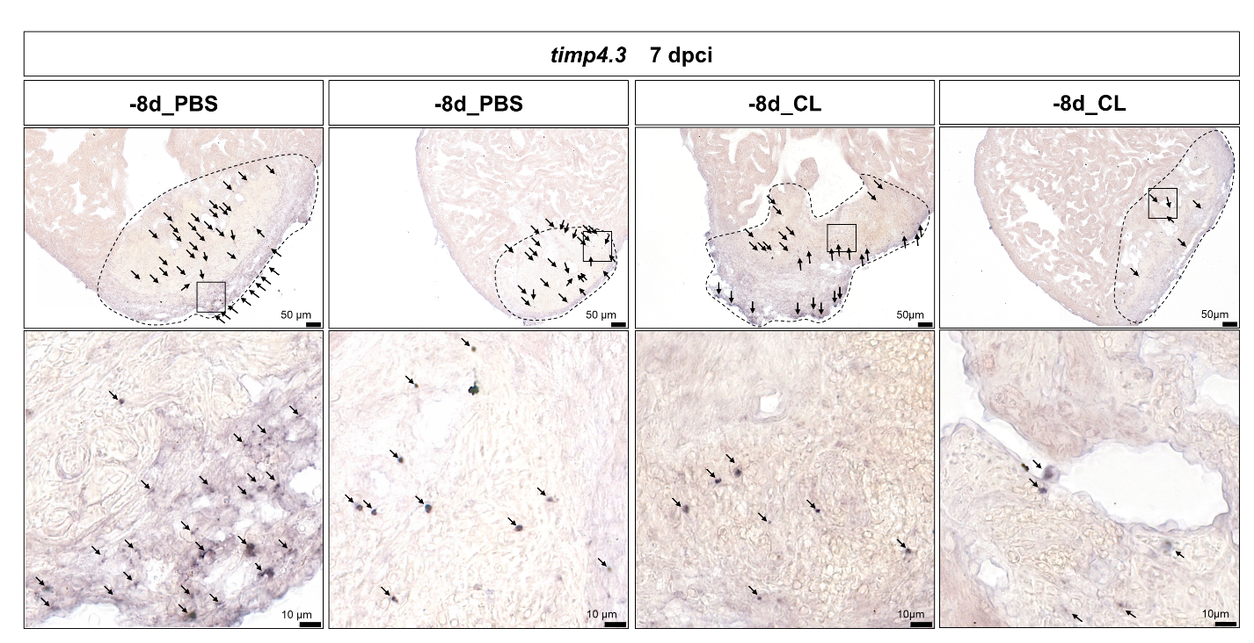
Chromogenic in situ hybridization of timp4.3 in additional zebrafish 7-dpci hearts with PBS or CL injection at 8 days before cardiac injury (-8d_PBS or -8d_CL). Dotted lines delineated injury areas (upper panels) and arrows highlight the timp4.3 expressed cells; scale bars, 50 μm for upper panels and 10 μm for lower panels. CL, Clodronate liposomes

