SUPPLEMENTARY FILE 1

Homophilic wiring principles underpin
neuronal network topology in vitro

Danyal Akarca^{1,2,3}*, Alexander W. E. Dunn^{4,5}*, Philipp J. Hornauer⁶, Silvia Ronchi⁶, Michele Fiscella⁶, Congwei Wang⁷, Marco Terrigno⁷, Ravi Jagasia⁷, Petra E. Vértes⁸, Susanna B. Mierau^{4,9,10}, Ole Paulsen⁴, Stephen J. Eglen⁵, Andreas Hierlemann⁶, Duncan E. Astle^{1,11†}, Manuel Schröter^{6†}

- MRC Cognition and Brain Sciences Unit, University of Cambridge, Cambridge, UK
- Department of Electrical and Electronic Engineering, Imperial College London, London, UK
- I-X, Imperial College London, London, UK
- Department of Physiology Development and Neuroscience, University of Cambridge, Cambridge, UK
- Department of Applied Mathematics and Theoretical Physics, University of Cambridge, Cambridge, UK
- Department of Biosystems Science and Engineering in Basel, ETH Zurich, Switzerland
- NRD, Roche Innovation Center Basel, F. Hoffmann-La Roche Ltd., Basel, Switzerland
- Department of Psychiatry, University of Cambridge, Cambridge, UK
- Division of Cognitive and Behavioral Neurology, Brigham & Women’s Hospital, Boston, USA
- Harvard Medical School, Boston, USA
- Department of Psychiatry, University of Cambridge, Cambridge, UK

Corresponding authors:
Dr Danyal Akarca
Email: danyal.akarca@mrc-cbu.cam.ac.uk
Dr Manuel Schröter
Email: manuel.schroeter@bsse.ethz.ch

*Co-lead first authors
†Co-lead senior authors

CONTENTS

Supplementary files

Supplementary file 1a. Overview of the datasets used in the study.

Supplementary file 1b. A list of all the value K_{i,j} terms that were included in the generative modeling, as given in the wiring equation.

Supplementary file 1c. A summary of all optimized parameters and energy values, for each dataset, across generative rules.
Supplementary file 1d. Statistical comparisons of the sparse rodent culture energy values across generative rules.

Supplementary file 1e. Statistical comparisons of the sparse rodent culture topological fingerprint dissimilarity across generative rules.

Supplementary file 1f. Statistical comparisons of the dense rodent culture topological fingerprint dissimilarity across generative rules.

Supplementary file 1g. Statistical comparisons of the dense rodent culture energy values across generative rules.

Supplementary file 1h. Statistical comparisons of human monolayer neuron and cerebral organoid culture energy values across generative rules.
Supplementary file 1i. Overview of used antibodies.

Supplementary file 1j. Confidence intervals of model energies, generated by subsampling from the dense rodent networks.

Cell line | Recording time points | Cells plated | Type of plating | Cells density  (cells/mm²) | Type of MEA | Samples
Primary rodent cortex (sparse) | DIV 7, 10, 12, 14 | 50,000 | Whole-array plating | ~1,000 | MaxTwo  (6-well plates) | 6
Primary rodent cortex (dense) | DIV 14/15, 28 | 100,000 | Whole-array plating | ~2,000 | MaxTwo (6-well plates) | 12
Human motor neurons | DIV 28 | 100,000 | Dot plating | ~10,000 | MaxOne (single wells) | 7
Human glutamatergic neurons | DIV 28 | 100,000 | Dot plating | ~10,000 | MaxOne (single wells) | 8
Human dopaminergic neurons | DIV 28 | 100,000 | Dot plating | ~10,000 | MaxOne (single wells) | 6
Human cerebral organoids | 120 days | - | - | - | MaxTwo (6-well plates) | 6

Supplementary file 1.

Overview of the datasets used in the study.

The plating density here reflects the number of cells plated, rather than the graph density of the connectivity of the functional networks that are subsequently inferred following developmental time.
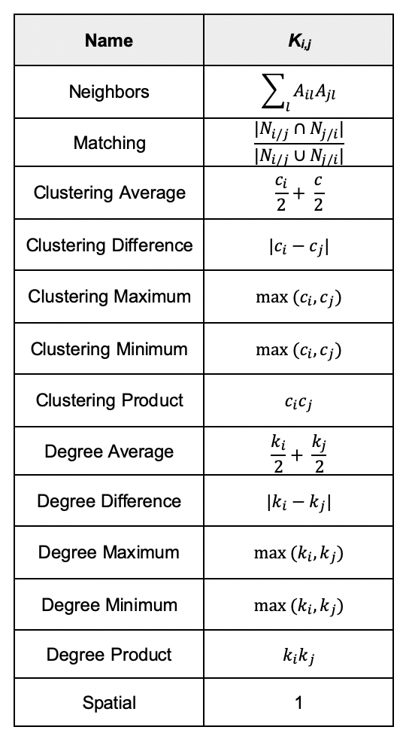

Supplementary file 2.

List of all value K_{i,j} terms that were included in the generative modeling, as given in the wiring equation.

A is the binary adjacency matrix, c is the local clustering coefficient, k is the node degree and N_{i/j} represents the neighbors of node i, excluding node j. Note that the spatial model enforces K_{i,j} =1, which means that the value term has no effect on the generative process.
Supplementary file 3.

A summary of all optimized parameters and energy values, for each dataset, across generative rules.

Each dataset is reported alongside the featured figure (s) they are presented in. This table provides a summary of the model performances, but all individual model data is available within our data repository.
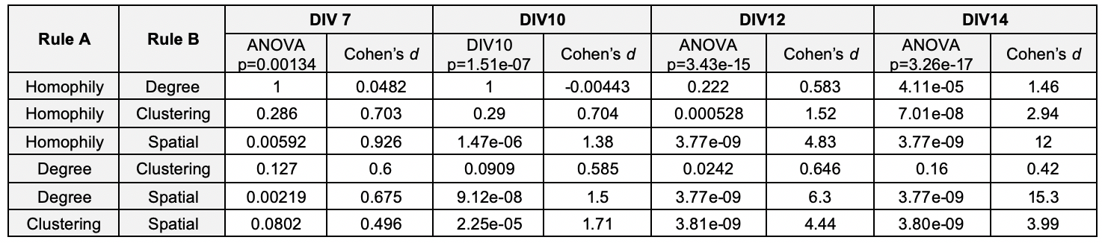

Supplementary file 4.

Statistical comparisons of the sparse rodent culture energy values across generative rules.

For each test, we quote the ANOVA p-value across the generative rules and the corresponding Cohen’s d if the ANOVA was significant at p<0.05. A positive Cohen’s d reflects that Rule A has a smaller energy than Rule B, reflecting a better fit. Generative rules have been binned across the generative model class.

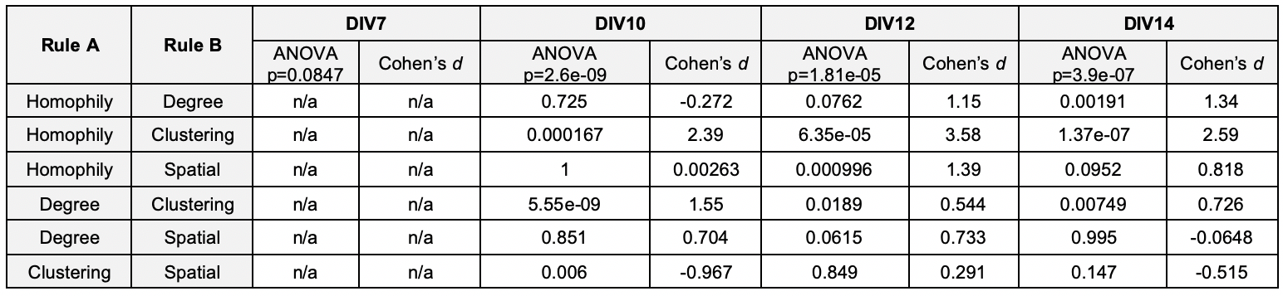

Supplementary file 5.

Statistical comparisons of sparse rodent culture topological fingerprint dissimilarity across generative rules.

For each test, we quote the ANOVA p-value across the generative rules and the corresponding Cohen’s d if the ANOVA was significant at p<0.05. A positive Cohen’s d reflects that Rule A has a smaller energy than Rule B, reflecting a better fit. Generative rules have been binned across the generative model class.
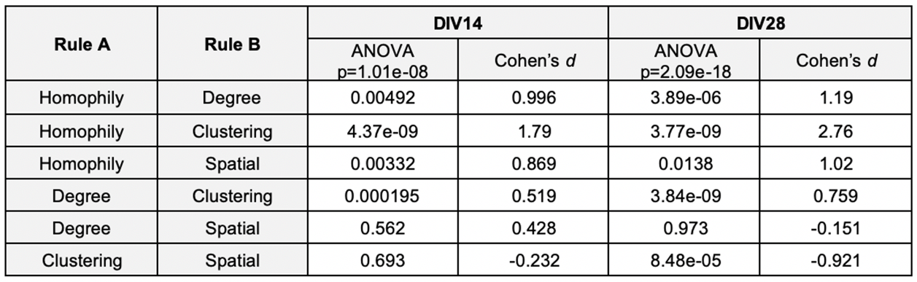

Supplementary file 6.

Statistical comparisons of dense rodent culture topological fingerprint dissimilarity across generative rules.

For each test, we quote the ANOVA p-value across the generative rules and the corresponding Cohen’s d if the ANOVA was significant at p<0.05. A positive Cohen’s d reflects that Rule A has a smaller energy than Rule B, reflecting a better fit. Generative rules have been binned across the generative model class.
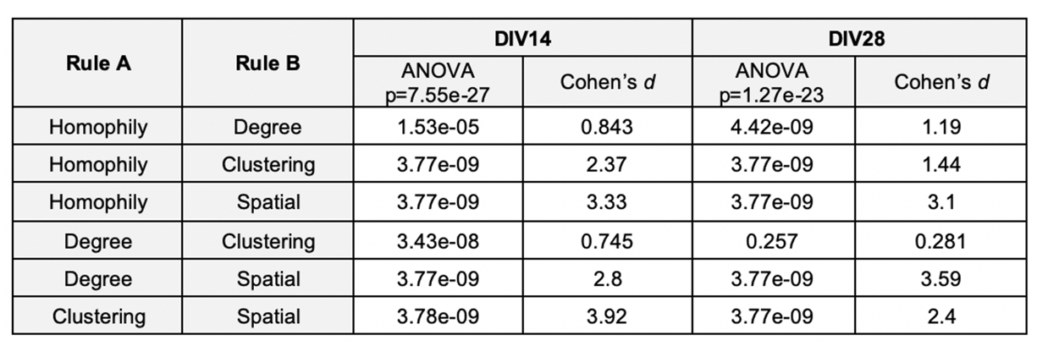

Supplementary file 7.

Statistical comparisons of dense rodent culture energy across generative rules.

For each test, we quote the ANOVA p-value across the generative rules and the corresponding Cohen’s d if the ANOVA was significant at p<0.05. A positive Cohen’s d reflects that Rule A has a smaller energy than Rule B, reflecting a better fit. Generative rules have been binned across the generative model class.

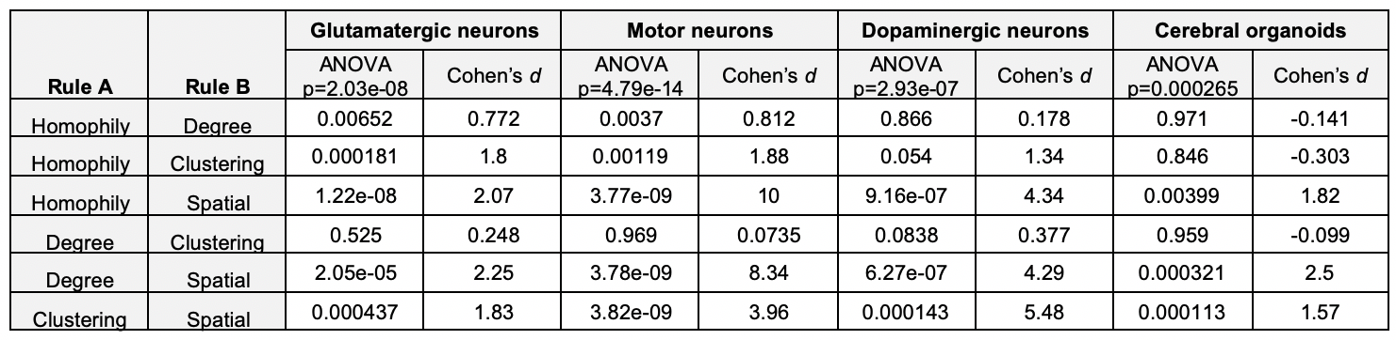

Supplementary file 8.

Statistical comparisons of human monolayer neuron and cerebral organoid culture energy values across generative rules.

For each test, we quote the ANOVA p-value across the generative rules and the corresponding Cohen’s d if the ANOVA was significant at p<0.05. A positive Cohen’s d reflects that Rule A has a smaller energy than Rule B, reflecting a better fit. Generative rules have been binned across the generative model class.
Antibodies (human organoids) | Type | Dilution | Catalog number
Tau | Primary | 1:500 | #MN1000, ThermoFisher
NeuN | Primary | 1:300 | #M11954-3, Boster Bio, Pleasanton, CA, USA
GFAP | Primary | 1:500 | #NB300-141, Novus Biologicals, Englewood, CO, USA
goat anti-mouse IgG, Alexa Fluor Plus 488 | Secondary | 1:400 | #A32723, ThermoFisher
goat anti-rabbit IgG, Alexa Fluor 568 | Secondary | 1:400 | #A11036, ThermoFisher
goat anti-chicken IgY, Alexa Fluor Plus 647 | Secondary | 1:400 | #A32933, ThermoFisher
Antibodies (human iPSC) | Type | Dilution | Catalog number
mouse anti-TH | Primary | 1:500 | #MAB318, Sigma-Aldrich
chicken anti-MAP2 | Primary | 1:1000 | #CH22103, Neuromics (Edina, MN, USA)
rabbit anti-GFAP | Primary | 1:500 | #Z0334, Agilent (Santa Clara, CA, USA)
donkey anti-mouse 488 | Secondary | 1:250 | #A-21202, ThermoFisher
goat anti-chicken 647 | Secondary | 1:500 | #A-32933, ThermoFisher
donkey anti-rabbit 568 | Secondary | 1:250 | #A-A10042, ThermoFisher
Antibodies (rodent PC) | Type | Dilution | Catalog number
mouse anti-Synaptophysin | Primary | 1:100 | #ab8049, Abcam
rabbit anti-NeuN | Primary | 1:300 | #ab177487, Abcam
chicken anti-beta III Tubulin | Primary | 1:1000 | #ab41489 Abcam
donkey anti-mouse IgG, Alexa Fluor 488 | Secondary | 1:500 | #ab150105, Abcam
donkey anti-Chicken IgY (IgG) | Secondary | 1:400 | #703–165-155, Jackson ImmunoResearch, West Grove, USA
donkey anti-rabbit IgG, Alexa Fluor 405 | Secondary | 1:1000 | #ab175651, Abcam

Supplementary file 9.

Primary and secondary antibodies.

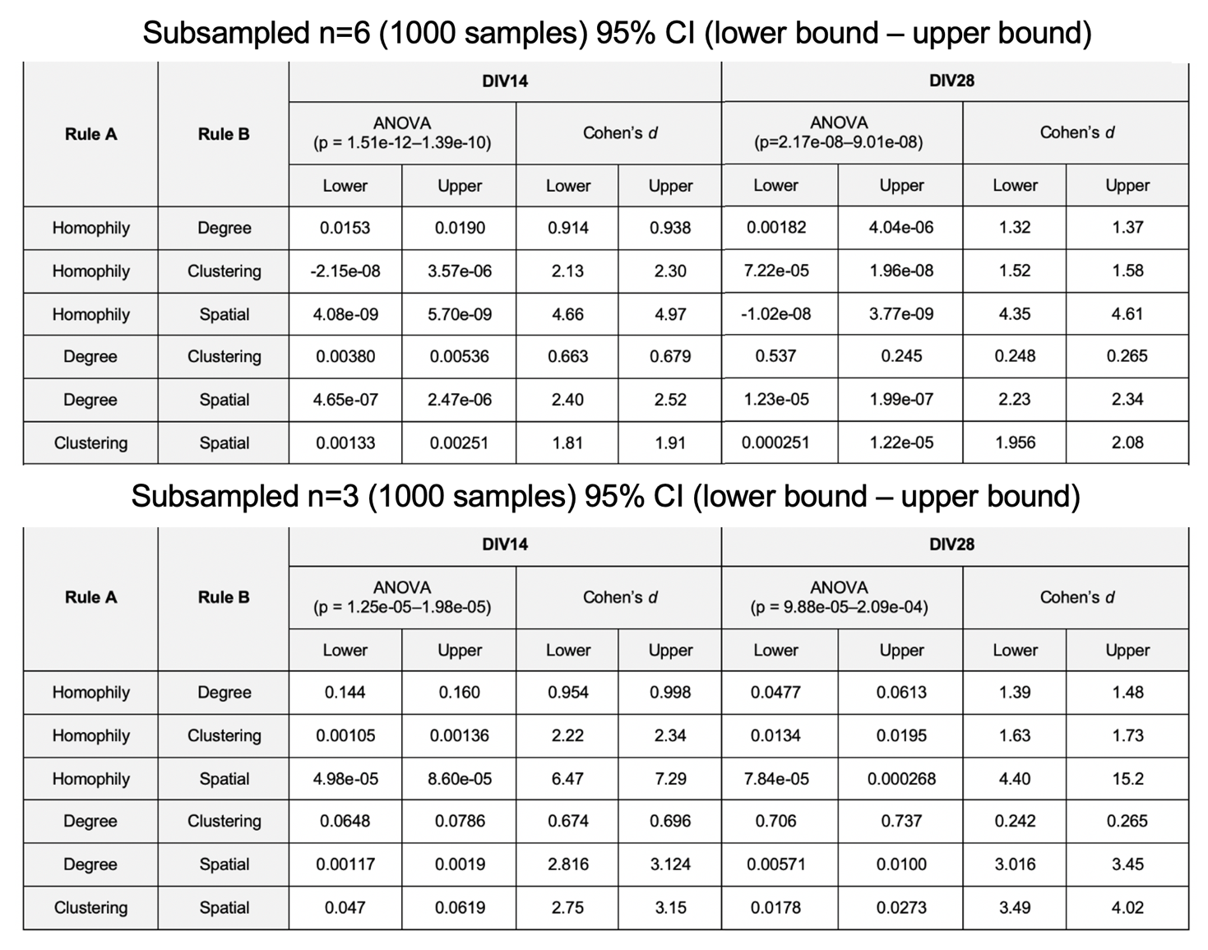

Supplementary file 10.

Confidence intervals of model energies, generated by subsampling from the dense rodent networks.

