*Fig SF 4.1: Relation between conservative and inclusive measures of the FP volume*

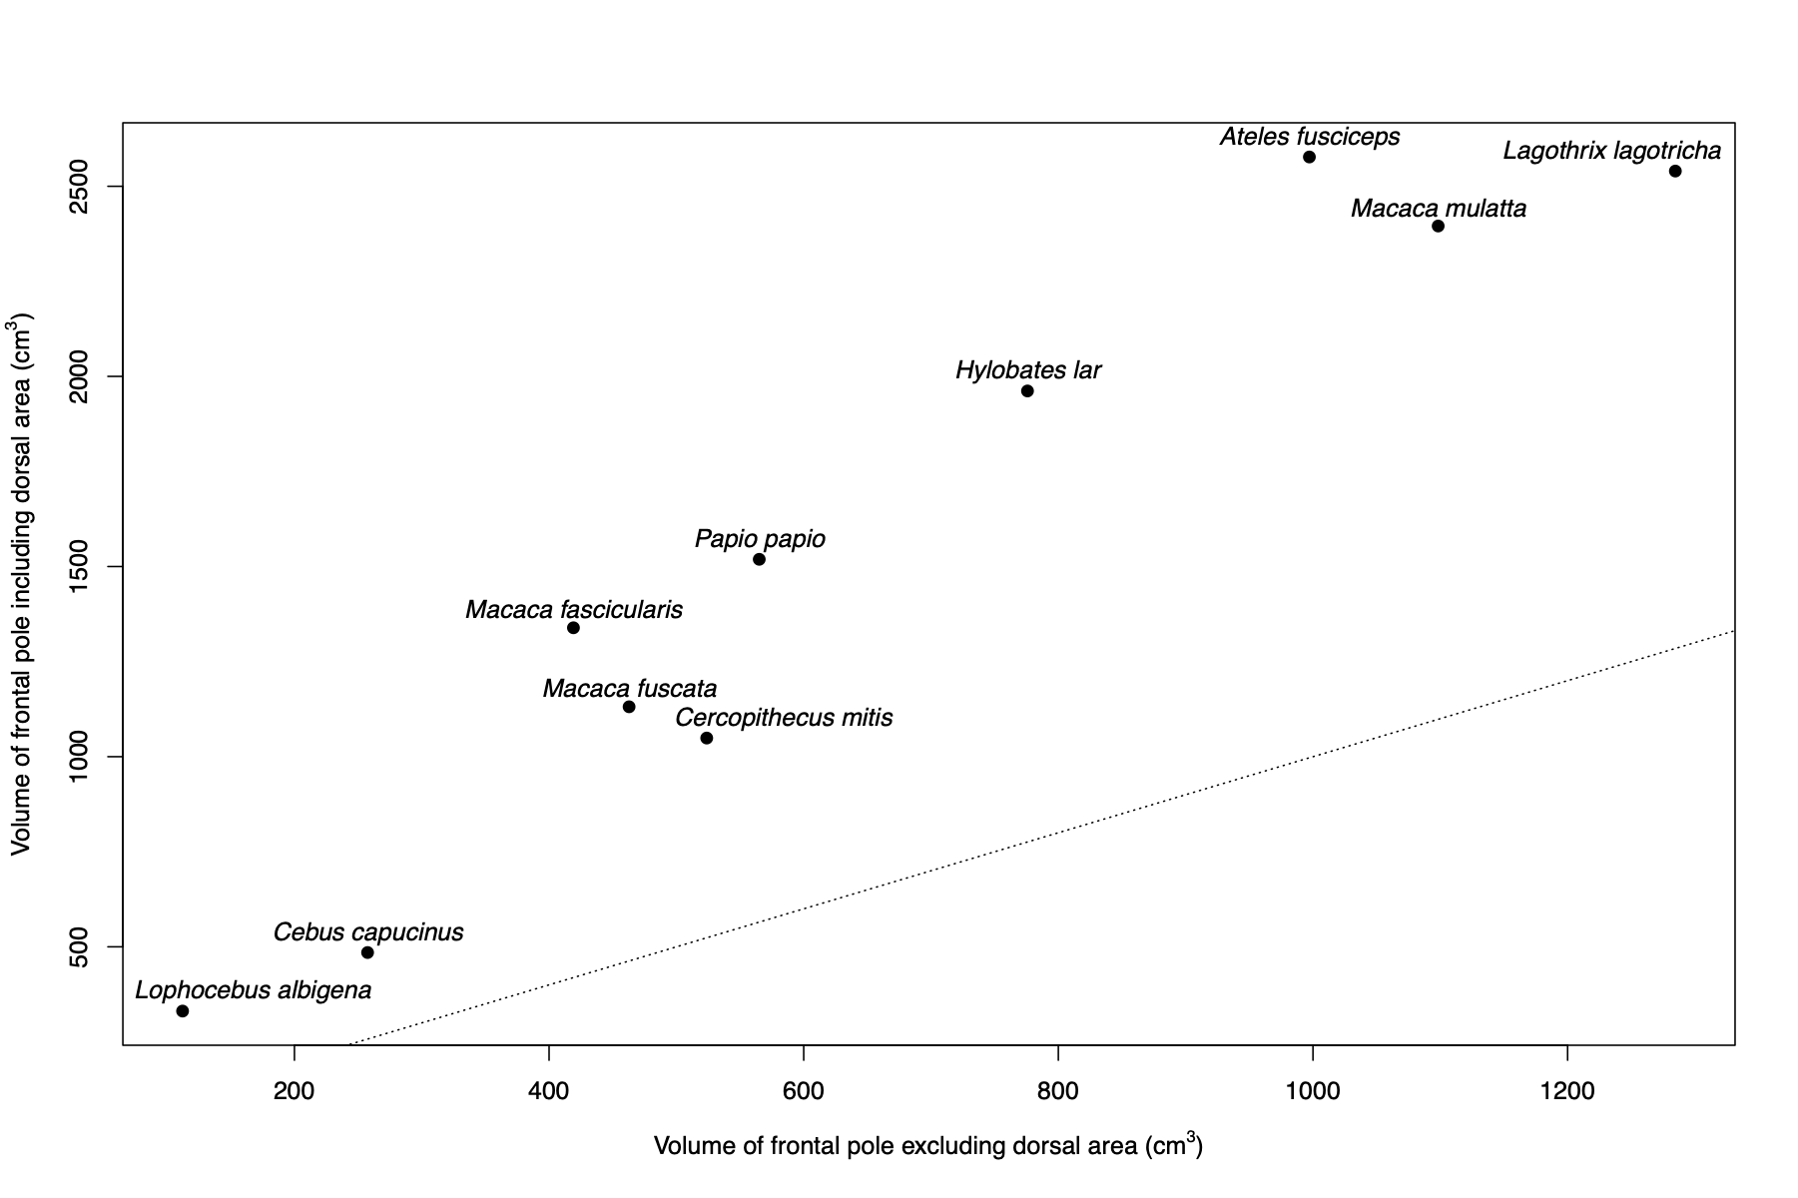

*Table SF 4.2: Model comparison data for the inclusive measure of the FP*

|  |  |  |  |
| --- | --- | --- | --- |
| **Response** | **Predictor(s)** | **OLS** | **PGLS** |
| FP (inc. dorsal area) | log10(Body) | 15.19 | 23.95 |
| FP (inc. dorsal area) | Pop_d | 22.54 | 23.27 |
| FP (inc. dorsal area) | DTD | 15.14 | 12.18 |
| FP (inc. dorsal area) | log10(Body) + Pop_d | 15.23 | 20.98 |
| FP (inc. dorsal area) | log10(Body) + DTD | **10.22** | 12.45 |
| FP (inc. dorsal area) | Pop_d + DTD | 16.98 | 12.18 |
| FP (inc. dorsal area) | log10(Body) + Pop_d + DTD | 10.37 | **10.25** |

*Table SI 4.3: Parameter estimate for the best model according to OLS*

|  |  |  |  |  |
| --- | --- | --- | --- | --- |
| **Coefficient** | **Estimate** | **SE** | ***t*-test** | ***P*** |
| (intercept) | 2.660 | 0.182 | 14.623 | 0 |
| log10(Body) | 0.376 | 0.142 | 2.653 | 0.020 |
| DTD | 0.067 | 0.025 | 2.663 | 0.019 |

*Table SI 4.4: Parameter estimate for the best model according to PGLS*

|  |  |  |  |  |
| --- | --- | --- | --- | --- |
| **Coefficient** | **Estimate** | **SE** | ***t*-test** | ***P*** |
| (intercept) | 2.455 | 0.371 | 6.610 | 0 |
| log10(Body) | 0.430 | 0.235 | 1.830 | 0.092 |
| Pop_d | 0.008 | 0.004 | 1.900 | 0.081 |
| DTD | 0.072 | 0.019 | 3.821 | 0.002 |