*Table SF 7.1:* Pairwise correlations for all pairs of continuous variables

|  |  |  |  |  |  |  |
| --- | --- | --- | --- | --- | --- | --- |
|  | Body | DQI | DTD | Gp | Pop_d | Weaning |
| Body |  | 0.011 | 0.867 | 0.780 | 0.067 | 0.006 |
| DQI | -0.617 |  | 0.063 | 0.266 | 0.159 | 0.019 |
| DTD | 0.046 | 0.475 |  | 0.000 | 0.891 | 0.292 |
| Gp | -0.076 | 0.296 | 0.822 |  | 0.870 | 0.270 |
| Pop_d | -0.469 | 0.370 | -0.037 | -0.045 |  | 0.022 |
| Weaning | 0.652 | -0.577 | -0.281 | -0.293 | -0.566 |  |

*Fig SF 7.2:* Pairwise plots of correlations across continuous socio-ecological variables.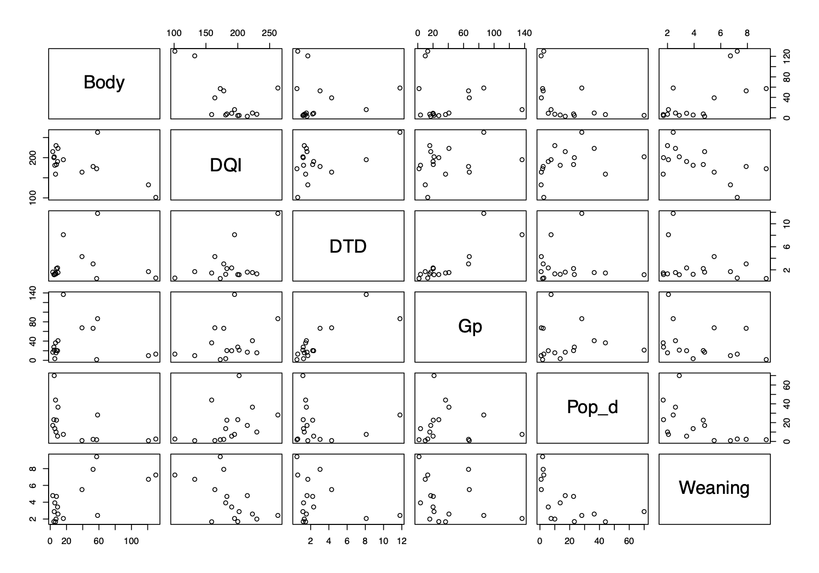

Table SF 7.3: Contingency table of the 2 correlated categorical variables: Social System and Mating System.

|  |  |  |  |  |
| --- | --- | --- | --- | --- |
|  | Harem polygyny | Monogamy | Polygynandry | Spatial polygyny |
| Multi-male multi-female | 3 | 0 | 9 | 0 |
| Pair | 0 | 1 | 0 | 0 |
| Single male | 2 | 0 | 0 | 0 |
| Solitary | 0 | 0 | 0 | 1 |

*Fig SF 7.4: Boxplots of relation between continuous vs categorical variables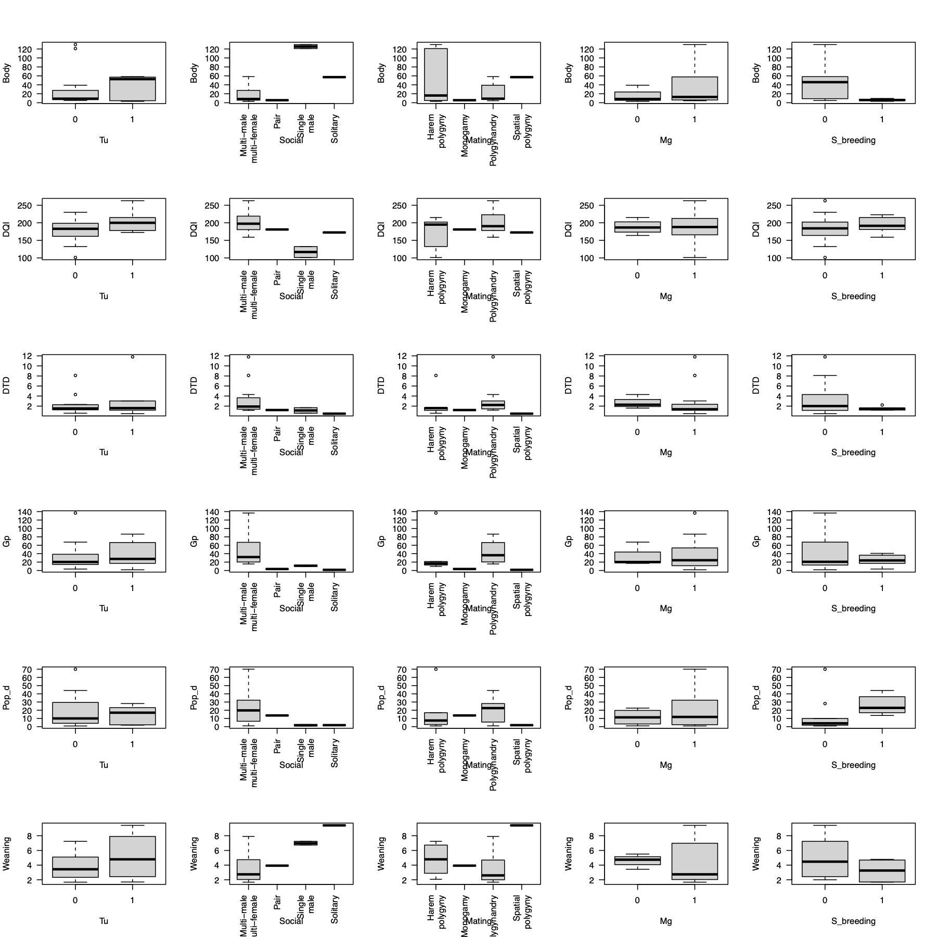*

*Table SI 7.5: Quantification of the relation between continus vs categorical variables.*

|  |  |  |  |
| --- | --- | --- | --- |
| **Continuous Var.** | **Categorical Var.** | **P-value** | **P-value_log(Cont. V)** |
| Body | Tool Use (tu) | 0.9066 | 0.7374 |
| Body | Social | 0.0001 | 0.0210 |
| Body | Mating | 0.4435 | 0.5965 |
| Body | Mate guarding (Mg) | 0.3146 | 0.3534 |
| Body | S_breeding | 0.0361 | 0.0057 |
| DQI | Tool Use (tu) | 0.1953 | 0.2133 |
| DQI | Social | 0.0191 | 0.0041 |
| DQI | Mating | 0.5952 | 0.5491 |
| DQI | Mate guarding (Mg) | 0.9437 | 0.8144 |
| DQI | S_breeding | 0.6095 | 0.5050 |
| DTD | Tool Use (tu) | 0.4575 | 0.8264 |
| DTD | Social | 0.6578 | 0.1643 |
| DTD | Mating | 0.8248 | 0.3263 |
| DTD | Mate guarding (Mg) | 0.9220 | 0.4887 |
| DTD | S_breeding | 0.2270 | 0.4255 |
| Gp | Tool Use (tu) | 0.8142 | 0.9169 |
| Gp | Social | 0.3294 | 0.0014 |
| Gp | Mating | 0.6116 | 0.0063 |
| Gp | Mate guarding (Mg) | 0.7476 | 0.7579 |
| Gp | S_breeding | 0.3103 | 0.7023 |
| Pop_d | Tool Use (tu) | 0.6456 | 0.9510 |
| Pop_d | Social | 0.4628 | 0.1187 |
| Pop_d | Mating | 0.8709 | 0.6741 |
| Pop_d | Mate guarding (Mg) | 0.4642 | 0.6738 |
| Pop_d | S_breeding | 0.1942 | 0.0201 |
| Weaning | Tool Use (tu) | 0.3157 | 0.5044 |
| Weaning | Social | 0.0189 | 0.0719 |
| Weaning | Mating | 0.1299 | 0.2857 |
| Weaning | Mate guarding (Mg) | 0.7920 | 0.4331 |
| Weaning | S_breeding | 0.1758 | 0.2188 |