Figure 4–Source Data 1 Additive and non-additive gene expression in allotetraploid groups
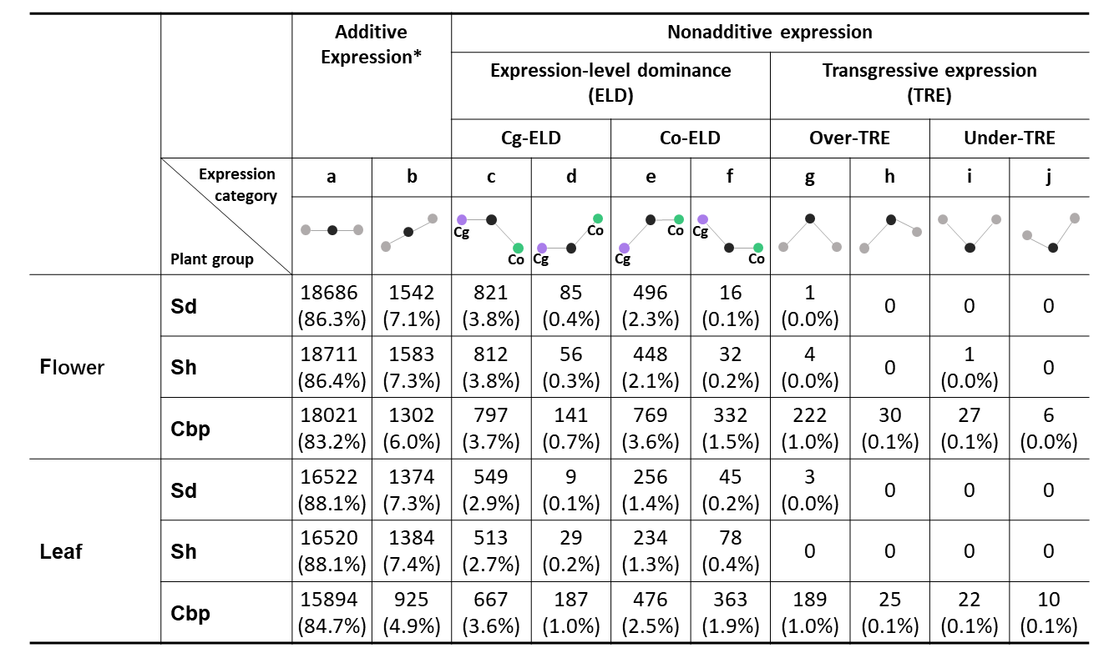
*Partial expression-level dominance (expression level in allotetraploids was not the same as the mid-parent value but still in the middle of the two diploid groups) was included in category b of additive expression. The ten gene expression categories were: a) additive expression with no parental differentiation, b) partial ELD or additive expression with parental differentiation, c) Up-regulated ELD toward diploid C. grandiflora (Cg2), d) Down-regulated ELD toward Cg2, e) Up-regulated ELD toward diploid C. orientalis (Cg2), f) Down-regulated ELD toward Co2, g) Up-regulated TRE with no parental differentiation, h) Up-regulated TRE with parental differentiation, i) Down-regulated TRE with no parental differentiation, g) Down-regulated TRE with parental differentiation.

