Supplementary File 1A

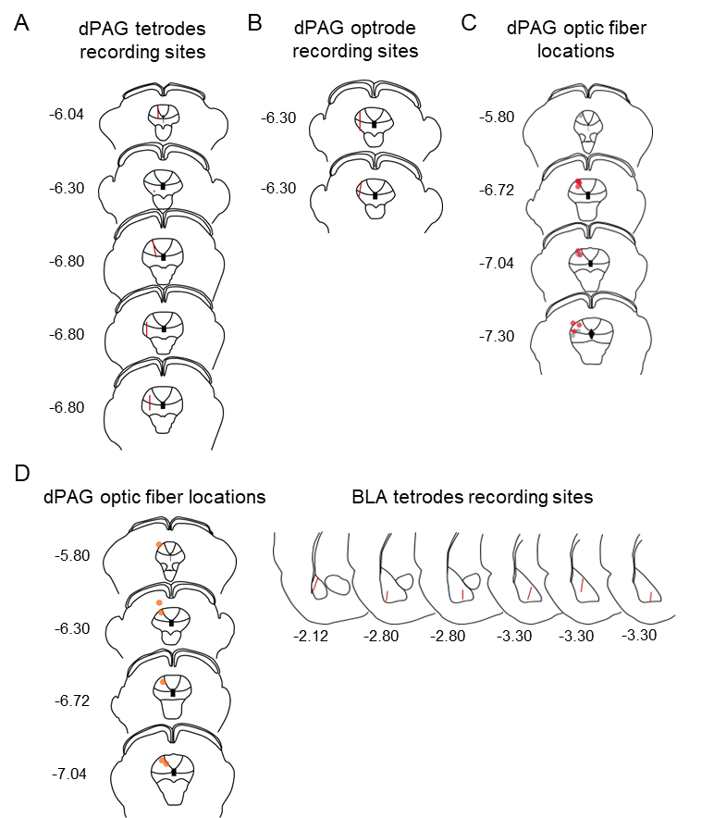

Supplementary File 1B

Fig | Variables | KS  distance | P | Passed  (α = .01)? | Fig | Variables | KS  distance | P | Passed  (α = .01)?
1C | Outbound foraging time (s) |  |  |  | 4H | CTB density (% of control)
 | pre | 0.2916 | <0.0001 | No |  | Foraging only | 0.2191 | >0.1000 | Yes
 | robot | 0.1713 | 0.0033 | No |  | Robot experienced | 0.3914 | 0.0118 | Yes
 | post | 0.2807 | <0.0001 | No |  | (cFos+CTB)/CTB (% of control)
1D | Success rate (%) |  |  |  |  | Foraging only | 0.267 | >0.1000 | Yes
 | pre | 1 | <0.0001 | No |  | Robot experienced | 0.1972 | >0.1000 | Yes
 | robot | 0.5102 | <0.0001 | No | S1D | Average firing (spikes/s)
 | post | 1 | <0.0001 | No |  | Pre-robot | 0.3185 | <0.0001 | No
1F | PAG robot cells firing (Z) |  |  |  |  | Robot | 0.3045 | <0.0001 | No
 | pre_bin1 (0-1 s) | 0.1094 | >0.1000 | No |  | Post-robot | 0.3197 | <0.0001 | No
 | pre_bin2 (1-2 s) | 0.2252 | 0.005 | No |  | Max firing (spikes/s)
 | pre_bin3 (2-3 s) | 0.2933 | <0.0001 | No |  | Pre-robot | 0.2578 | 0.0005 | No
 | pre_bin4 (3-4 s) | 0.2553 | 0.0006 | No |  | Robot | 0.1969 | 0.0263 | Yes
 | pre_bin5 (4-5 s) | 0.2324 | 0.0031 | No |  | Post-robot | 0.2103 | 0.0125 | Yes
 | robot_bin1 (0-1 s) | 0.2035 | 0.0184 | Yes | S3H | AUC (Z, 0-0.5s)
 | robot_bin2 (1-2 s) | 0.2038 | 0.0181 | Yes |  | Stim cells | 0.2519 | <0.0001 | No
 | robot_bin3 (2-3 s) | 0.1826 | 0.0544 | Yes |  | nonStim cells | 0.1462 | >0.1000 | Yes
 | robot_bin4 (3-4 s) | 0.1913 | 0.0353 | Yes | S3I | AUC (Z, 0-5s)
 | robot_bin5 (4-5 s) | 0.1564 | >0.1000 | Yes |  | Stim cells | 0.2161 | <0.0001 | No
 | post_bin1 (0-1 s) | 0.1948 | 0.0294 | Yes |  | nonStim cells | 0.1709 | 0.0799 | Yes
 | post_bin2 (1-2 s) | 0.153 | >0.1000 | Yes | S4B | CC AUC (Z)
 | post_bin3 (2-3 s) | 0.0917 | >0.1000 | Yes |  | pre | 0.2343 | 0.0008 | No
 | post_bin4 (3-4 s) | 0.1499 | >0.1000 | Yes |  | stim | 0.2587 | <0.0001 | No
 | post_bin5 (4-5 s) | 0.1822 | 0.0556 | Yes |  | post | 0.2898 | <0.0001 | No
2G-J | Control group n (=4) was too small to analyze normality.  Nonparametric statistics were used for analyzing the data. |  |  |  |  | robot | 0.1273 | >0.1000 | Yes
 |  |  |  |  | S4C | CC peak (Z)
3C | Outbound foraging time (s) |  |  |  |  | pre | 0.1998 | 0.009 | No
 | pre | 0.1481 | 0.0002 | No |  | stim | 0.2359 | 0.0007 | No
 | robot | 0.1155 | 0.0119 | Yes |  | post | 0.3407 | <0.0001 | No
 | post | 0.1483 | 0.0002 | No |  | robot | 0.1926 | 0.0142 | Yes
3D | Success rate (%) |  |  |  | S4E | CC AUC (Z)
 | pre | 1 | <0.0001 | No |  | pre | 0.2408 | 0.0138 | Yes
 | robot | 1 | <0.0001 | No |  | stim | 0.2842 | 0.0012 | No
 | post | 1 | <0.0001 | No |  | post | 0.1278 | >0.1000 | Yes
3G | (Outbound foraging time (s) |  |  |  |  | robot | 0.2174 | 0.0417 | Yes
 | pre | 0.1375 | >0.1000 | Yes |  | CC peak (Z)
 | stim | 0.1758 | >0.1000 | Yes |  | pre | 0.2297 | 0.0237 | Yes
 | post | 0.2018 | 0.0808 | Yes |  | stim | 0.2183 | 0.0401 | Yes
 | robot | 0.2389 | 0.0152 | Yes |  | post | 0.3022 | 0.0004 | No
3M | Relative firings (Z) - All significant pairs |  |  |  |  | robot | 0.2014 | 0.0821 | Yes
 | pre | 0.1998 | 0.009 | No | S4F | CC AUC (Z)
 | stim | 0.2359 | 0.0007 | No |  | pre | 0.2647 | 0.0454 | Yes
 | post | 0.3407 | <0.0001 | No |  | stim | 0.2759 | 0.0298 | Yes
 | robot | 0.1926 | 0.0142 | Yes |  | post | 0.3317 | 0.0026 | No
3N | Relative firings (Z) - Stim pairs |  |  |  |  | robot | 0.1438 | >0.1000 | Yes
 | pre | 0.2297 | 0.0237 | Yes |  | CC peak (Z)
 | stim | 0.2183 | 0.0401 | Yes |  | pre | 0.2153 | >0.1000 | Yes
 | post | 0.3022 | 0.0004 | No |  | stim | 0.2321 | >0.1000 | Yes
 | robot | 0.2014 | 0.0821 | Yes |  | post | 0.4233 | <0.0001 | No
 | Relative firings (Z) - nonStim pairs |  |  |  |  | robot | 0.3327 | 0.0025 | No
 | pre | 0.2153 | >0.1000 | Yes | S4G | CC AUC (Z)
 | stim | 0.2321 | >0.1000 | Yes |  | stim pair (0-20 ms) | 0.1021 | >0.1000 | Yes
 | post | 0.4233 | <0.0001 | No |  | stim pair (20-40 ms) | 0.2242 | 0.0307 | Yes
 | robot | 0.3327 | 0.0025 | No |  | stim pair (40-60 ms | 0.192 | >0.1000 | Yes
4C | Latency to procure pellets (s) |  |  |  |  | stim pair (60-80 ms) | 0.2829 | 0.0013 | No
 | Base_Foraging only | 0.3539 | 0.0181 | Yes |  | stim pair (80-100 ms) | 0.2552 | 0.0065 | No
 | Base_Robot experienced | 0.2801 | 0.0253 | Yes |  | nonstim pair (0-20 ms) | 0.1589 | >0.1000 | Yes
 | Test_Foraging only | 0.2047 | >0.1000 | Yes |  | nonstim pair (20-40 ms) | 0.2269 | >0.1000 | Yes
 | Test_Robot experienced | 1 | <0.0001 | No |  | nonstim pair (40-60 ms) | 0.2308 | >0.1000 | Yes
4E | Fos-positive cells (% of control) |  |  |  |  | nonstim pair (60-80 ms) | 0.3189 | 0.0048 | No
 | PVT_Foraging only | 0.2505 | >0.1000 | Yes |  | nonstim pair (80-100 ms) | 0.2742 | 0.0319 | Yes
 | PVT_Robot experienced | 0.3508 | 0.0010 | No | S4H | CC peak
 | IMD_Foraging only | 0.2808 | >0.1000 | Yes |  | Stim pairs | 0.3327 | 0.0025 | No
 | IMD_Robot experienced | 0.1831 | >0.1000 | Yes |  | nonStim pairs | 0.2014 | 0.0821 | Yes
 | CM_Foraging only | 0.2105 | >0.1000 | Yes | S5 | CTB density (cells/0.1 mm²)
 | CM_Robot experienced | 0.2463 | 0.0866 | Yes |  | Foraging only | 0.2488 | >0.1000 | Yes
 | Rh_Foraging only | 0.2892 | >0.1000 | Yes |  | Robot experienced | 0.3321 | 0.0748 | Yes
 | Rh_Robot experienced | 0.1480 | >0.1000 | Yes |  | % (cFos+CTB)/CTB
 | Re_Foraging only | 0.1952 | >0.1000 | Yes |  | Foraging only | 0.2206 | >0.1000 | Yes
 | Re_Robot experienced | 0.1330 | >0.1000 | Yes |  | Robot experienced | 0.2192 | >0.1000 | Yes

