**(A)** Alignment of murine lnc*DACH1* and human orthologue

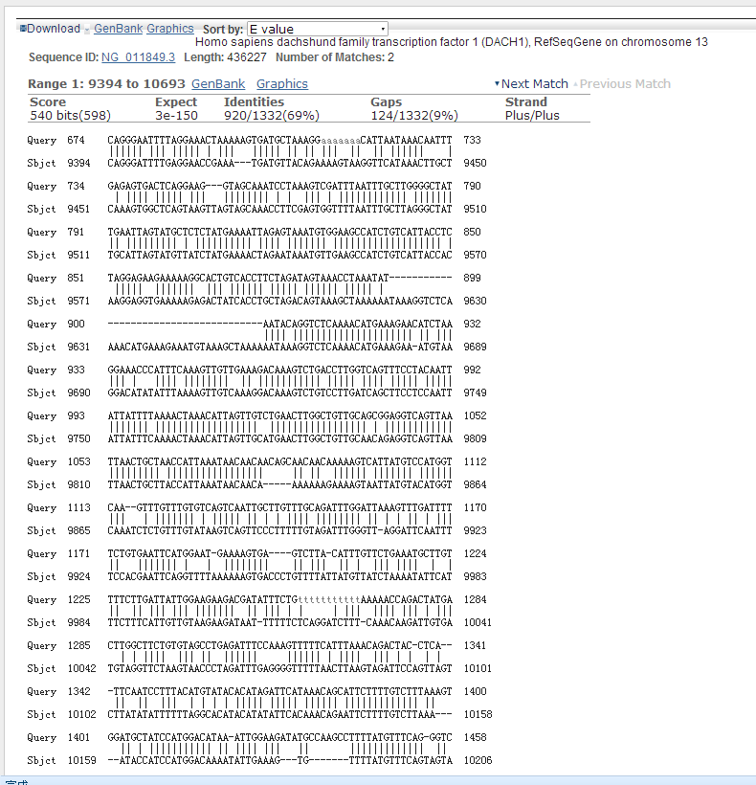

**Human**

**Murine**

**(B)** Alignment of murine lnc*DACH1* and sheep orthologue

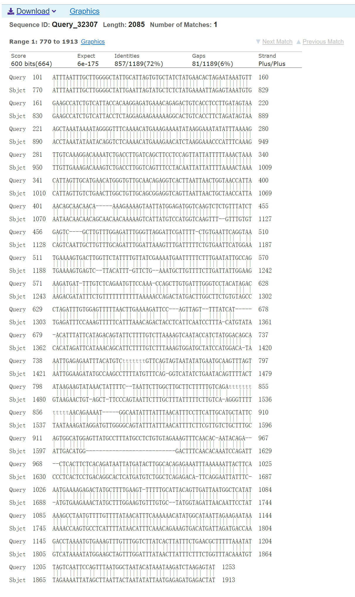

**Sheep**

**Murine**

**(C)** Alignment of murine lnc*DACH1* and Pig orthologue

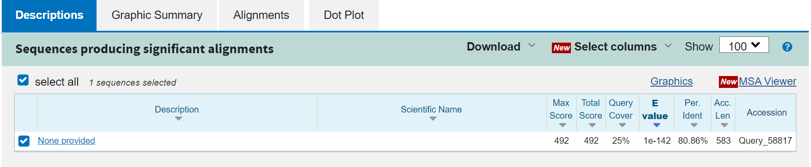

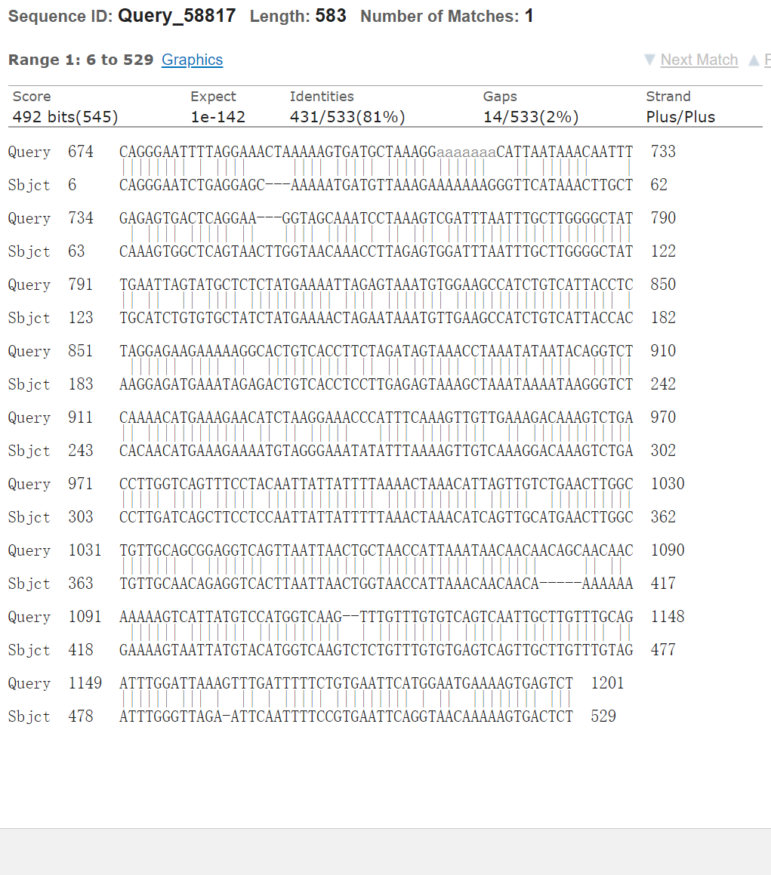

**Pig**

**Murine**

**(D)** Alignment of murine lnc*DACH1* and dog orthologue

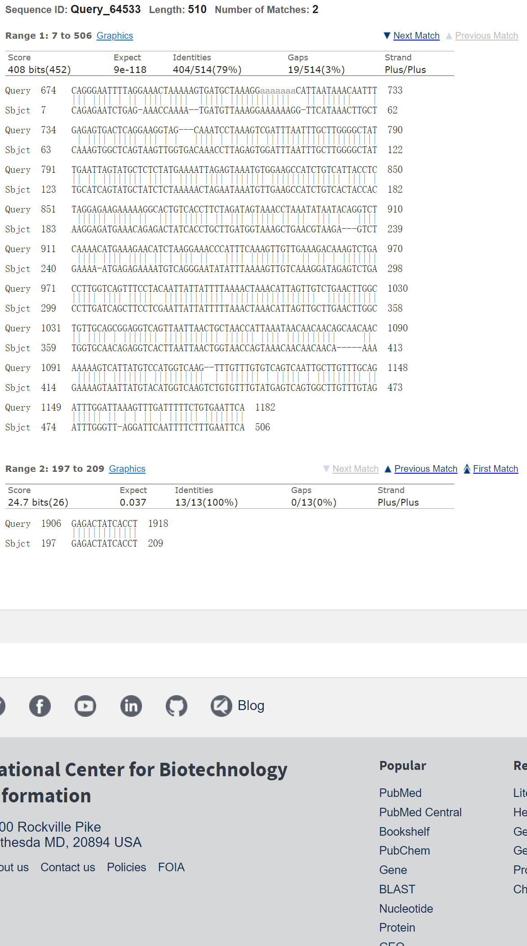

**Dog**

**Murine**

**(E)** Alignment of murine lnc*DACH1* and Rat orthologue

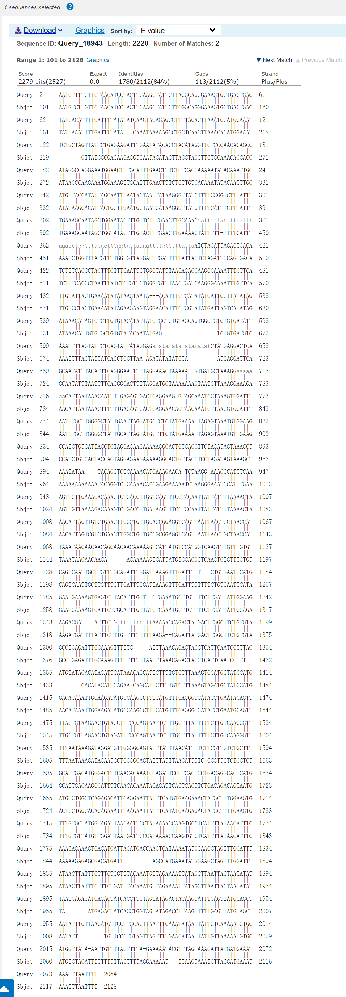

**Rat**

**Murine**