Supplementary File 1: Ligand properties; 2D structures were taken from wikipedia
Ligand | TPSA | MW | HAcceptor | HDonor | Hetero  Atoms | Rotatable  bond | CrippenlogP
Buprenorphine  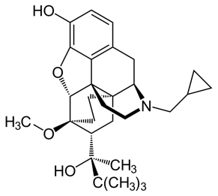 | 63,36 | 468,658 | 4 | 3 | 5 | 4 | 2,9967
Etorphine  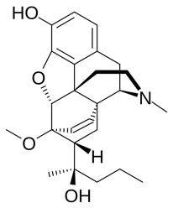 | 63,36 | 412,55 | 4 | 3 | 5 | 4 | 1,7465
Fentanyl  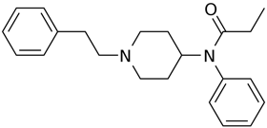 | 24,75 | 337,487 | 1 | 1 | 3 | 6 | 2,7196
Loperamide  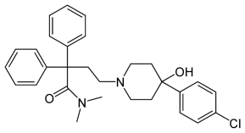 | 44,98 | 478,056 | 2 | 2 | 5 | 7 | 3,6709
Meptazinol  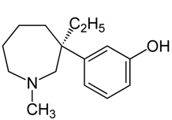 | 24,67 | 234,363 | 1 | 2 | 2 | 2 | 1,7386
Methadone  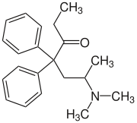 | 21,51 | 310,461 | 1 | 1 | 2 | 7 | 2,8749
Morphine  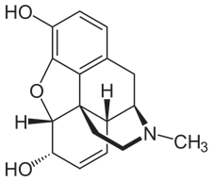 | 54,13 | 286,351 | 3 | 3 | 4 | 0 | -0,219
Naloxone  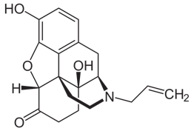 | 71,2 | 328,388 | 4 | 3 | 5 | 2 | -0,1157
Pethidine  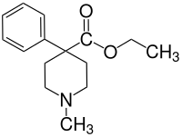 | 30,74 | 248,346 | 2 | 1 | 3 | 3 | 0,796
PZM21  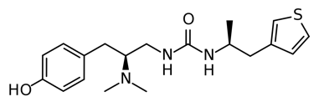 | 65,8 | 362,519 | 3 | 4 | 6 | 8 | 1,4397
SR17018  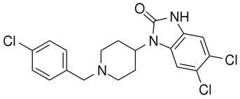 | 42,23 | 411,74 | 2 | 2 | 7 | 3 | 3,7098
Tramadol  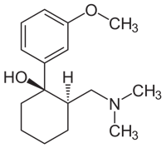 | 33,9 | 264,389 | 2 | 2 | 3 | 4 | 1,2175
TRV130  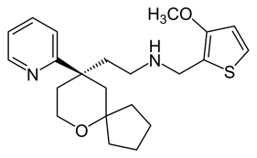 | 47,96 | 387,569 | 4 | 1 | 5 | 7 | 3,6664
DAMGO  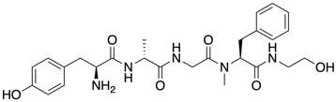 | 175,71 | 514,603 | 6 | 6 | 11 | 13 | -1,6557

