Supplementary File 3
Trial types and numbers
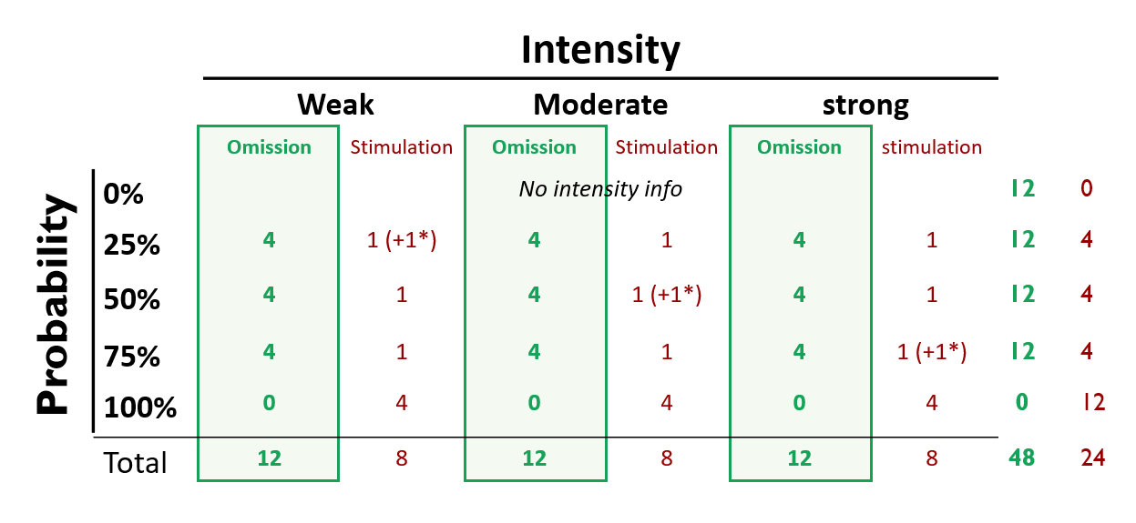
* This is an example. In general there should be one additional weak, one additional moderate, and one additional strong stimulation with exactly one having probability 25%, one having probability 50%, and one having probability 75%

