BETA: MOTIF ANALYSIS
Motif Scan on the TF Target Genes

PART1: UP TARGET GENES

Symbol | DNA BindDom | Species | Pvalue (T Test) | T Score | Logo
Myb Mybl1 | Myb Domain Family Myb Domain Family | Mus musculus | 1.85e-02 | 2.09 | 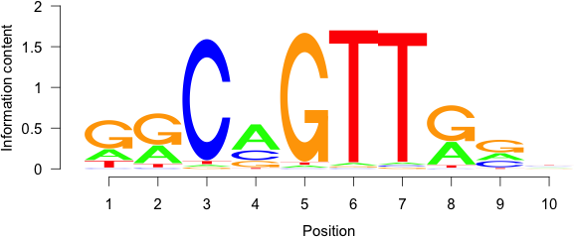
Hmbox1 | Homeodomain Family | Mus musculus | 2.85e-02 | 1.90 | 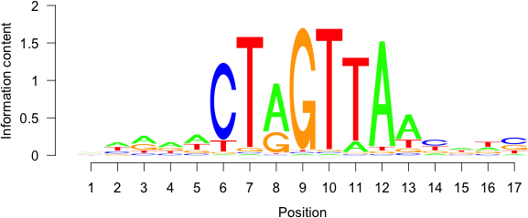
Klf4 Klf1 Klf12 Klf7 | BetaBetaAlpha-zinc finger Family BetaBetaAlpha-zinc finger Family BetaBetaAlpha-zinc finger Family BetaBetaAlpha-zinc finger Family | Mus musculus | 3.75e-02 | 1.78 | 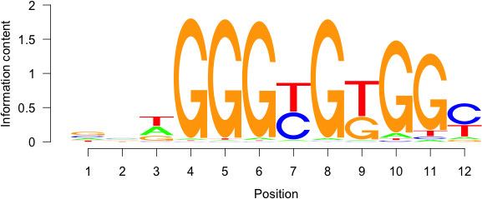
Gsc | Homeodomain Family | Mus musculus | 4.34e-02 | 1.71 | 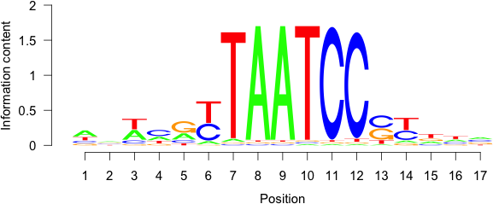
Sox1 | High Mobility Group (Box) Family | Mus musculus | 6.75e-02 | 1.50 | 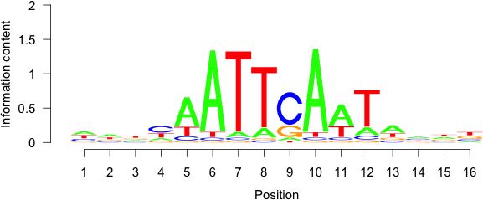
Rhox11 | Homeodomain Family | Mus musculus | 8.37e-02 | 1.38

PART3: UP VS DOWN MOTIF SCAN

Symbol | DNA BindDom | Species | Pvalue (T Test) | T Score | Logo
Uncx Nkx6-1 Hoxd9 | Homeodomain Family Homeodomain Family Homeodomain Family | Mus musculus | 1.05e-04 | 3.89 | 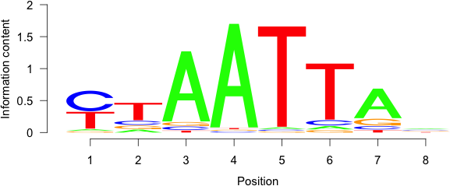
Zfp423 | BetaBetaAlpha-zinc finger Family | Mus musculus | 6.57e-04 | -3.41 | 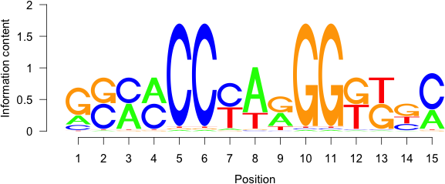
Etv3 Elk3 | Ets Domain Family Ets Domain Family | Mus musculus | 2.02e-03 | 3.09 | 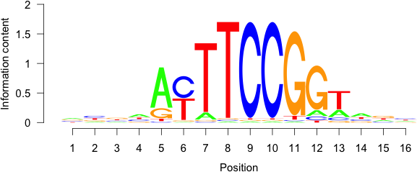
Hoxd8 Sox17 | Homeodomain Family  High Mobility Group (Box) Family | Mus musculus | 2.43e-03 | -3.04 | 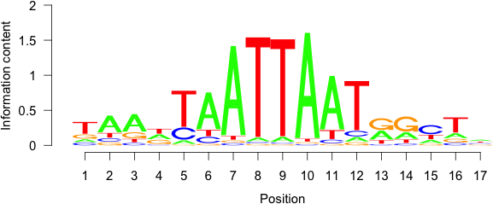
Creb5 | Leucine Zipper Family | Mus musculus | 4.47e-03 | 2.85 | 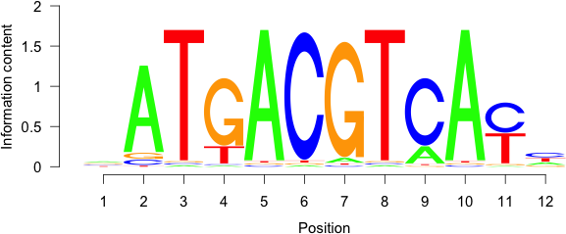
Rfx2 | RFX Domain Family | Mus musculus | 5.98e-03 | 2.75 | 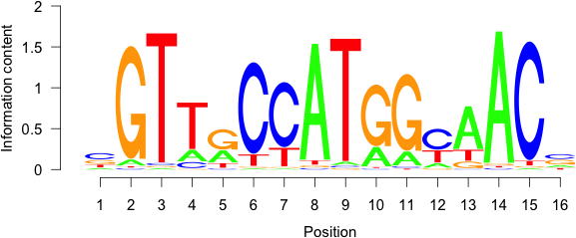

Hoxb4 | Homeodomain Family | Mus musculus | 8.08e-02 | 1.75 | 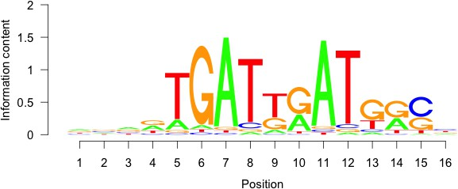
Rfx2 | RFX Domain Family | Mus musculus | 1.20e-01 | -1.55 | 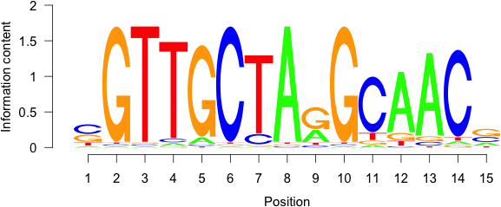
Lhx8 | Homeodomain Family | Mus musculus | 1.20e-01 | -1.55 | 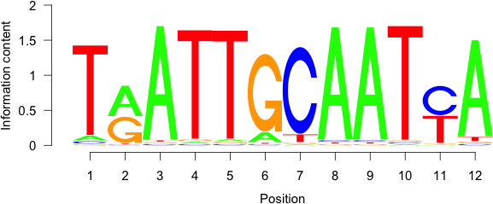

PART4: UP VS NON TARGET MOTIF

Symbol | DNA BindDom | Species | Pvalue (T Test) | T Score | Logo
Uncx | Homeodomain Family | Mus musculus | 3.96e-09 | 5.94
Etv3 Ets1 | Ets Domain Family Ets Domain Family | Mus musculus | 6.53e-06 | 4.53
Olig2 | Helix-Loop-Helix Family | Mus musculus | 9.17e-06 | 4.46 | 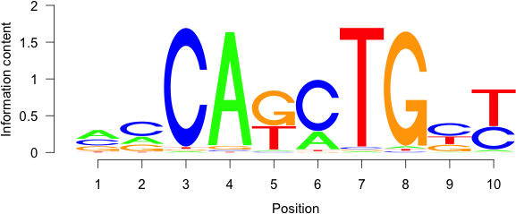

Olig2 | Helix-Loop-Helix Family | Mus musculus | 3.07e-04 | 3.62
Batf | Leucine zipper Family | Mus musculus | 5.92e-04 | 3.44 | 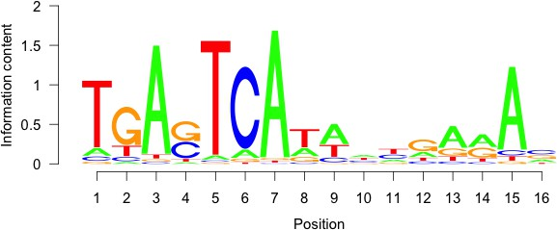
Otx1 | Homeodomain Family | Mus musculus | 2.77e-03 | 3.00 | 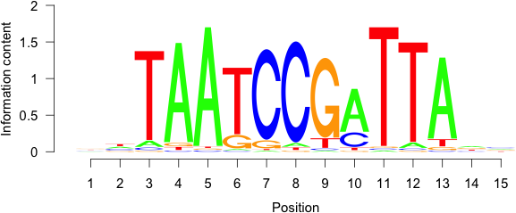
Nanog | Homeodomain Family | Mus musculus | 3.01e-03 | 2.97 | 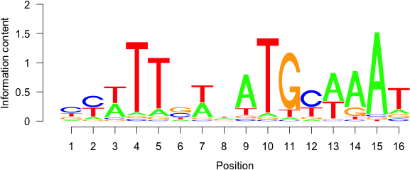
Nkx3-1 | Homeodomain Family | Mus musculus | 3.05e-03 | 2.97 | 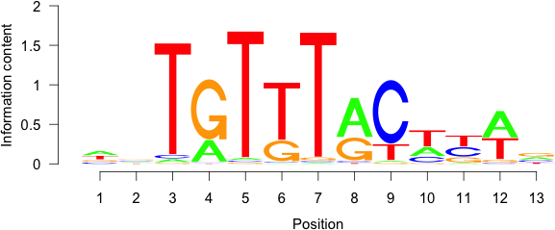
Hoxd3 | Homeodomain Family | Mus musculus | 4.23e-03 | 2.87 | 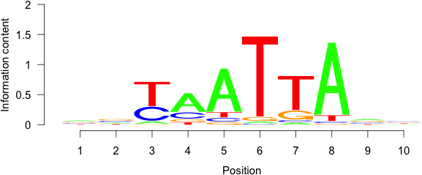
Sox3 | High Mobility Group (Box) Family | Mus musculus | 5.25e-03 | 2.80 | 