BETA: MOTIF ANALYSIS
Motif Scan on the TF Target Genes

PART1: UP TARGET GENES

Symbol | DNA BindDom | Species | Pvalue (T Test) | T Score | Logo
Ebf1 | Helix-Loop-Helix Family | Mus musculus | 1.57e-02 | 2.15 | 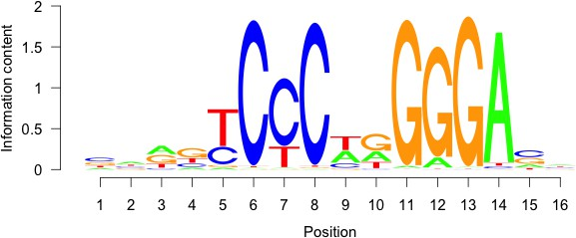
Zfp128 | BetaBetaAlpha-zinc finger Family | Mus musculus | 5.24e-02 | 1.62 | 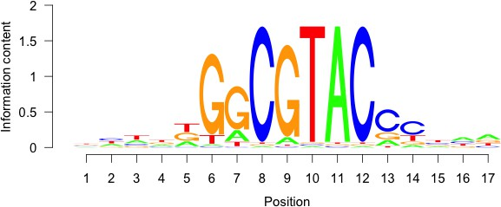
Otx1 | Homeodomain Family | Mus musculus | 5.38e-02 | 1.61 | 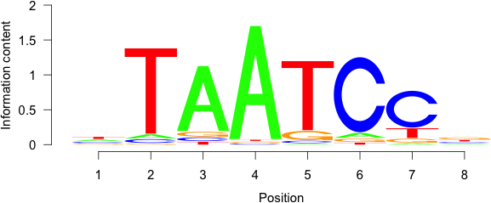
Rela | Rel Homology Region Family | Mus musculus | 5.53e-02 | 1.60 | 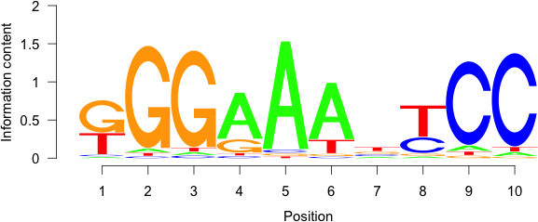
Tp53 | Loop-Sheet-Helix Family | Mus musculus | 5.87e-02 | 1.57 | 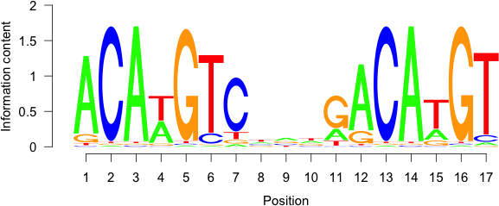
Tcfap2e Tcfap2c | Helix-Loop-Helix Family Helix-Loop-Helix Family | Mus musculus | 6.92e-02 | 1.48

 |  |  |  |  | 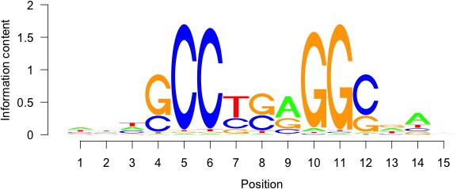
Nr2e1 | Hormone-nuclear Receptor Family | Mus musculus | 8.68e-02 | 1.36 | 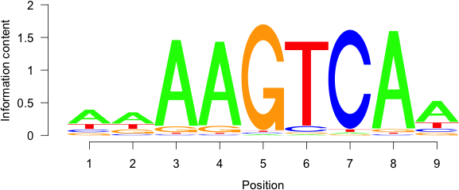
Srf | MADS Box Family | Mus musculus | 1.16e-01 | 1.19 | 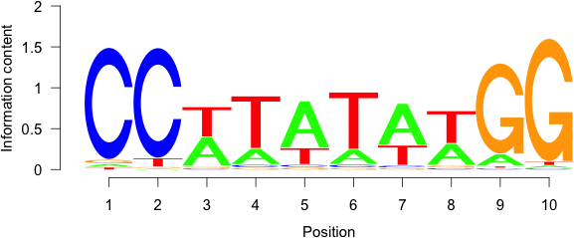
Mybl1 | Myb Domain Family | Mus musculus | 1.50e-01 | 1.04 | 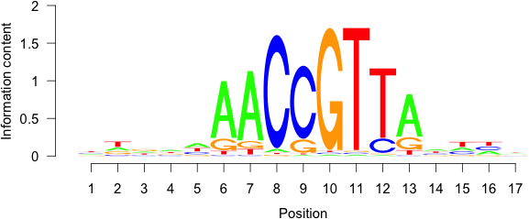

PART2: DOWN TARGET GENES

Symbol | DNA BindDom | Species | Pvalue (T Test) | T Score | Logo
Arx | Homeodomain Family |  |  |  | 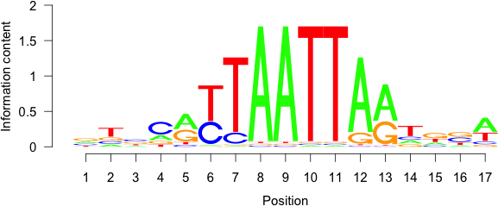
Isx | Homeodomain Family
Pax7 | Homeodomain Family
Lbx2 | Homeodomain Family | Mus musculus | 2.60e-02 | 1.94
Lhx9 | Homeodomain Family
Lhx1 | Homeodomain Family
Egr3 | BetaBetaAlpha-zinc finger Family | Mus musculus | 4.43e-02 | 1.70 | 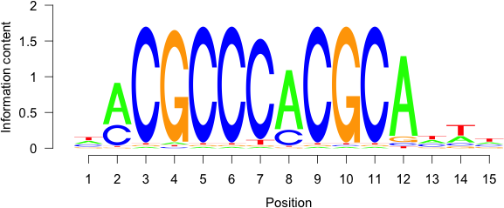

Pax5 | Homeodomain Family | Mus musculus | 4.65e-02 | 1.68 | 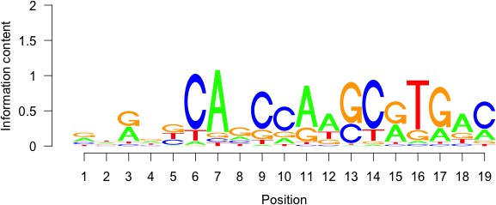
Hoxd10 | Homeodomain Family | Mus musculus | 6.83e-02 | 1.49 | 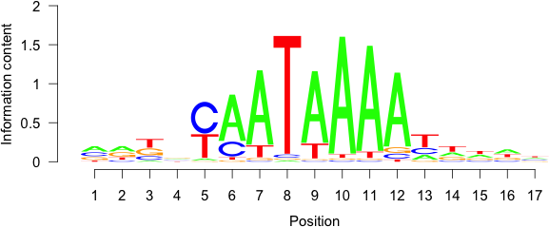
Hoxd11 | Homeodomain Family | Mus musculus | 8.41e-02 | 1.38 | 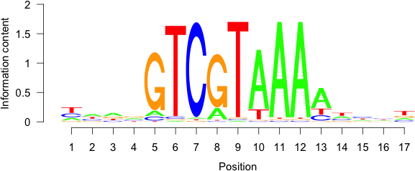

PART3: UP VS DOWN MOTIF SCAN

Symbol | DNA BindDom | Species | Pvalue (T Test) | T Score | Logo
Creb3l2 Jdp2 | Leucine Zipper Family Leucine Zipper Family | Mus musculus | 3.58e-02 | 2.10 | 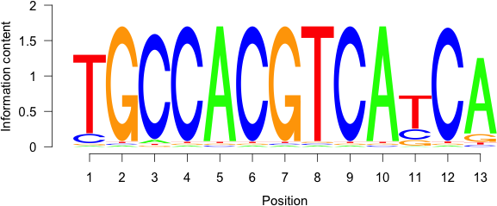
Spi1 | Ets Domain Family | Mus musculus | 6.40e-02 | -1.85 | 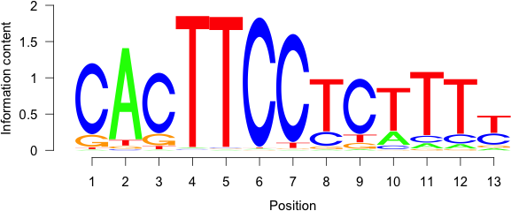
Nkx3-1 Gbx1 | Homeodomain Family Homeodomain Family | Mus musculus | 6.44e-02 | -1.85 | 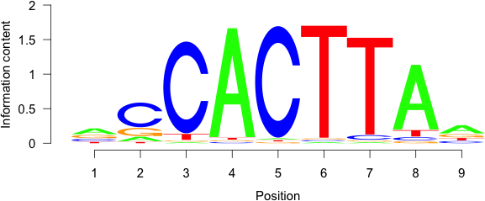

Foxj3 | Forkhead Domain Family | Mus musculus | 7.96e-02 | -1.75 | 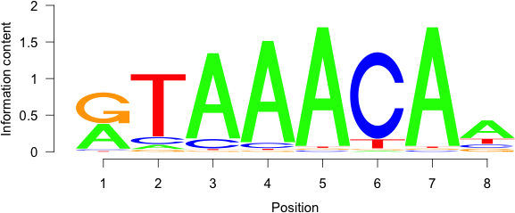
Nr2e1 | Hormone-nuclear Receptor Family | Mus musculus | 9.92e-02 | -1.65 | 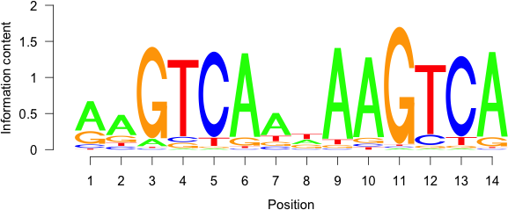
Foxj3 Foxg1 | Forkhead Domain Family Forkhead Domain Family | Mus musculus | 1.05e-01 | 1.62 | 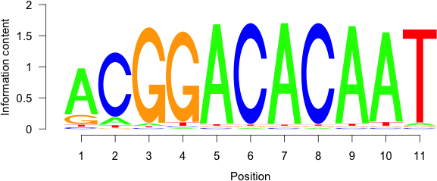
Mybl1 | Myb Domain Family | Mus musculus | 1.05e-01 | 1.62
Hmbox1 | Homeodomain Family | Mus musculus | 1.14e-01 | 1.58 | 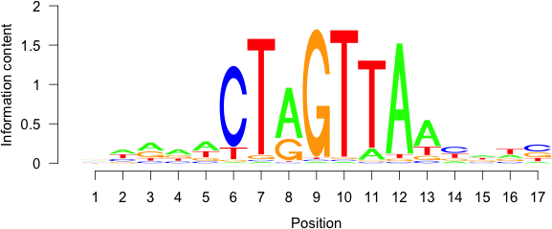
Elk3 Gm5454 | Ets Domain Family Ets Domain Family | Mus musculus | 1.33e-01 | 1.50 | 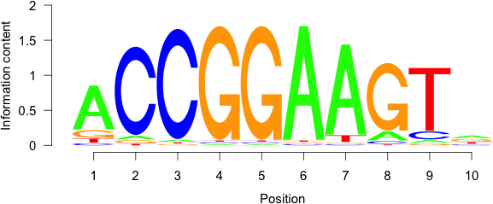
Pax7 Hoxd8 | Homeodomain Family Homeodomain Family | Mus musculus | 1.72e-01 | -1.37 | 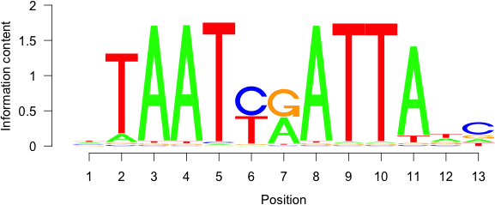

Max | Helix-Loop-Helix Family | Mus musculus | 1.78e-01 | -1.35 | 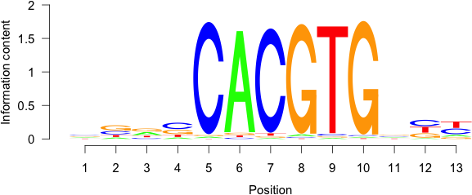
Irf4 | Interferon Regulatory Factor | Mus musculus | 1.87e-01 | 1.32 | 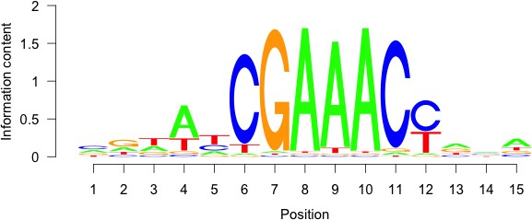
Jun | Leucine Zipper Family | Mus musculus | 1.87e-01 | -1.32 | 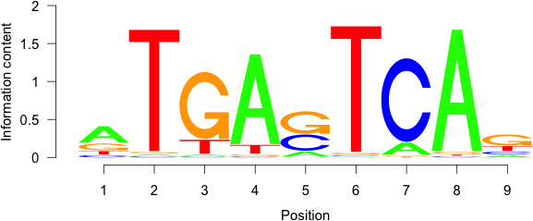
Pknox2 | Homeodomain Family | Mus musculus | 1.94e-01 | -1.30 | 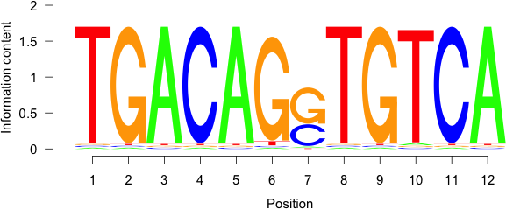
Nr2f6 | Hormone-nuclear Receptor Family | Mus musculus | 2.11e-01 | 1.25 | 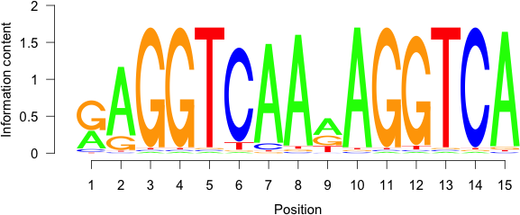

PART4: UP VS NON TARGET MOTIF

Symbol | DNA BindDom | Species | Pvalue (T Test) | T Score | Logo
Rfx2 | RFX Domain Family | Mus musculus | 1.18e-07 | 5.32 | 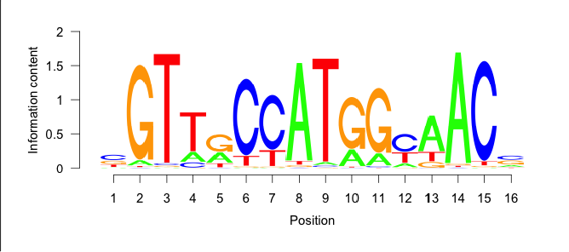

Etv3 Elk3 | Ets Domain Family Ets Domain Family | Mus musculus | 3.40e-05 | 4.16 | 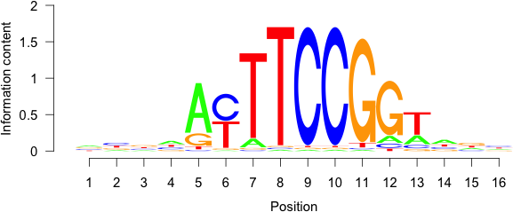
Tal1 | Helix-Loop-Helix Family | Mus musculus | 1.09e-04 | 3.88 | 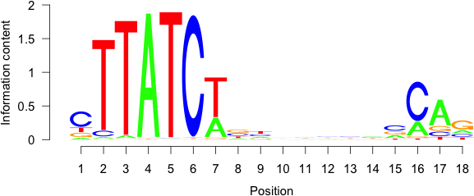
Ctcf | BetaBetaAlpha-zinc finger Family | Mus musculus | 1.65e-03 | 3.15 | 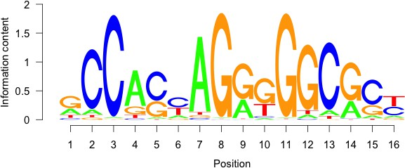
Dbp Jdp2 | Leucine Zipper Family Leucine Zipper Family | Mus musculus | 5.06e-03 | 2.81 | 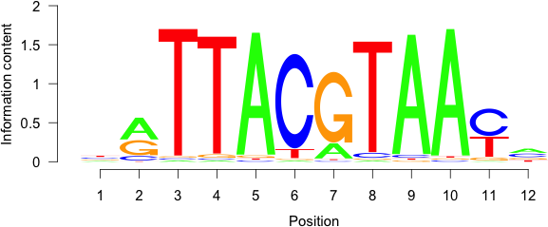
Nanog | Homeodomain Family | Mus musculus | 1.10e-02 | 2.54 | 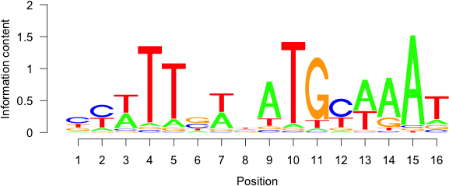
Foxg1 | Forkhead Domain Family | Mus musculus | 1.33e-02 | 2.48 | 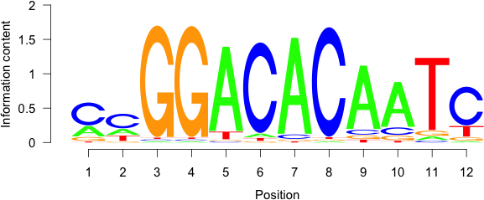
Rela | Rel Homology Region Family | Mus musculus | 2.17e-02 | 2.30

PART5: DOWN VS NON TARGET MOTIF

Symbol | DNA BindDom | Species | Pvalue (T Test) | T Score | Logo
Etv3 | Ets Domain Family | Mus musculus | 2.57e-08 | 5.60
Rfx2 | RFX Domain Family | Mus musculus | 1.42e-06 | 4.84 | 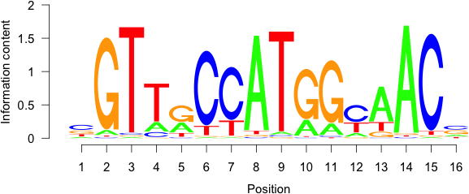
Tal1 | Helix-Loop-Helix Family | Mus musculus | 1.04e-03 | 3.28
Olig2 | Helix-Loop-Helix Family | Mus musculus | 3.85e-03 | 2.89 | 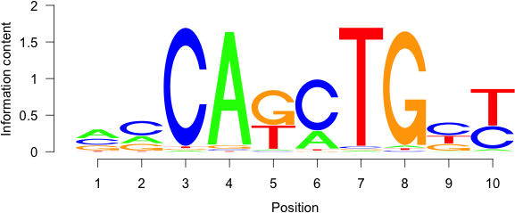
Osr2 | BetaBetaAlpha-zinc finger Family | Mus musculus | 4.15e-03 | 2.87 | 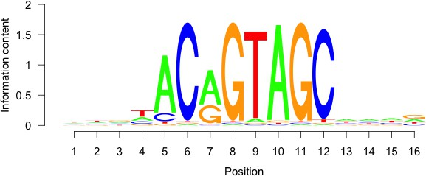
Otx1 | Homeodomain Family | Mus musculus | 1.10e-02 | 2.54 | 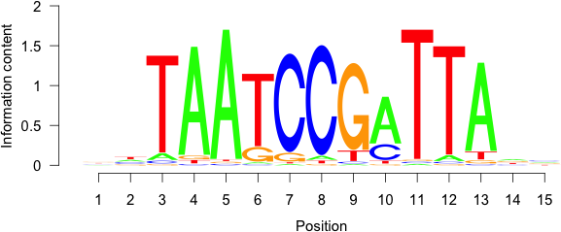

Ctcf | BetaBetaAlpha-zinc finger Family | Mus musculus | 1.61e-02 | 2.41
Rela | Rel Homology Region Family | Mus musculus | 3.40e-02 | 2.12
Uncx | Homeodomain Family | Mus musculus | 3.98e-02 | 2.06 | 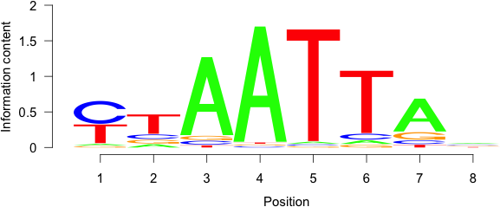
Dbp | Leucine Zipper Family | Mus musculus | 4.14e-02 | 2.04

BETA: Binding and Expression Target Analysis

