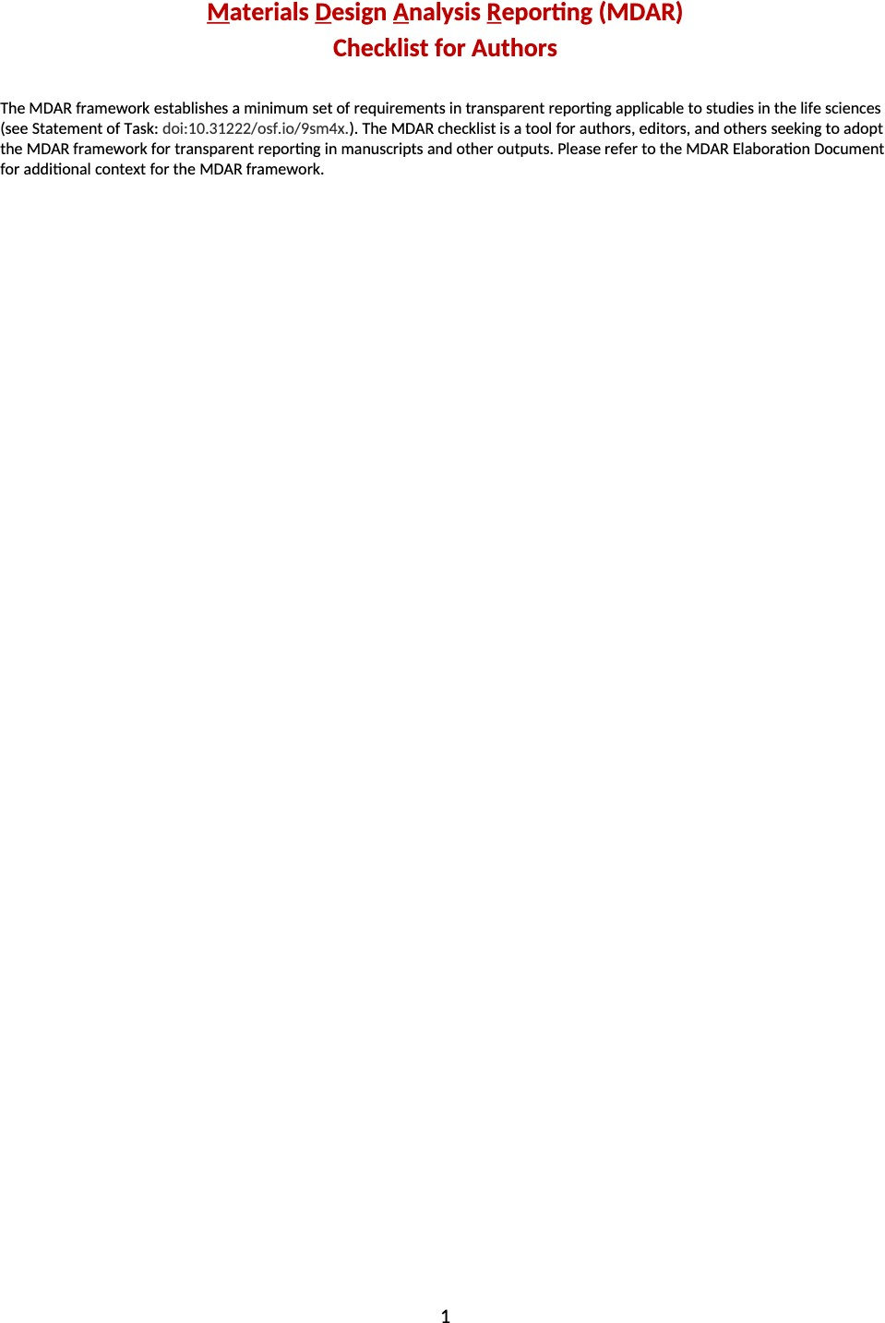

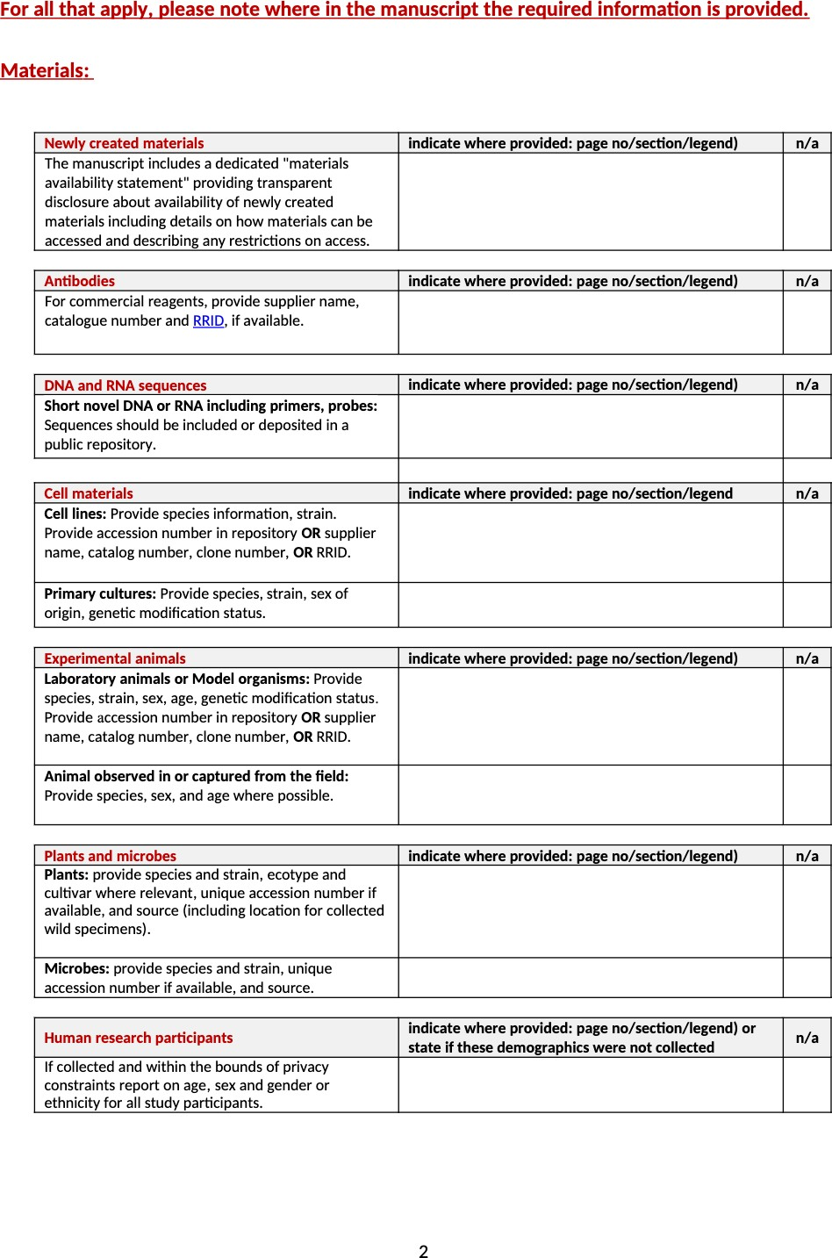
N/A
N/A
N/A
Yes - see the Materials and Methods section entitled “Reagents and chemical sources”.
Yes - see the Materials and Methods section entitled “Animals and housing conditions”.
N/A
N/A
N/A
N/A
N/A

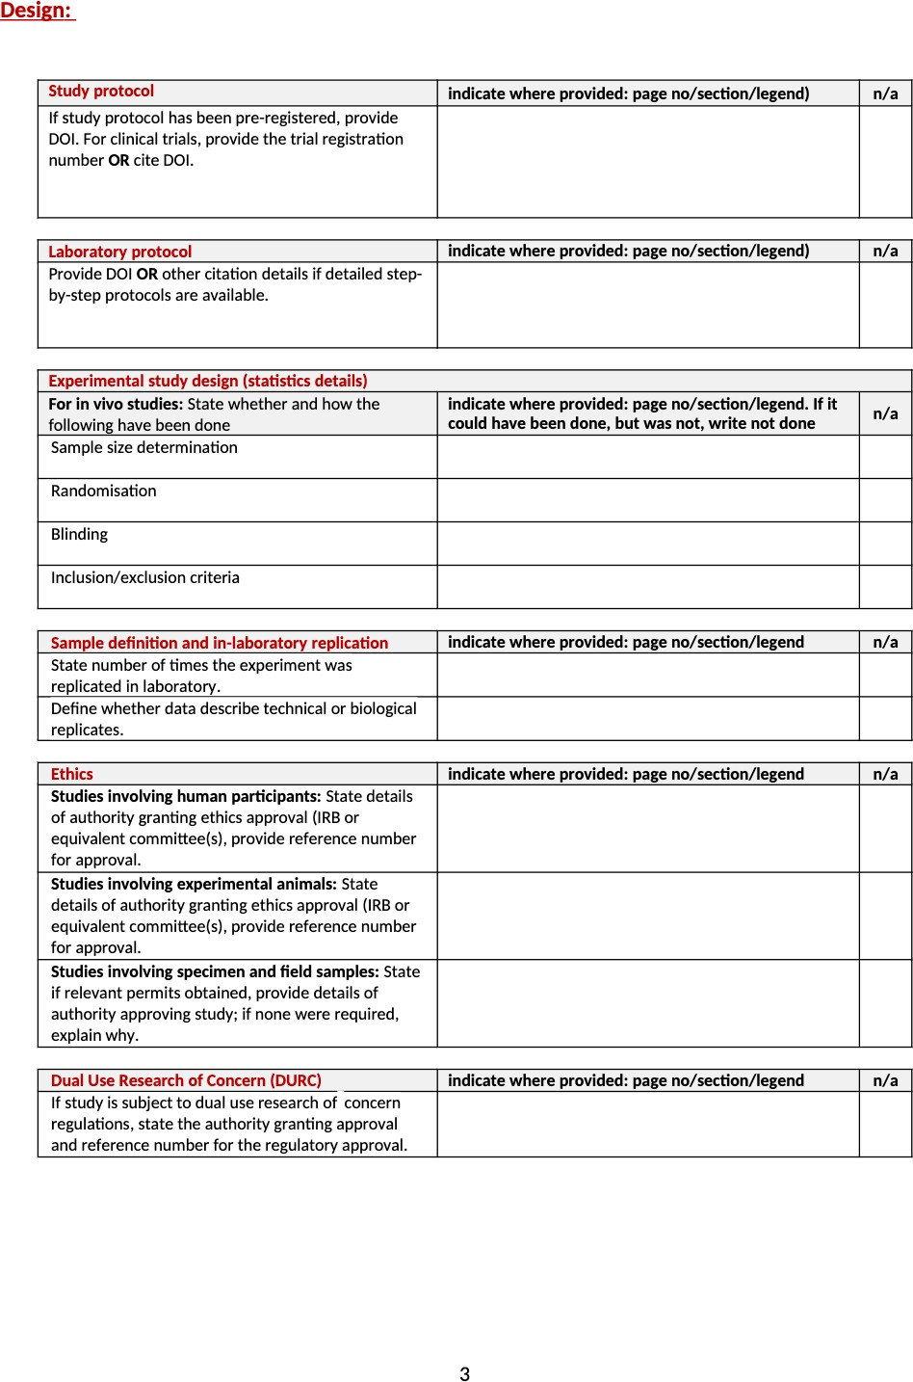
See the Materials and Methods section entitled “Animals and housing conditions”.
Experiments were replicated at least 3 times. Sample sizes are shown in Tables and Figure legends, and represent biological replicates (individual cells or animals).
Data describe biological replicates (individual cells or animals).

N/A
N/A
N/A
N/A
N/A
N/A
N/A
N/A
N/A

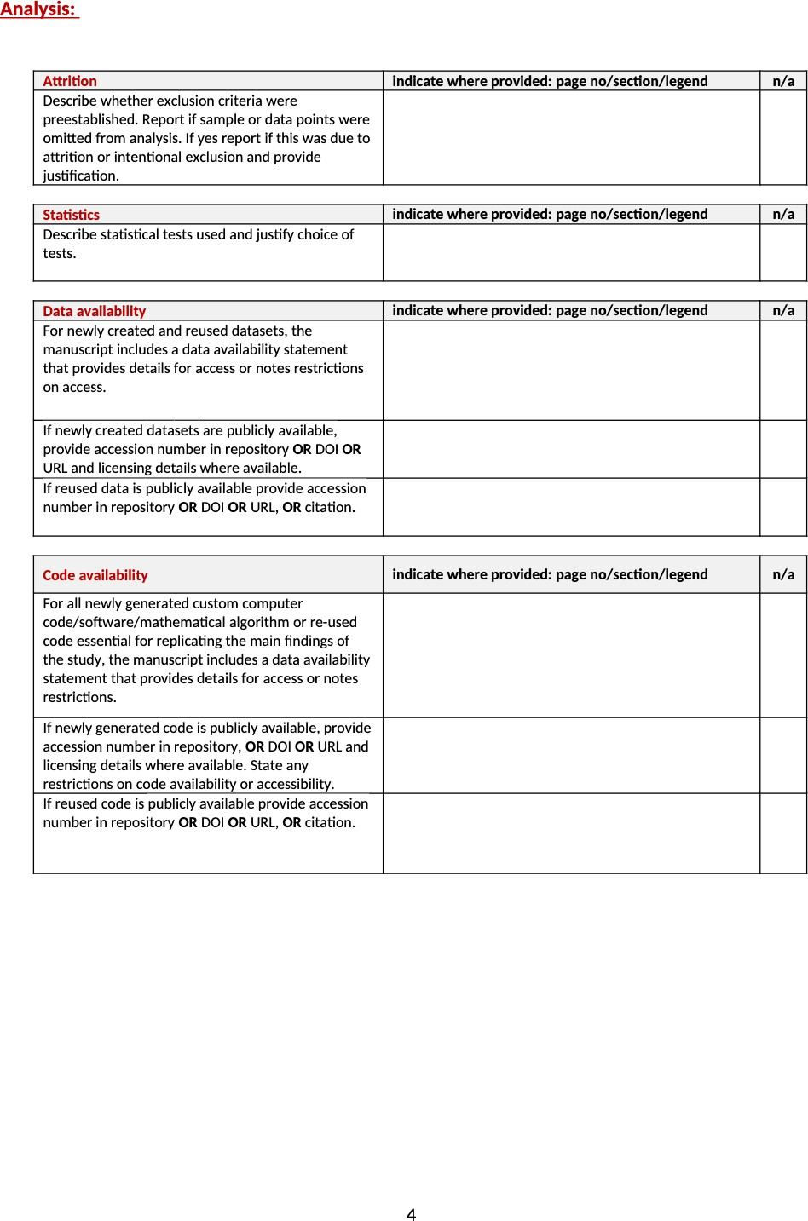
Github
https://github.com/martijab/Reorganization-of-the-Flagellum-Scaffolding-Induces-a-Sperm-Standstill-During-Fertilization.git

Github
https://github.com/martijab/Reorganization-of-the-Flagellum-Scaffolding-Induces-a-Sperm-Standstill-During-Fertilization.git

Zenodo. https://doi.org/10.5281/zenodo.13769608

Zenodo. https://doi.org/10.5281/zenodo.13769608

See the Materials and Methods section entitled “Statistical Analysis”.
N/A
N/A
N/A

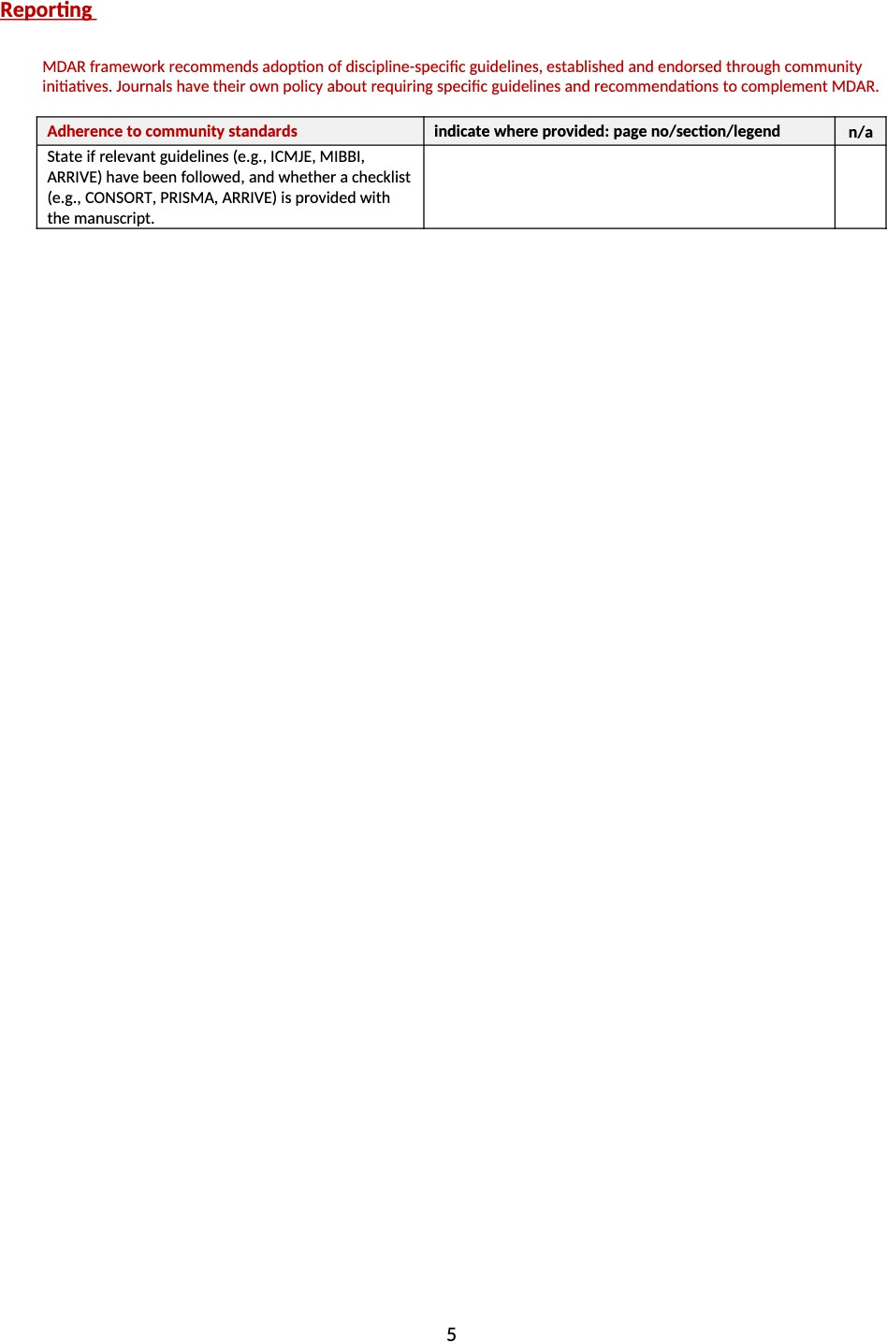
N/A

