Supplementary file 2.
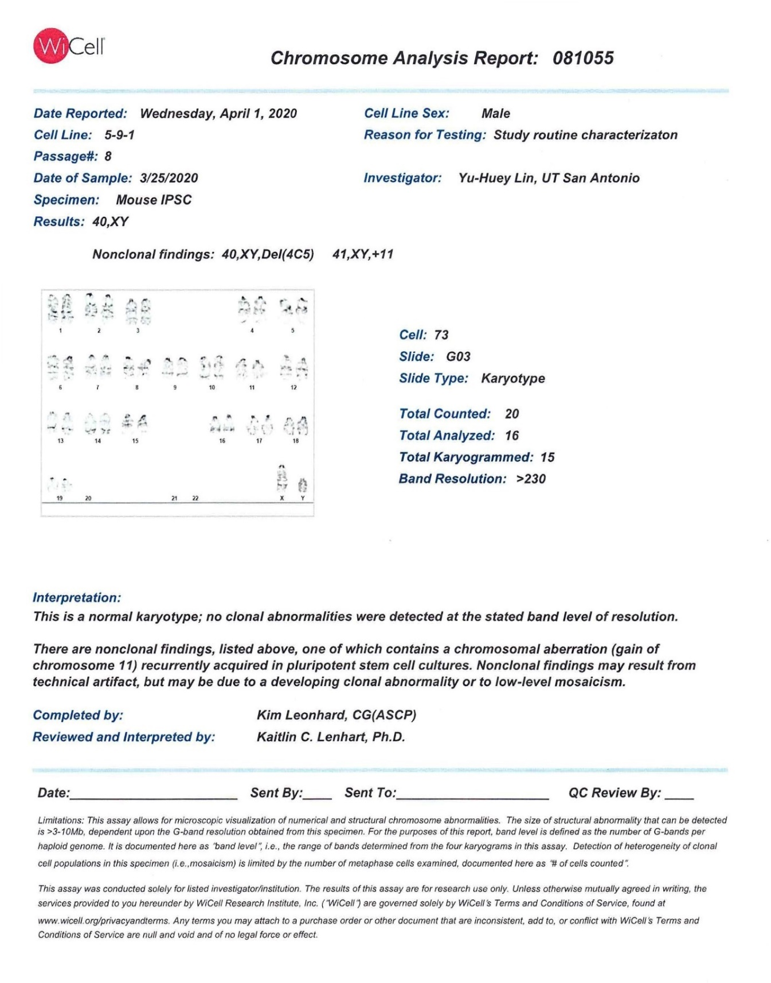
Validation of normal karyotype analysis of MF5-9-1 iPSCs. iPSCs from reprogrammed MEFs were validated for a normal karyotype prior to use in this project.

