Table S1. Pre- and post-survey questions. Survey questions given to study participants before the Hidden Curriculum Symposium and immediately after the Hidden Curriculum Symposium.
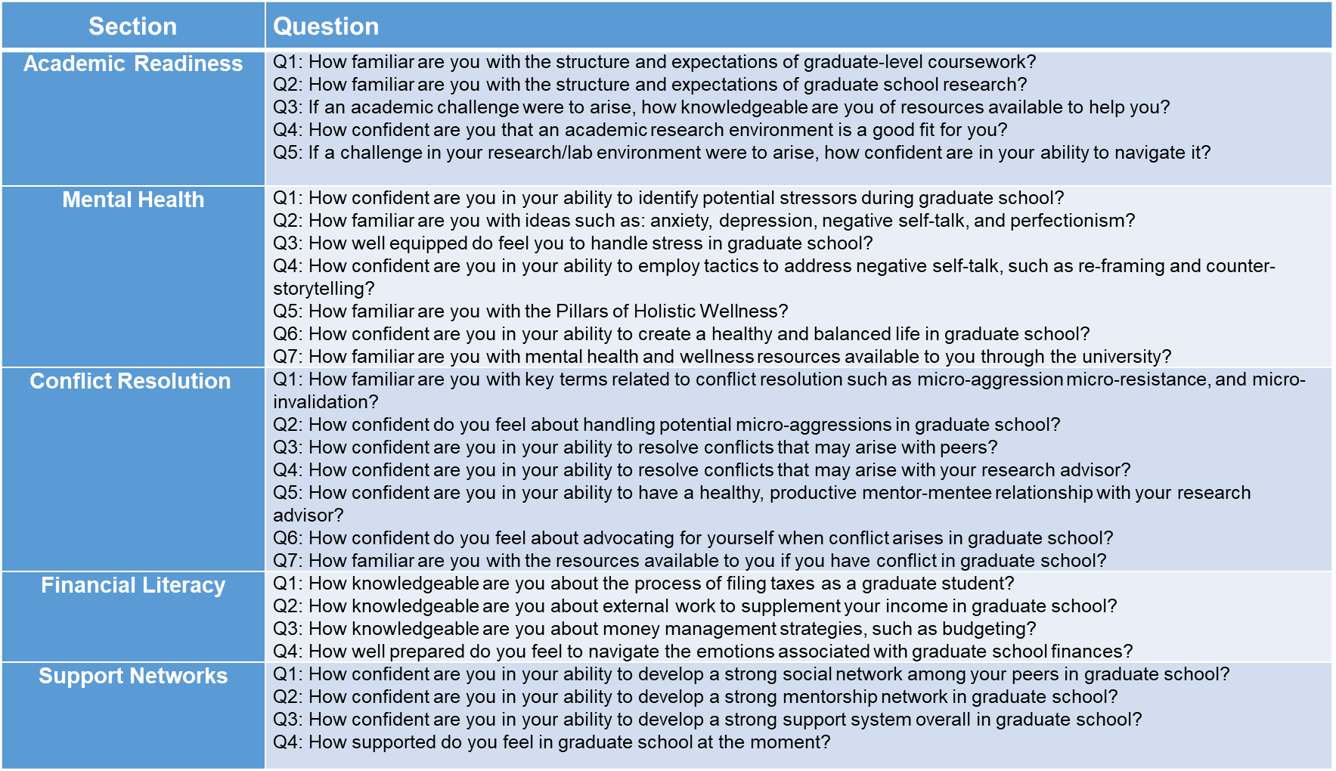

Table S2. End-of-year survey questions. Survey questions given to study participants at the end of the first year of graduate school, having completed the Hidden Curriculum Symposium.

Table S3. Response to the surveys before the 2022 symposium (pre), immediately after the 2022 symposium (post), and at the end of the 2022/2023 academic year. For each of the five areas covered by the surveys (column 1), this table contains the number of questions (column 2), the value of Cronbach α (which is a measure of internal consistency), the mean value of the summary score (column 4), and the standard deviation (column 5). Note that Figure 1 displays median values rather than the mean values shown here.

Area | # of questions | Cronbach’s α | M | SD
Academic Success
Pre | 5 | .883 | 6.2 | 1.8
Post | 5 | .938 | 8.3 | 1.6
End of year | 7 | .790 | 7.8 | 1.0
Mental Health
Pre | 7 | .816 | 5.6 | 1.5
Post | 7 | .914 | 8.2 | 1.5
End of year | 7 | .824 | 8.0 | 1.2
Conflict Resolution
Pre | 7 | .858 | 5.5 | 1.7
Post | 7 | .955 | 7.9 | 1.3
End of year | 7 | .955 | 7.6 | 1.5
Financial Literacy
Pre | 4 | .715 | 3.8 | 1.6
Post | 4 | .896 | 7.9 | 1.7
End of year | 4 | .968 | 6.7 | 2.4
Support Network
Pre | 4 | .764 | 6.8 | 1.6
Post | 4 | .671 | 8.7 | 0.8
End of year | 4 | .890 | 8.5 | 1.4

Table S4. Results of repeated measure ANOVAs examining the Hidden Curriculum Symposium’s associations with student outcomes over time in unadjusted and adjusted models.
 | Unadjusted Model |  |  |  | Adjusted Model
Outcome | F_{time}  df: 2,22 | p value (time) | M_{diff} (SE) | p value (M_{diff}) | F_{time}  df: 2,18 | p value (time) | M_{diff} (SE) | p value (M_{diff})
Academic Success | 6.2 | .007 |  |  | 3.1 | .069
Pre-post |  |  | -2.1 (0.6) | .007 |  |  | -1.8 (0.8) | .045
Pre-end of year |  |  | -1.6 (0.7) | .035 |  |  | -0.9 (0.7) | .239
Post-end of year |  |  | 0.5 (0.6) | .426 |  |  | 0.9 (0.7) | .211
Mental Health | 11.5 | <.001 |  |  | 6.5 | .008
Pre-post |  |  | -2.6 (0.6) | .001 |  |  | -2.4 (0.8) | .011
Pre-end of year |  |  | -2.4 (0.7) | .004 |  |  | -2.2 (0.8) | .027
Post-end of year |  |  | 0.2 (0.5) | .690 |  |  | 0.3 (0.6) | .637
Conflict Resolution | 10.1 | <.001 |  |  | 5.0 | .019
Pre-post |  |  | -2.5 (0.6) | .002 |  |  | -2.2 (0.8) | .020
Pre-end of year |  |  | -2.2 (0.8) | .015 |  |  | -1.6 (0.9) | .100
Post-end of year |  |  | 0.3 (0.4) | .422 |  |  | 0.6 (0.4) | .195
Financial Literacy | 21.2 | <.001 |  |  | 11.8 | <.001
Pre-post |  |  | -4.0 (0.6) | <.001 |  |  | -3.8 (0.8) | <.001
Pre-end of year |  |  | -2.9 (0.8) | .005 |  |  | -2.5 (1.0) | .035
Post-end of year |  |  | 1.2 (0.4) | .013 |  |  | 1.3 (0.5) | .028
Support Network | 7.6 | .003 |  |  | 3.7 | .04
Pre-post |  |  | -1.9 (0.5) | .004 |  |  | -1.7 (0.7) | .029
Pre-end of year |  |  | -1.7 (0.6) | .023 |  |  | -1.2 (0.8) | .142
Post-end of year |  |  | 0.2 (0.4) | .622 |  |  | 0.5 (0.5) | .342

Note: The unadjusted models examined only the within subjects effect of participating in the Hidden Curriculum event over time (pre-Hidden Curriculum, post-Hidden Curriculum, and at the end of the academic year) on each outcome. The adjusted model adjusts for two factors: i) whether or not the participants enrolled in graduate school the same year they graduated from an undergraduate institution; ii) whether or not they attended a Historically Black College or University, a Hispanic Serving Institution, or other Minority Serving Institution (compared to a predominantly white institution) for their undergraduate education. Neither of these control variables were significantly associated with any of the outcomes at p <.05. The F_{time} is the F value for the overall effect of the Hidden Curriculum event over time (pre-Hidden Curriculum, post-Hidden Curriculum, and at the end of the academic year); the p value (time) column shows the significance of that effect. The M_{diff} columns show the mean difference in scores from pre-Hidden Curriculum to post-Hidden Curriculum, from pre-Hidden Curriculum to the end of the year, and from post-Hidden Curriculum to the end of the year; the p value (M_{diff}) column shows the significance of those differences. Effects significant at p < .05 are bolded.

