**Original Western Blot Image** **of Three Replications for Figure 1F**

**1.**

pCDK5

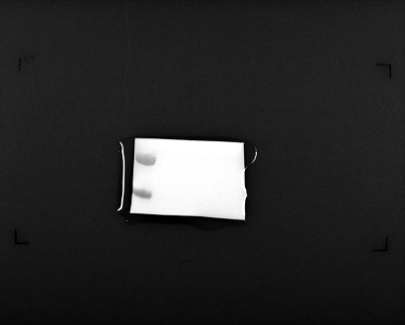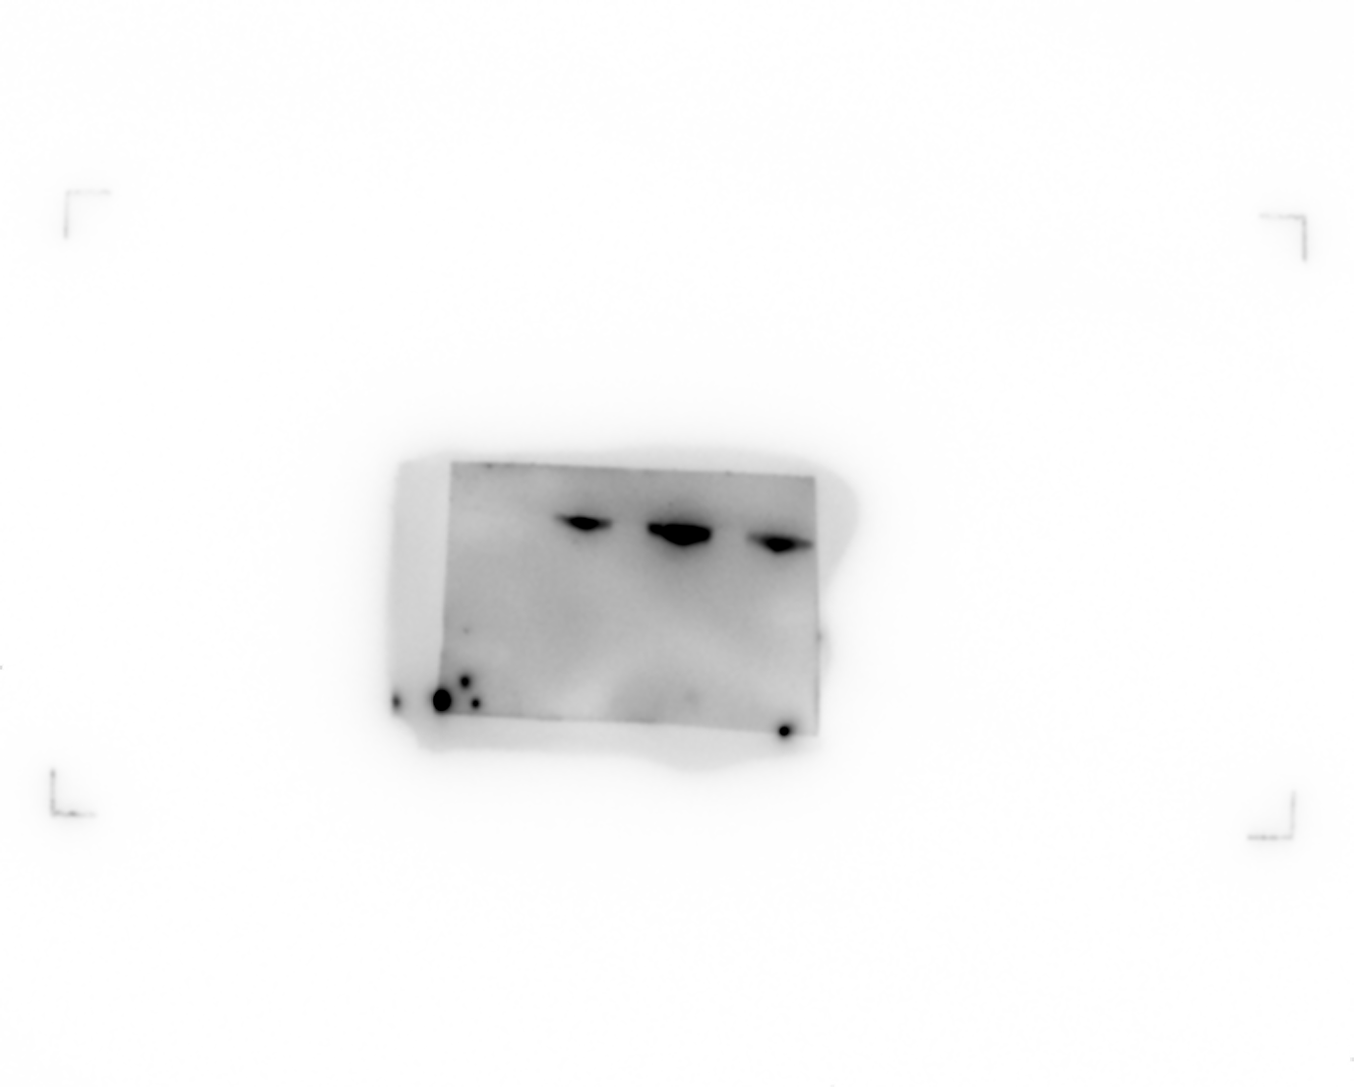

CDK5

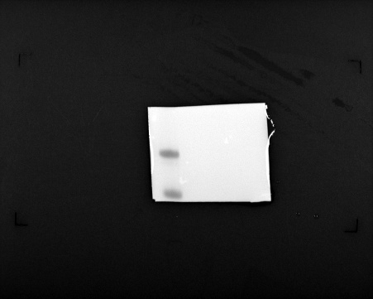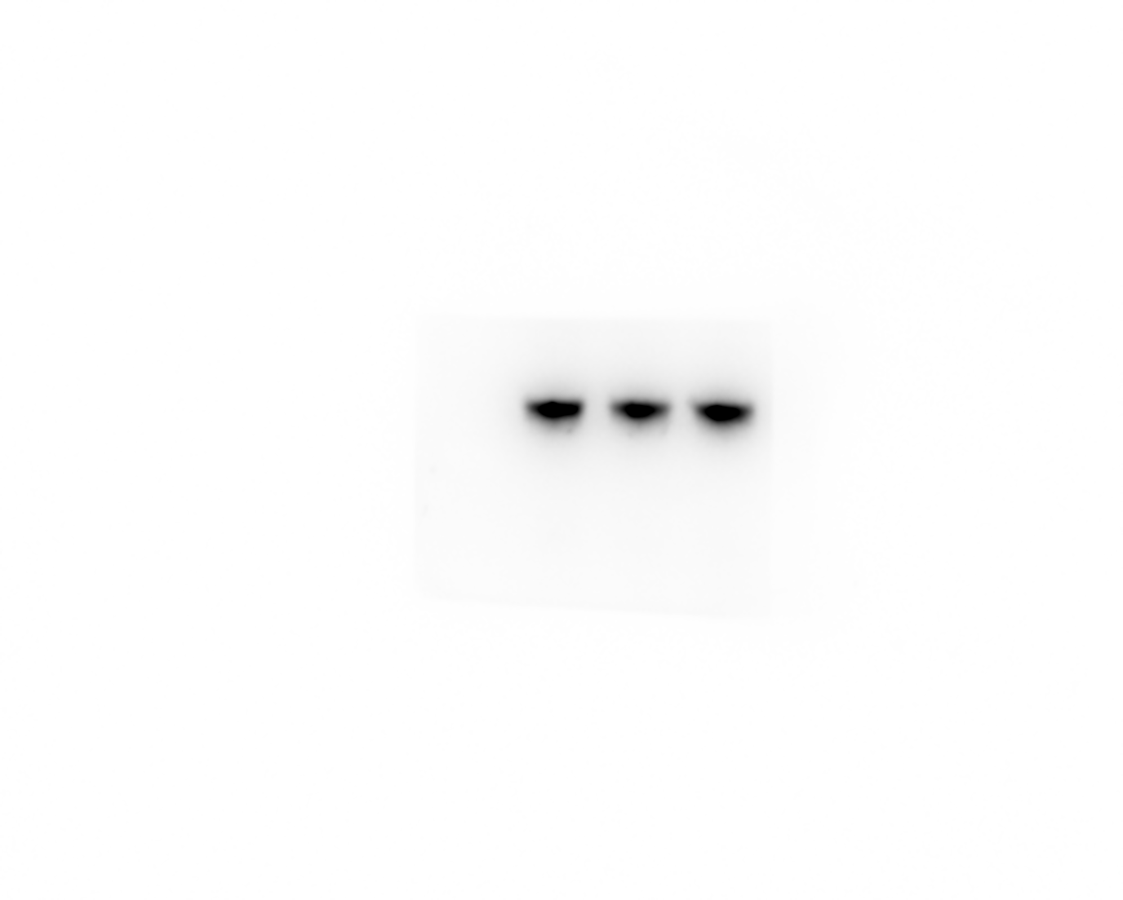

EPHA4

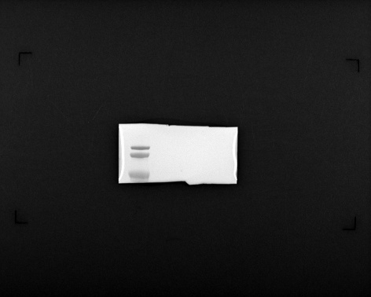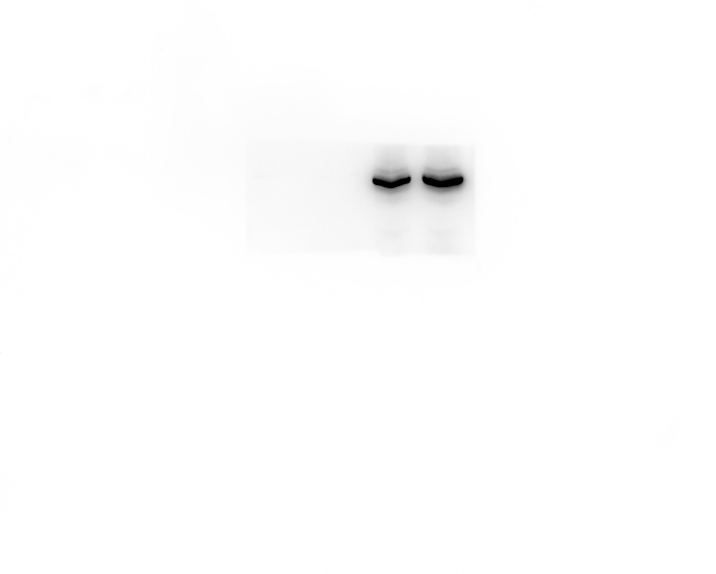

β-actin

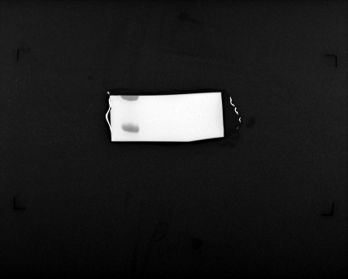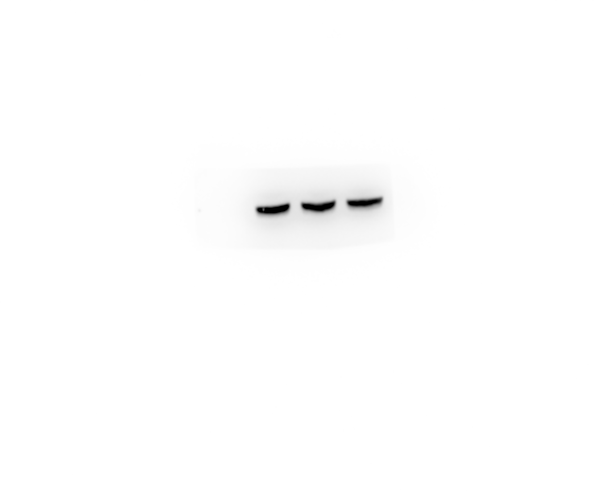

**2.**

pCDK5

### 

CDK5

### 

EPHA4

### 

β-actin

### 

**3.**

pCDK5

### 

CDK5

### 

EPHA4

### 

β-actin

### 