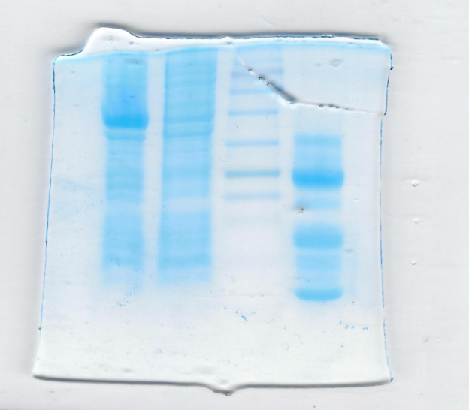E:\Labrotory\lab meetings & JC\2023\Paper1\Manuscript\Elife\raw images\figure4\DU+TEV+Pk211N_1.2_14.01.23_0001_2_0001.tif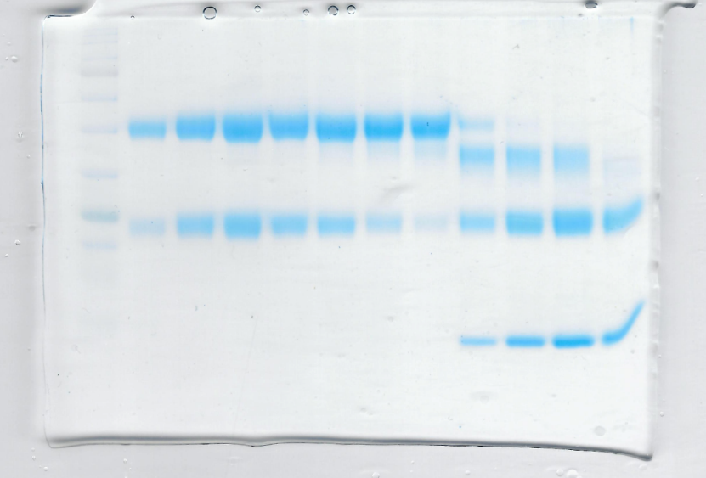E:\Labrotory\lab meetings & JC\2023\Paper1\Manuscript\Elife\raw images\figure4\DUimg6_scan3_0001.tifE:\Labrotory\lab meetings & JC\2023\Paper1\Manuscript\Elife\raw images\figure4\DU+PK211n_2.tifE:\Labrotory\lab meetings & JC\2023\Paper1\Manuscript\Elife\raw images\figure4\DU+TEV.tif

Figure 4C

Figure 4C

Not used in this study

Figure 4B

Figure 4B

Figure 4A

Figure 4A