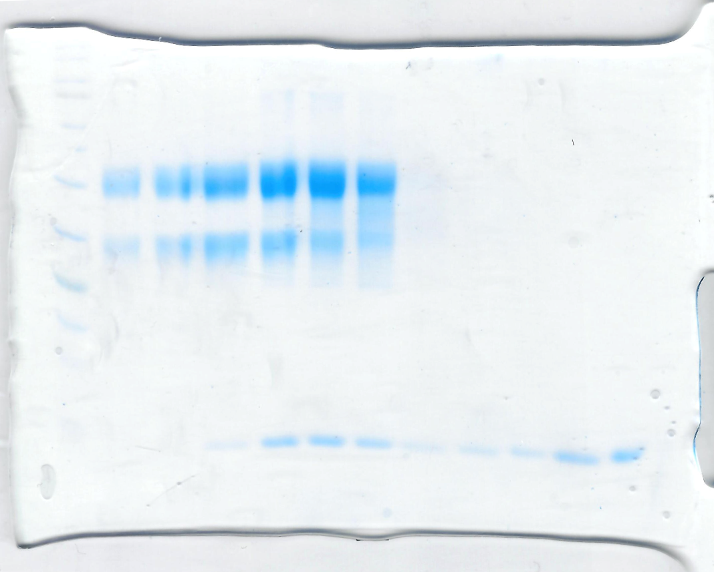
Figure 5E
Figure 5E
Figure 5A
Figure 5B
Figure 5B

