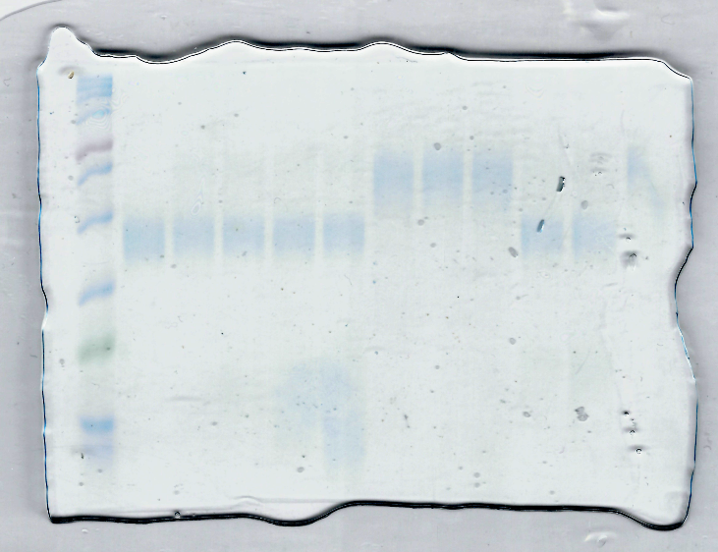
Figure 5-figure supplement 2D
Dot used in this study

