Supplementary File 3.
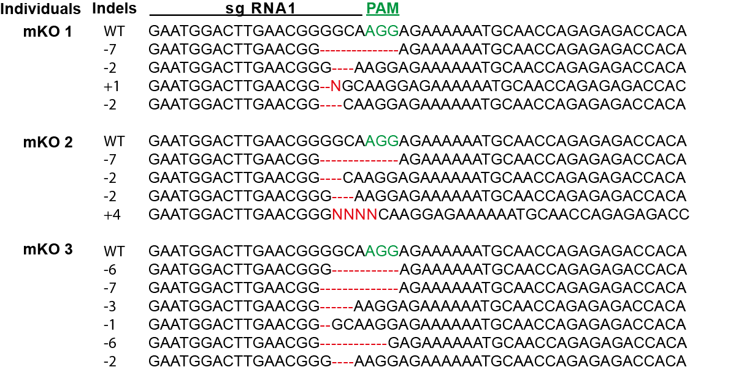
Supplementary File 3. Sanger sequencing confirms mutations at CRISPR sgRNA site in mirror mKOs. Sanger sequencing results from three different mirror mutant individuals. Each line denotes a different wild-type (WT) or mutant allele with indels indicated in red, and the PAM site in green.

