Supplementary File 3. EICs, retention times and reference spectra for level 1 identifications

1-Methylhistidine
RT std: 6.21min, RT experimental: 6.42min, RT Δ 0.21min
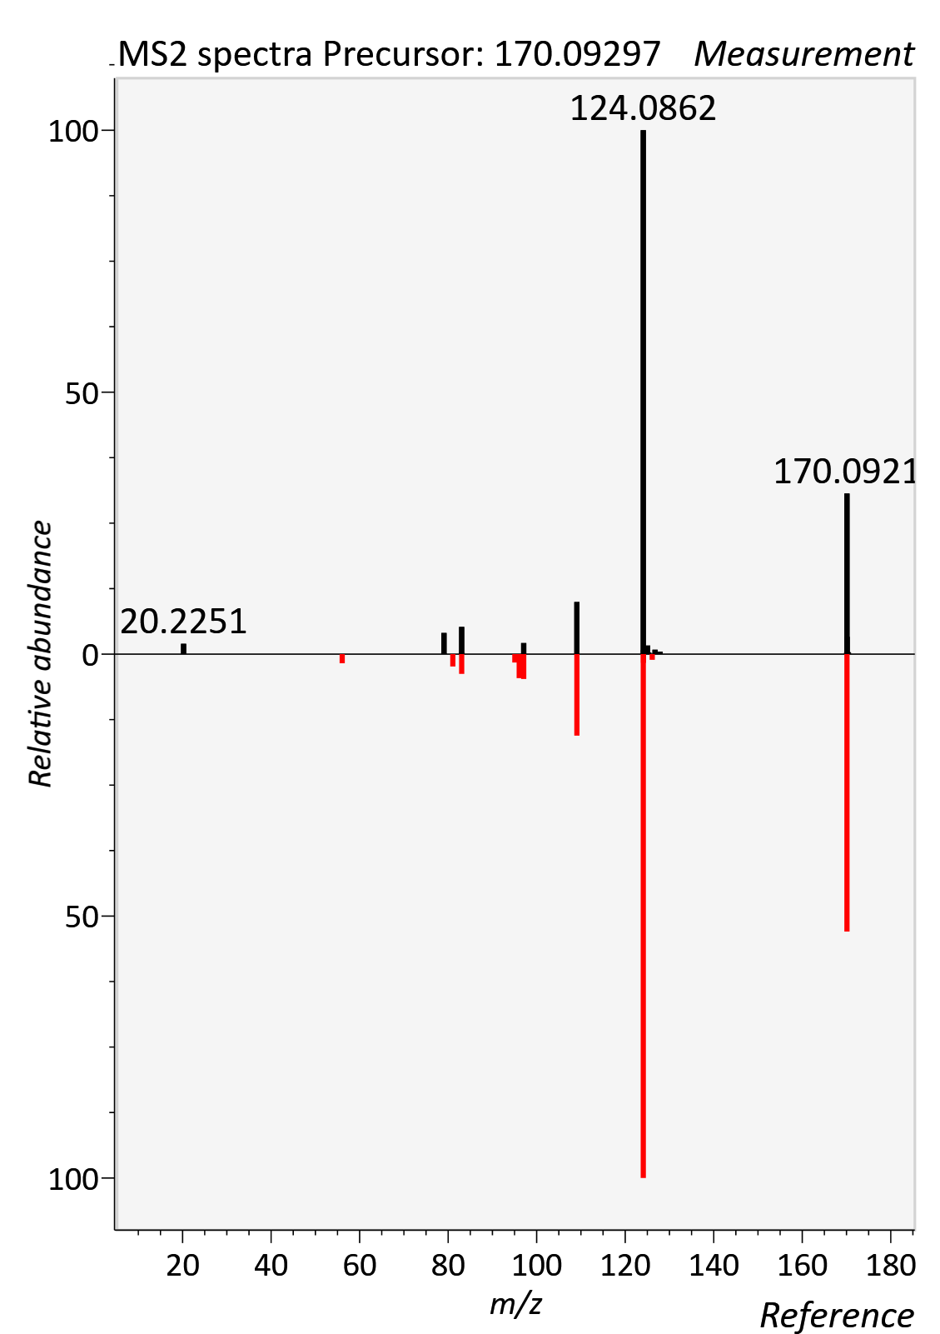

1-Methylnicotincamide
RT std: 2.18min, RT experimental: 2.39min, RT Δ 0.21min
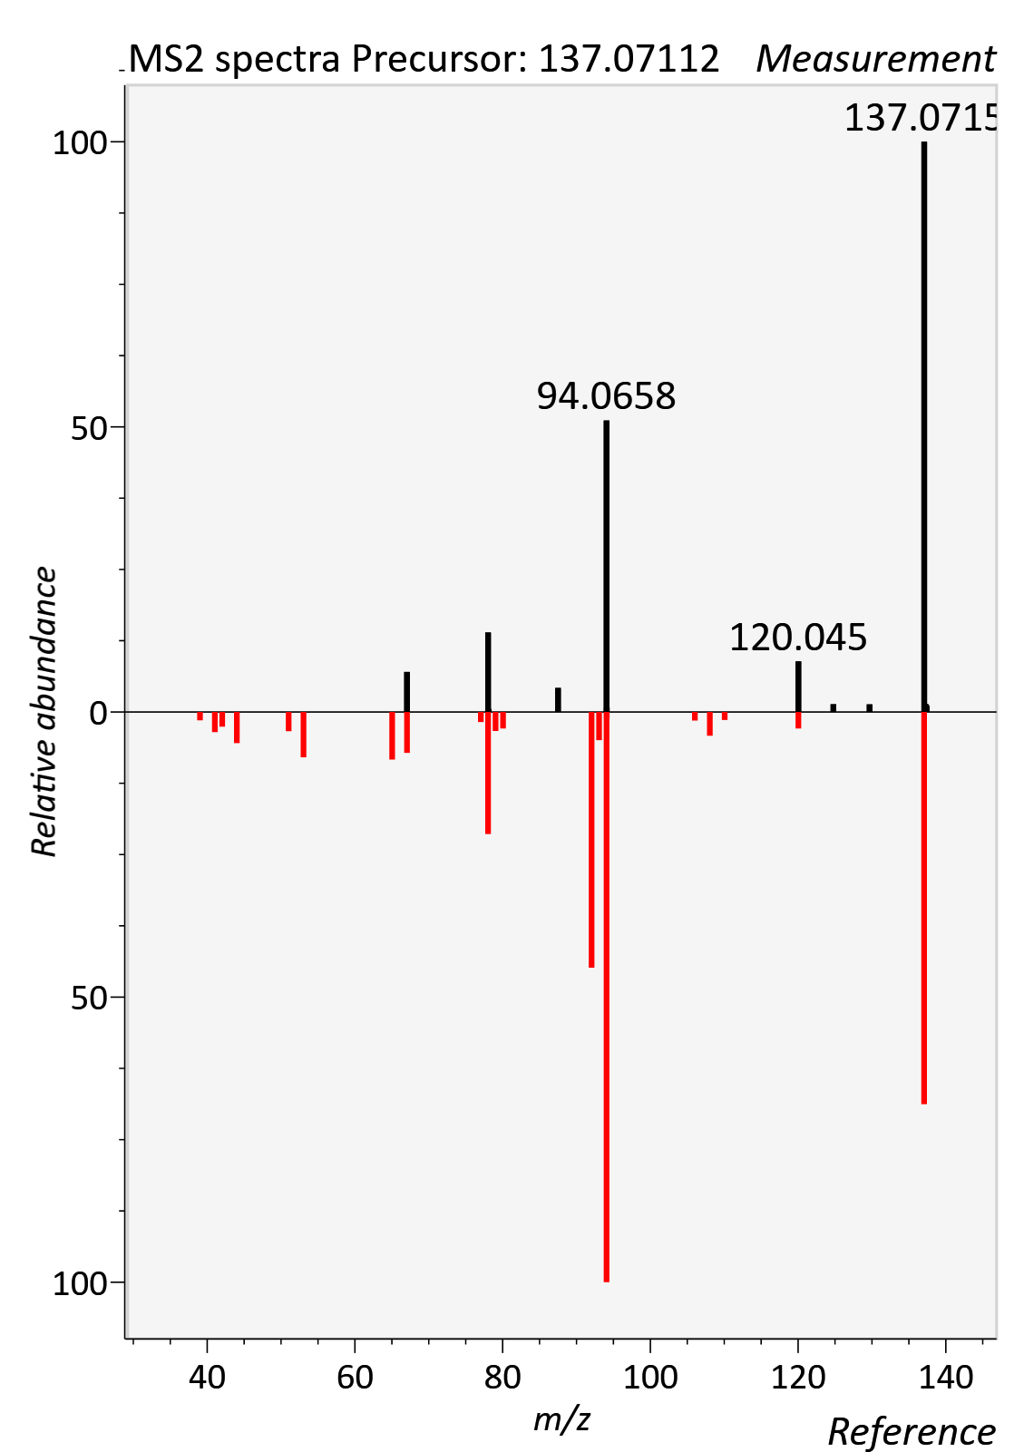

3-Indoleacetic acid
RT std: 5.00min, RT experimental: 5.28min, RT Δ 0.28min
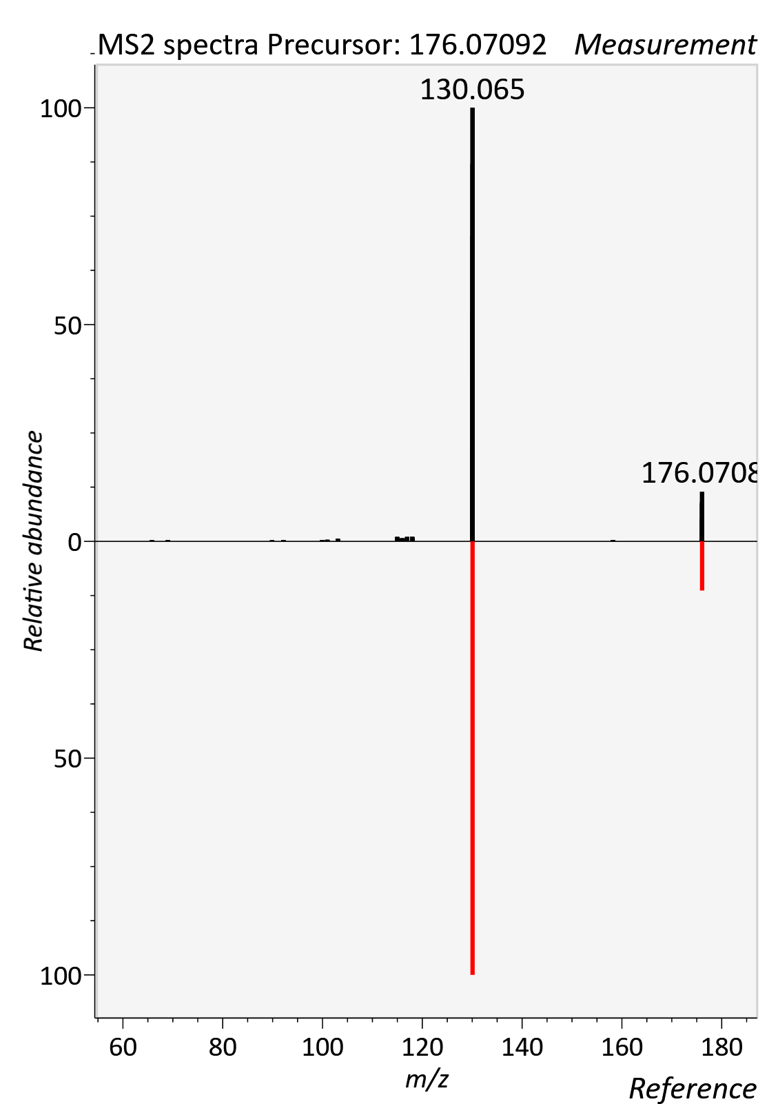

4-Trimethylammoniobutanoic acid
RT std: 3.36min, RT experimental: 3.60min, RT Δ 0.06min
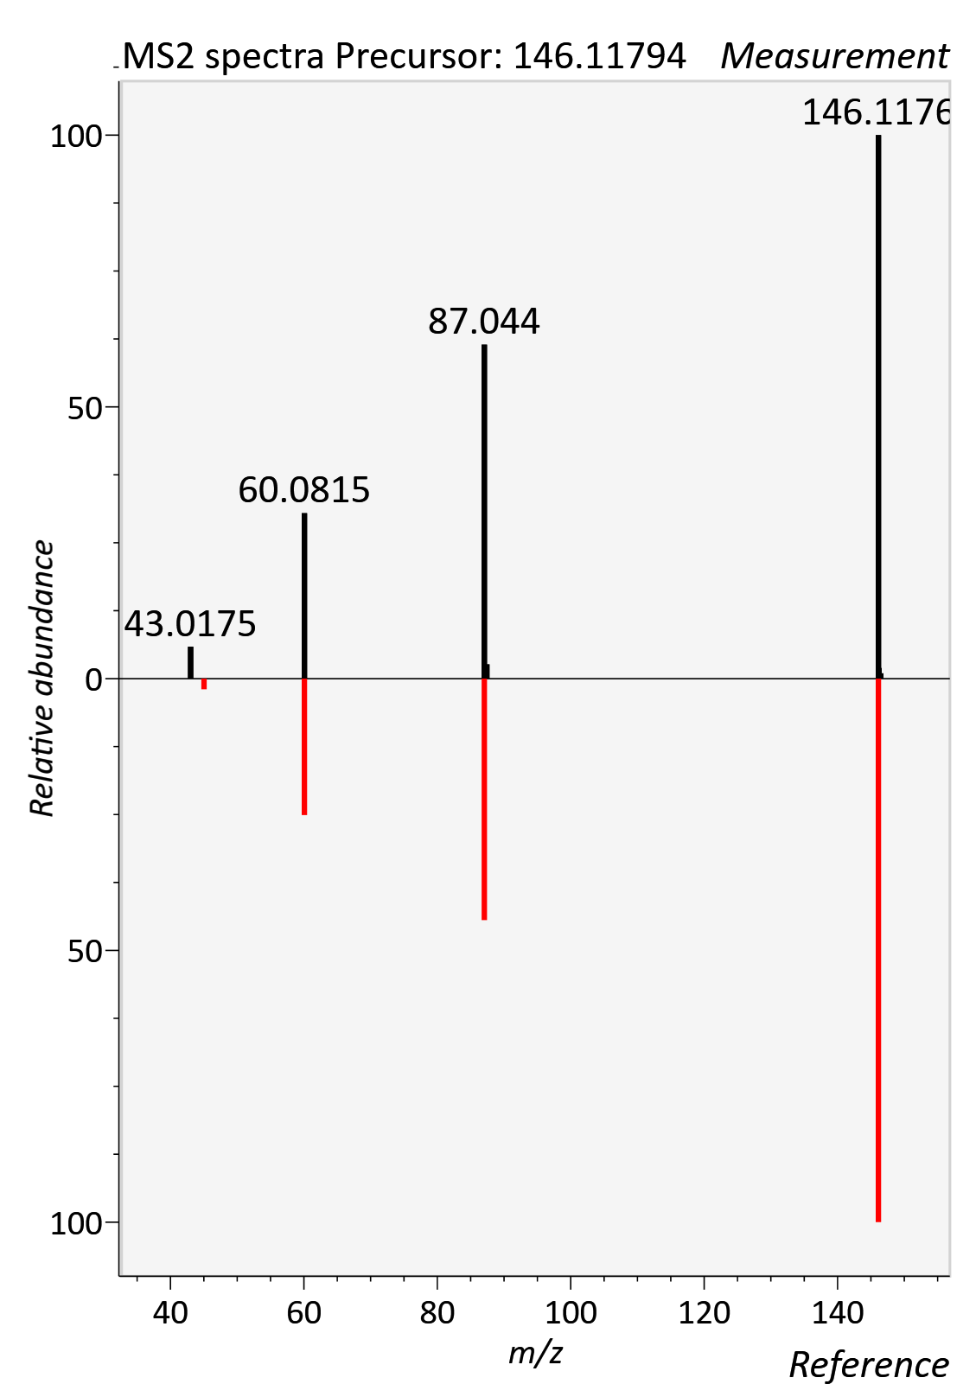

5-AVAB
RT std: 2.39min, RT experimental: 2.27min, RT Δ 0.12min
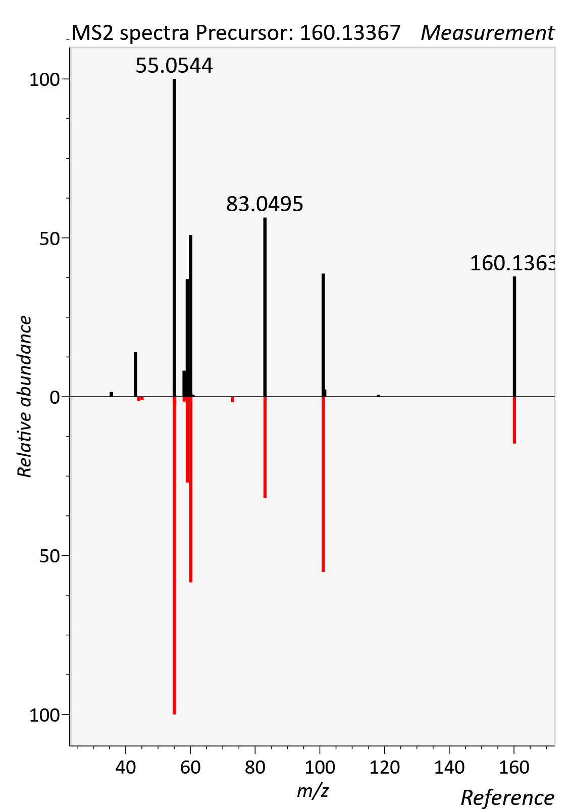

AC 05:0 (Isovalerylcarnitine)
RT std: 1.28min, RT experimental: 1.40min, RT Δ 0.12min
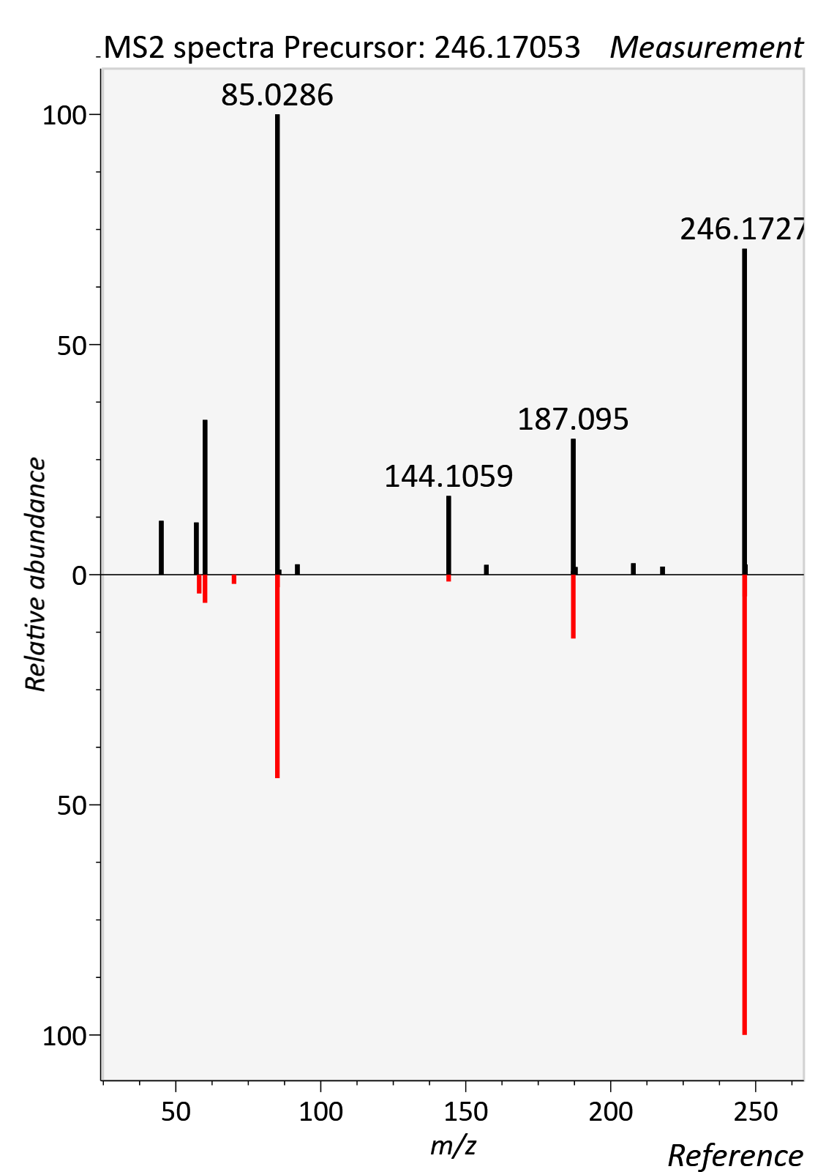

7a-hydroxy-3-oxo-4-cholestenoic acid
RT std: 9.71min, RT experimental: 9.94min, RT Δ 0.23min
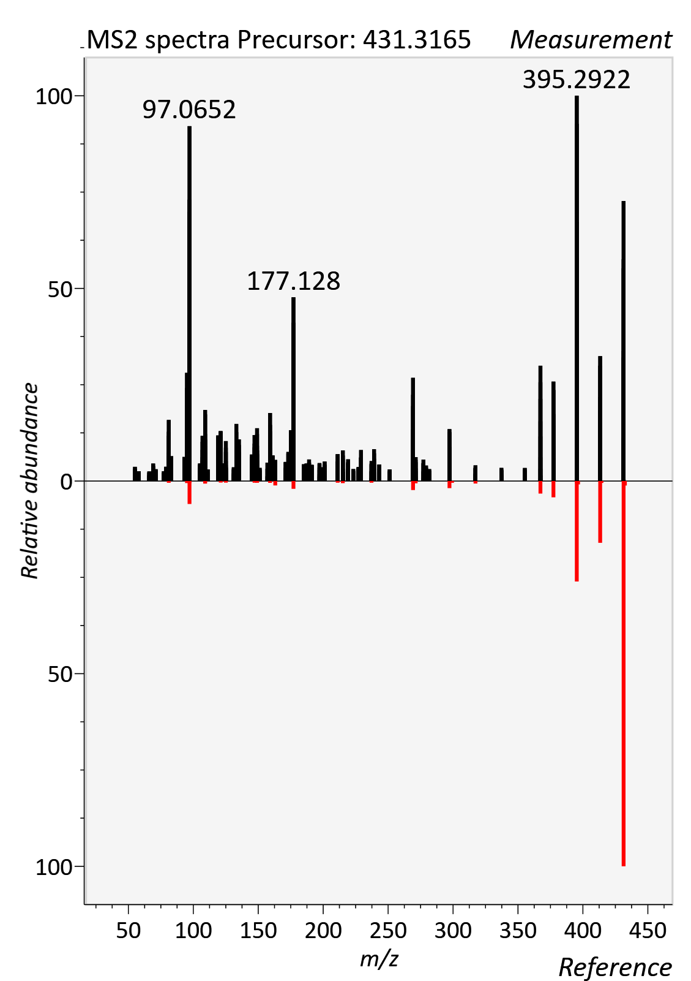

AC 04:0 (Butanoylcarnitine)
RT std: 1.85min, RT experimental: 1.77min, RT Δ 0.08min
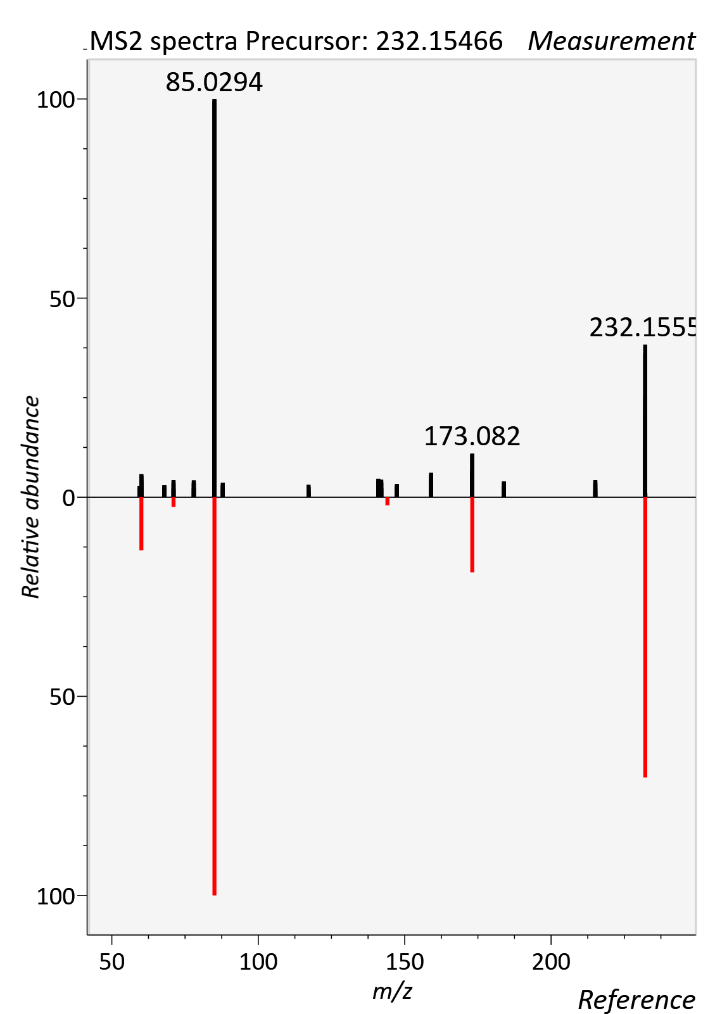

AC 06:0 (Hexanoylcarnitine)
RT std: 4.09min, RT experimental: 4.20min, RT Δ 0.11min
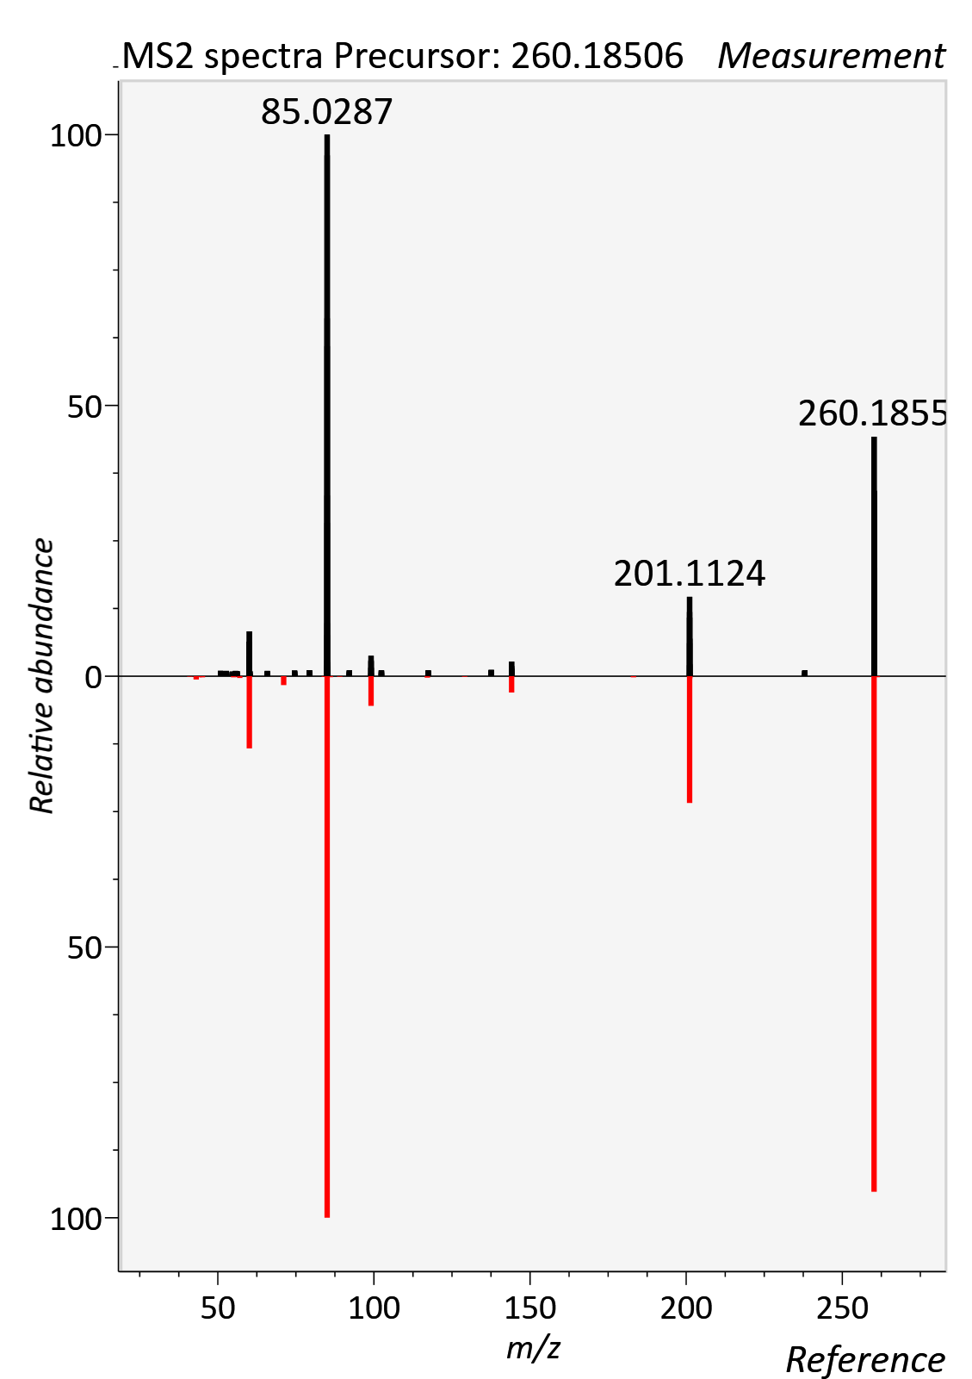

AC 08:0 (Octanoylcarnitine)
RT std: 5.89, RT experimental: 6.02min, RT Δ 0.13min
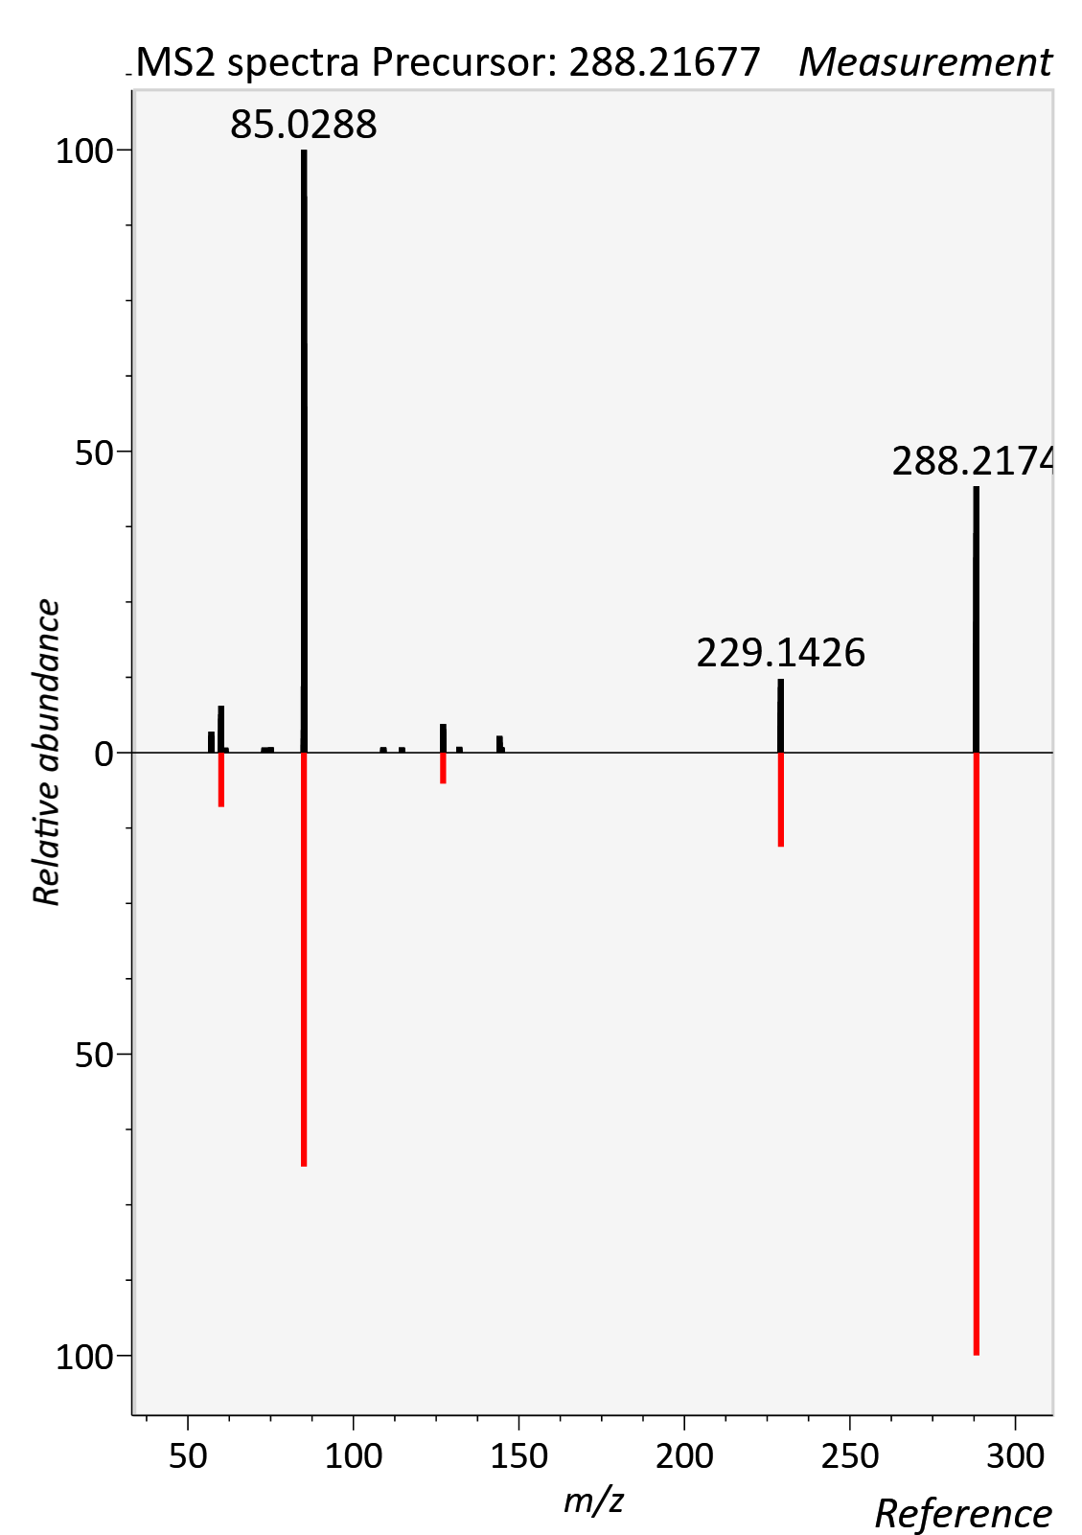

AC 08:1 (Octenoyl-L-carnitine)
RT std: 5.56min, RT experimental: 5.20min, RT Δ 0.23min
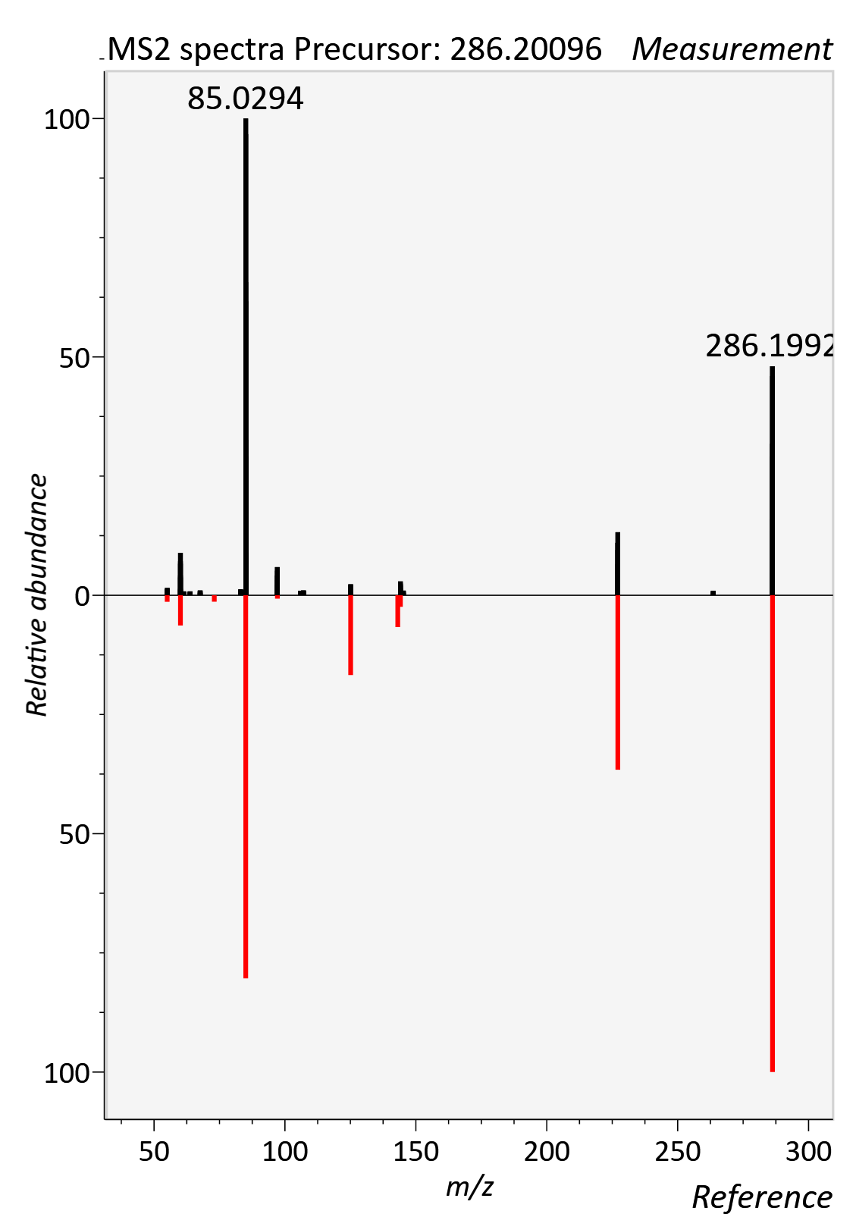

AC 10:0 (Decanoylcarnitine)
RT std: 7.17min, RT experimental: 7.28min, RT Δ 0.11min
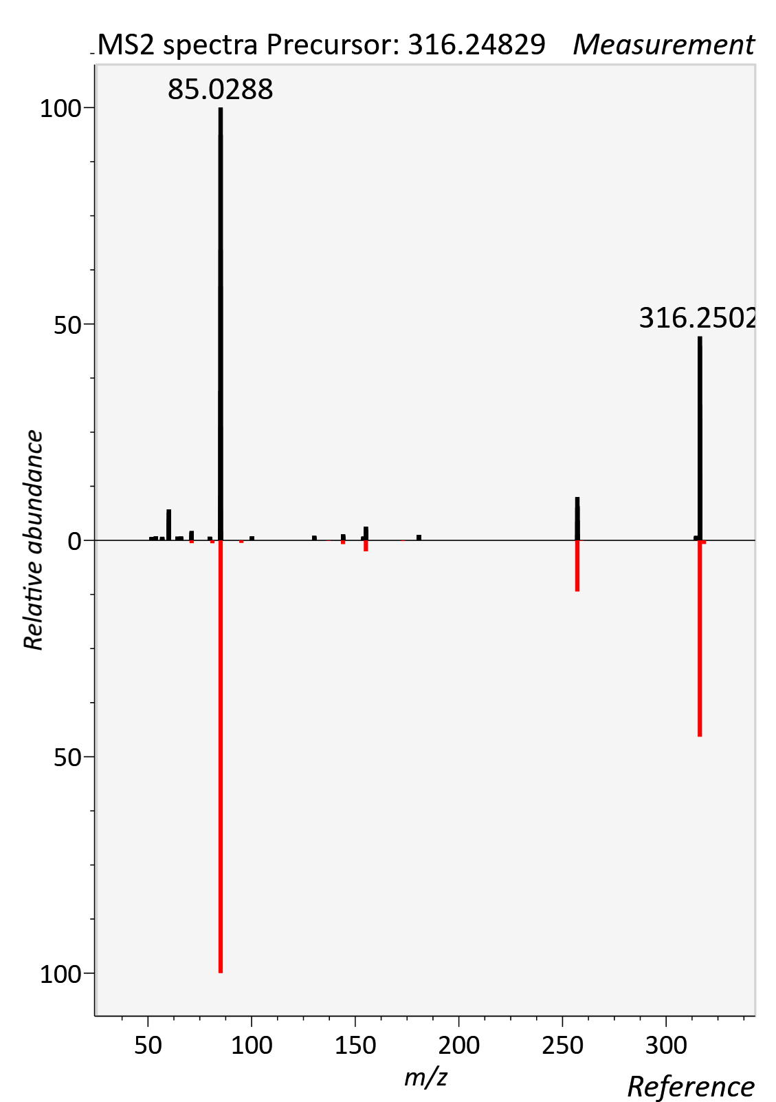

AC 12:0 (Dodecanoylcarnitine)
RT std: 8.09min, RT experimental: 8.17min, RT Δ 0.08min
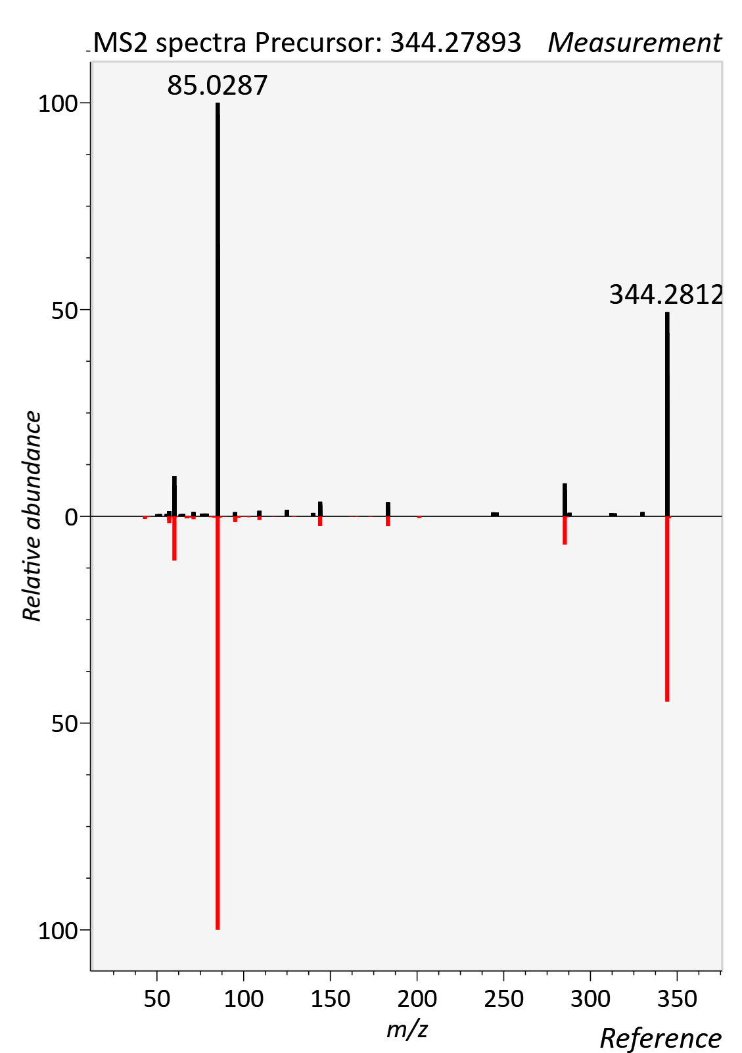

AC 12:1 (Dodecenoylcarnitine)
RT std: 7.91min, RT experimental: 7.76min, RT Δ 0.15min
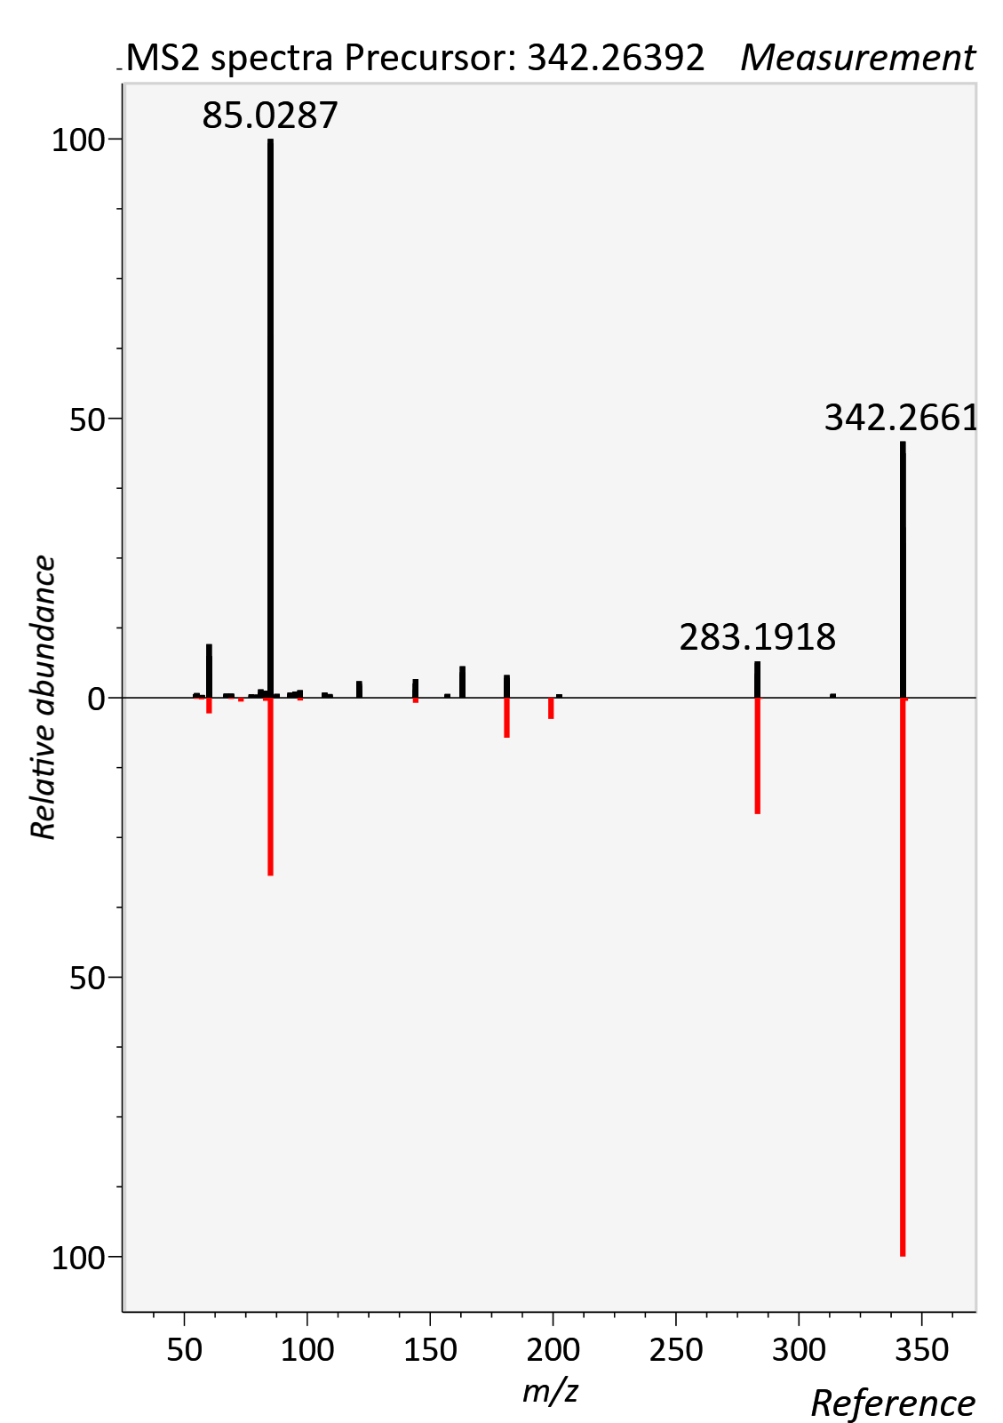

AC 14:0 (Tetradecanoyl-L-carnitine)
RT std: 8.60min, RT experimental: 8.80min, RT Δ 0.20min
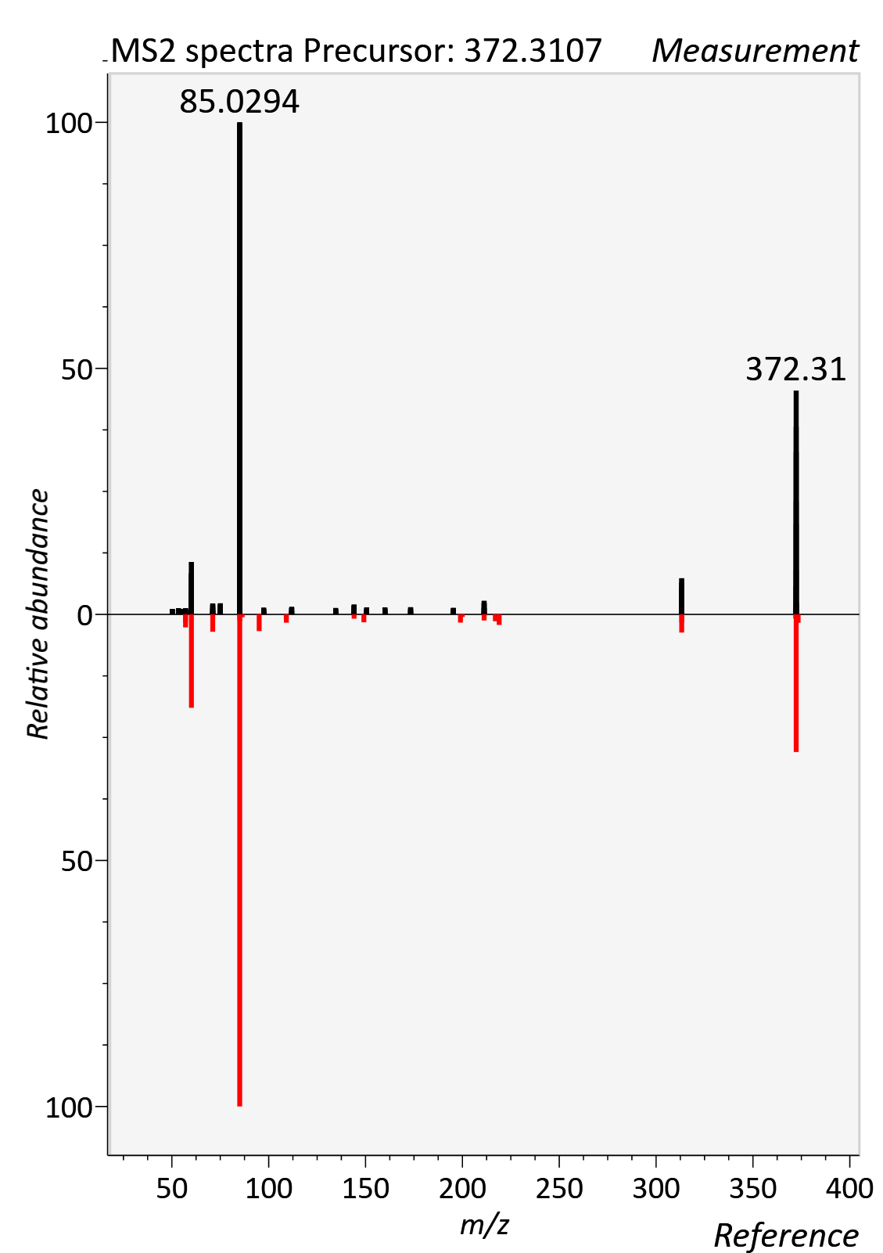

AC 14:1 (Tetradecenoylcarnitine)
RT std: 8.65min, RT experimental: 8.48min, RT Δ 0.23min
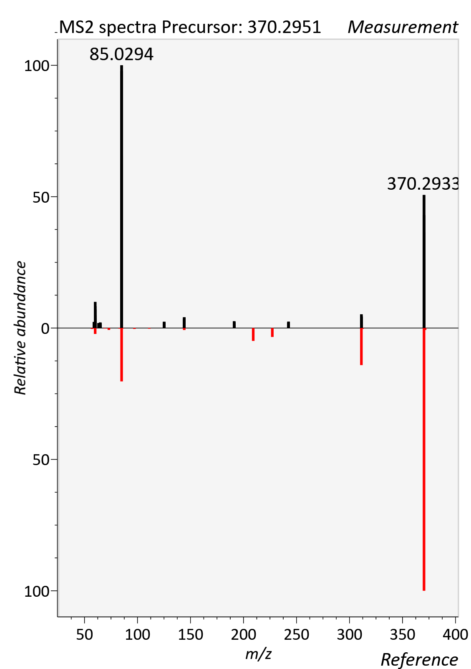

AC 16:0 (Palmitoylcarnitine)
RT std: 9.13min, RT experimental: 9.30min, RT Δ 0.20min
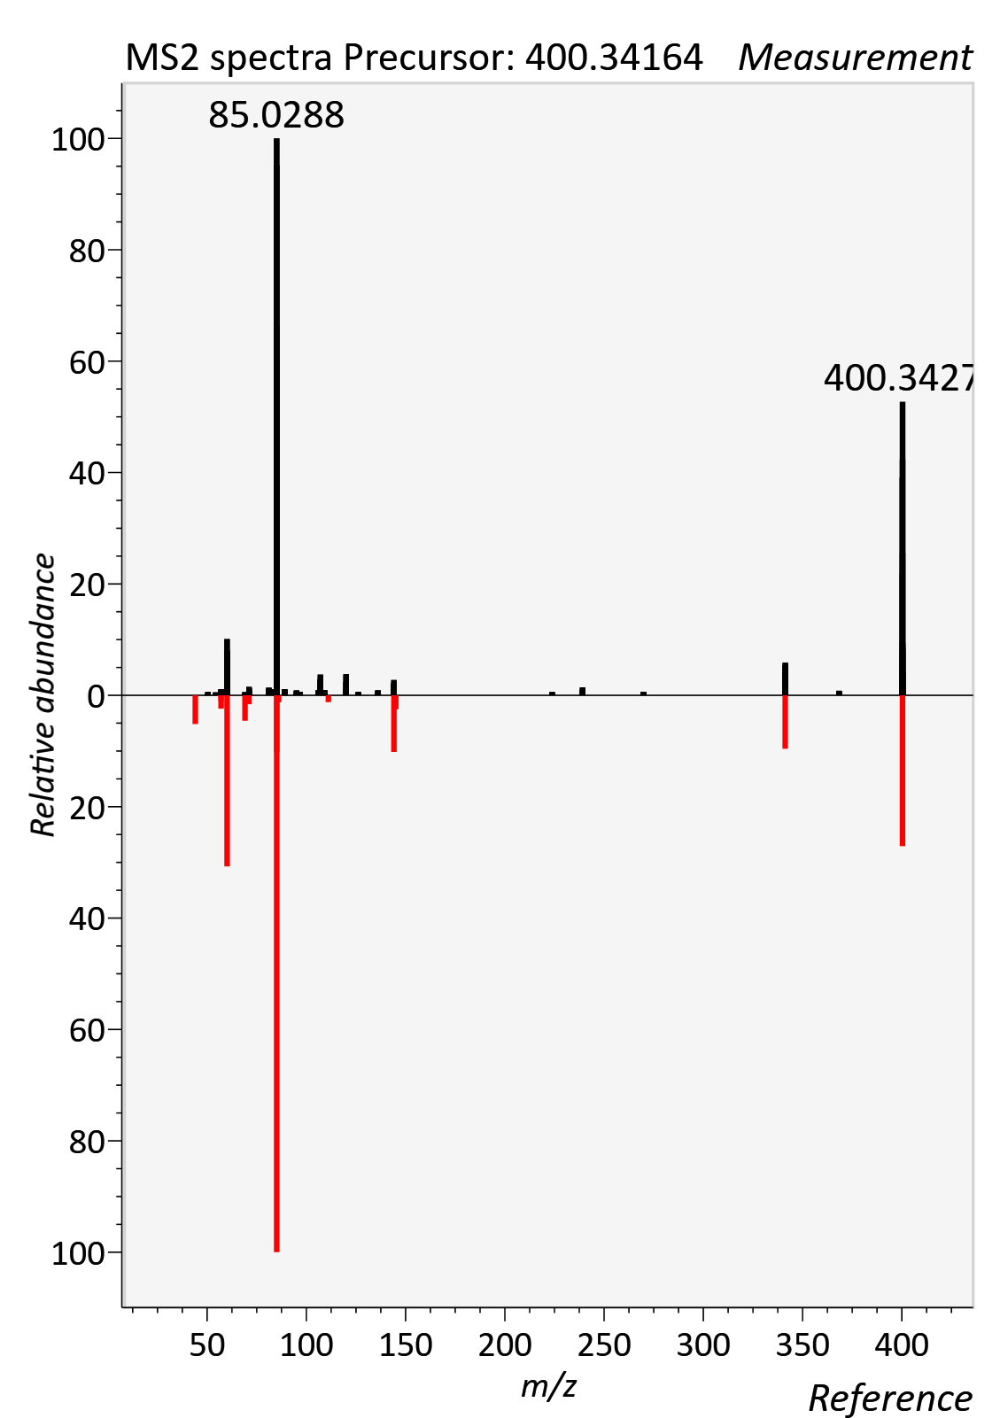

AC 18:1 (Oleylcarnitine)
RT std: 9.34min, RT experimental: 9.44min, RT Δ 0.10min
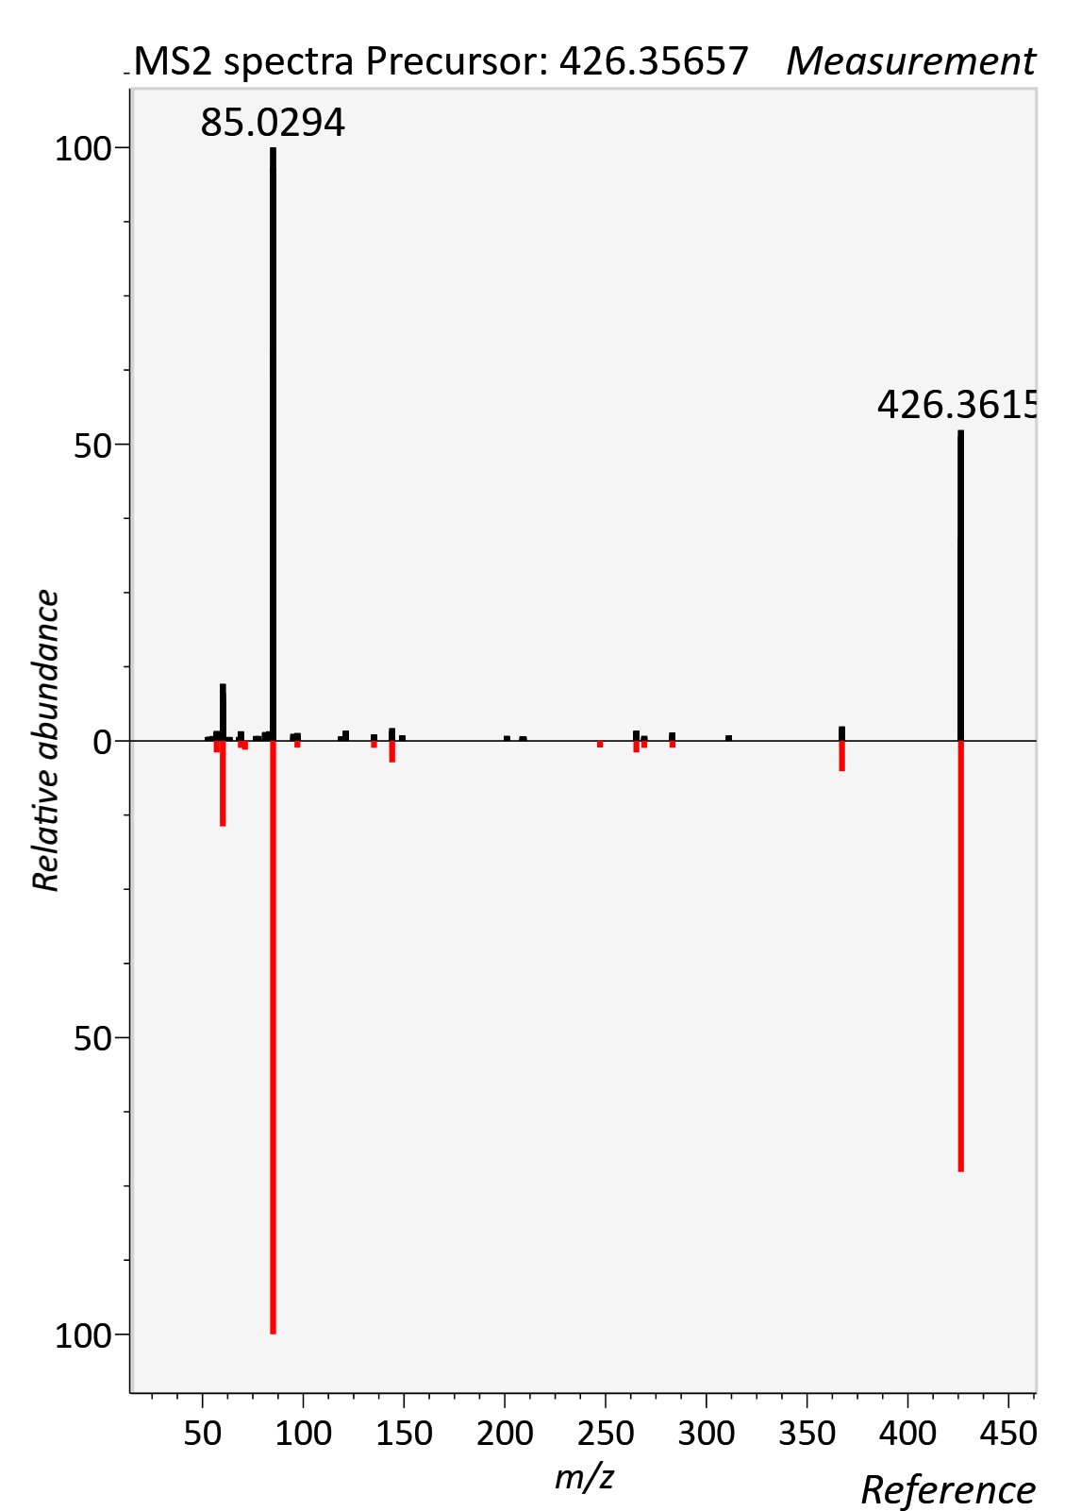

AC 18:2 (Linoleylcarnitine)
RT std: 9.15min, RT experimental: 9.17min, RT Δ 0.02min
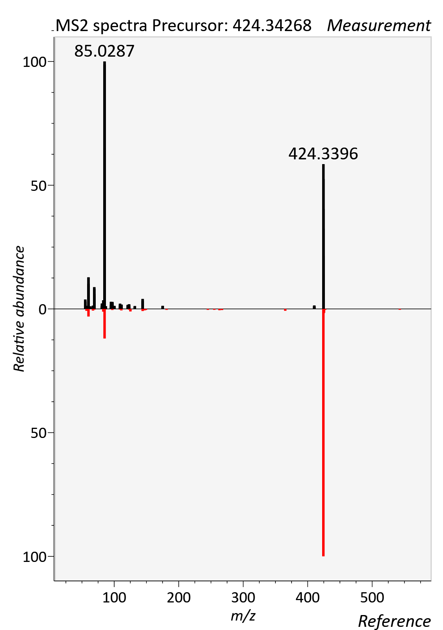

Acetylcarnitine
RT std: 2.71min, RT experimental: 3.25min, RT Δ 0.54min
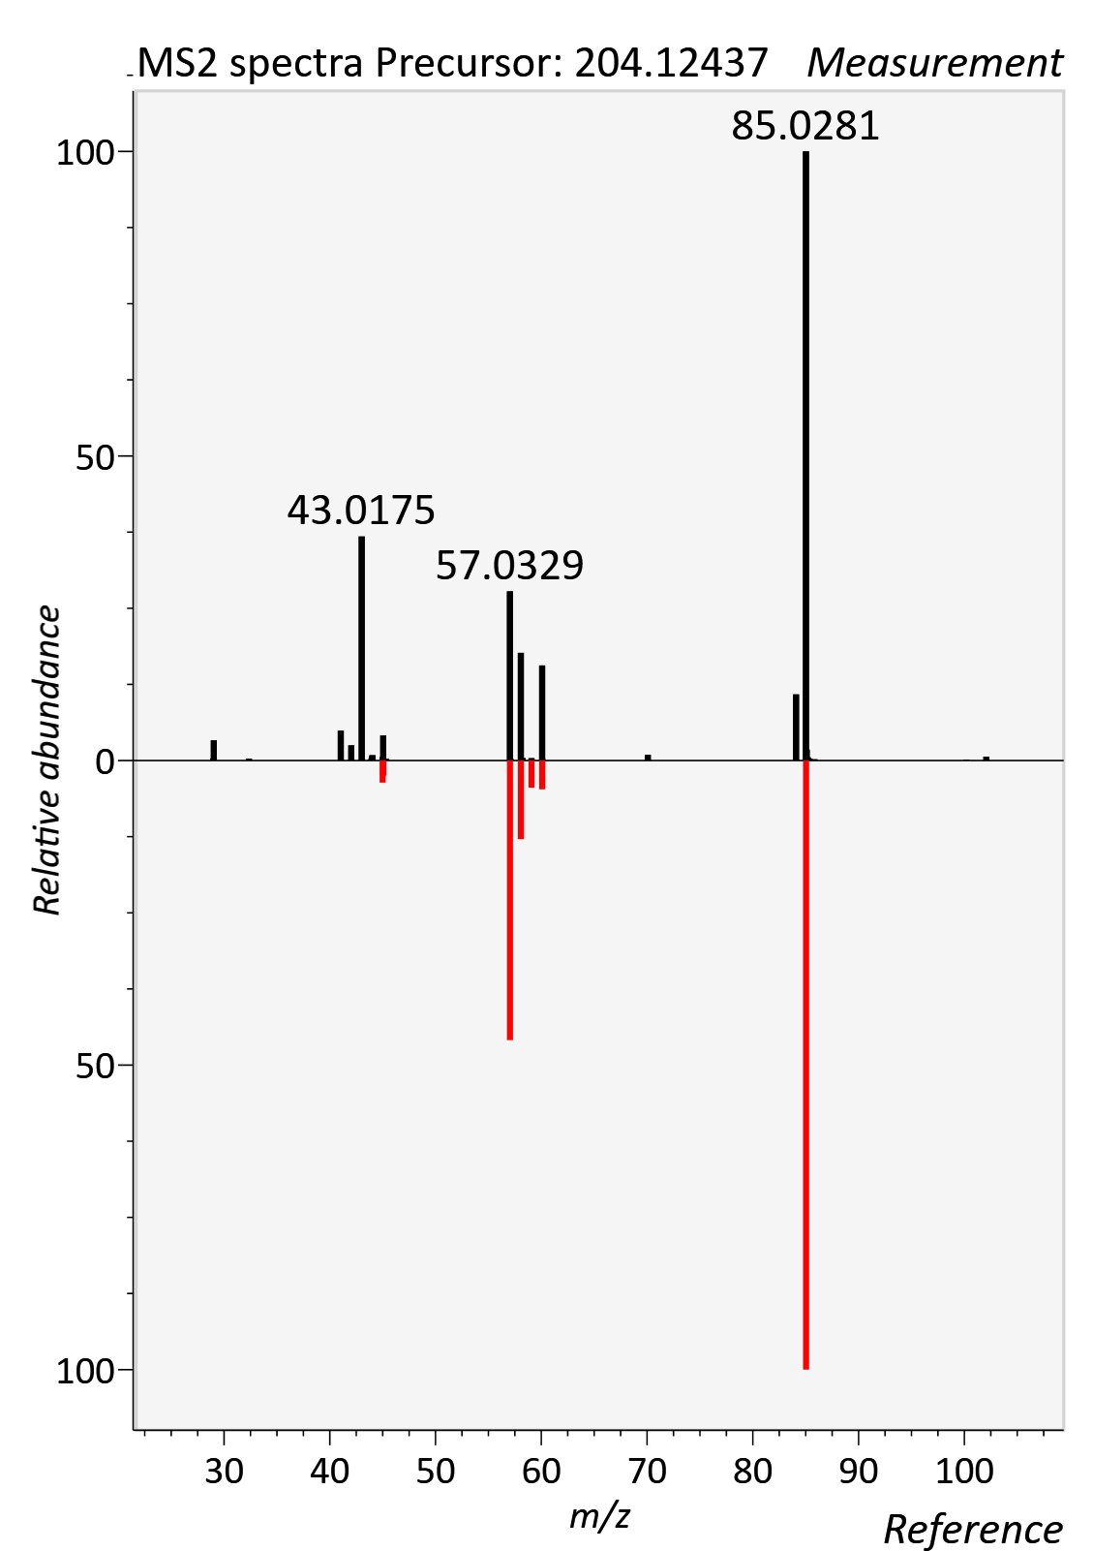

Caffeine
RT std: 3.67min, RT experimental: 3.80min, RT Δ 0.13min
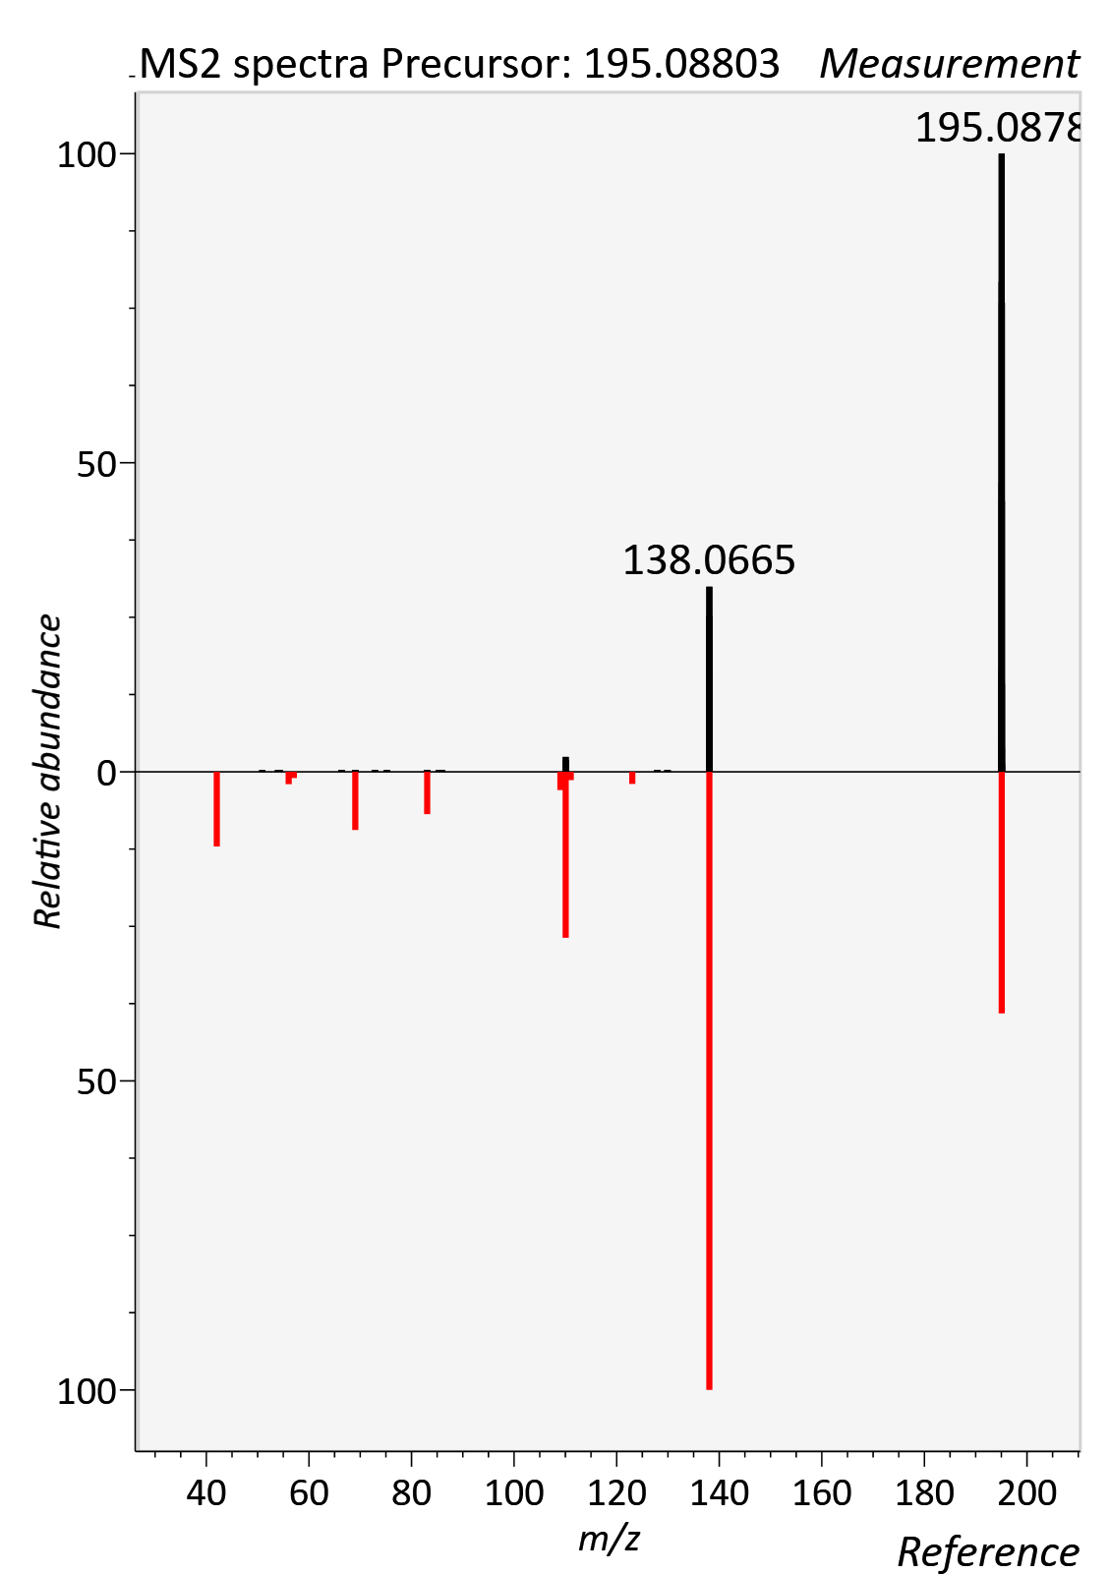

Citrulline
RT std: 6.35min, RT experimental: 6.50min, RT Δ 0.15min
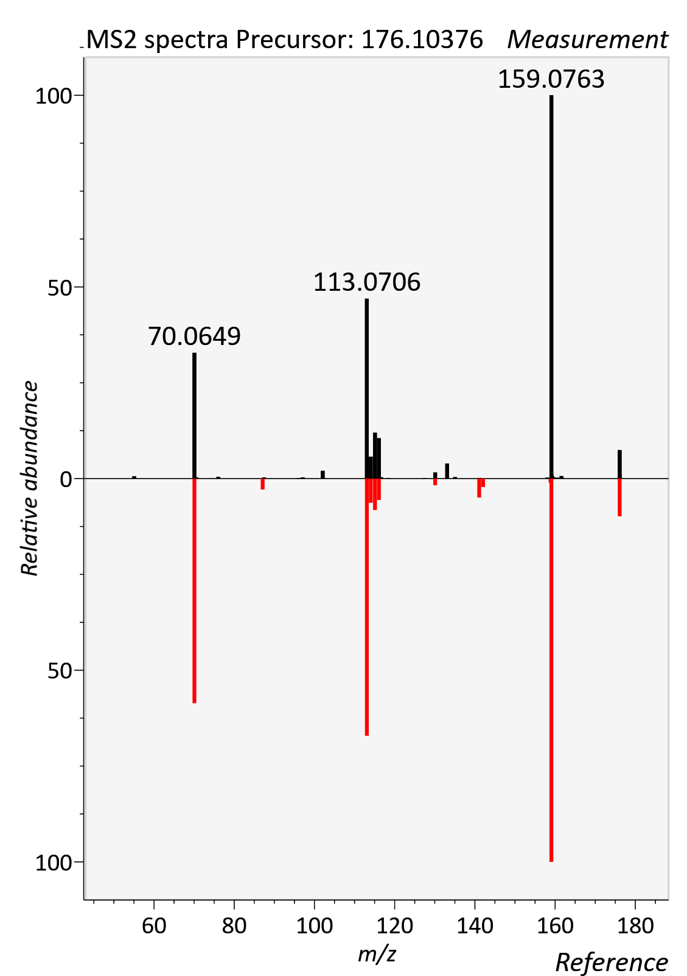

Cholic acid
RT std: 9.08min, RT experimental: 9.28min, RT Δ 0.20min
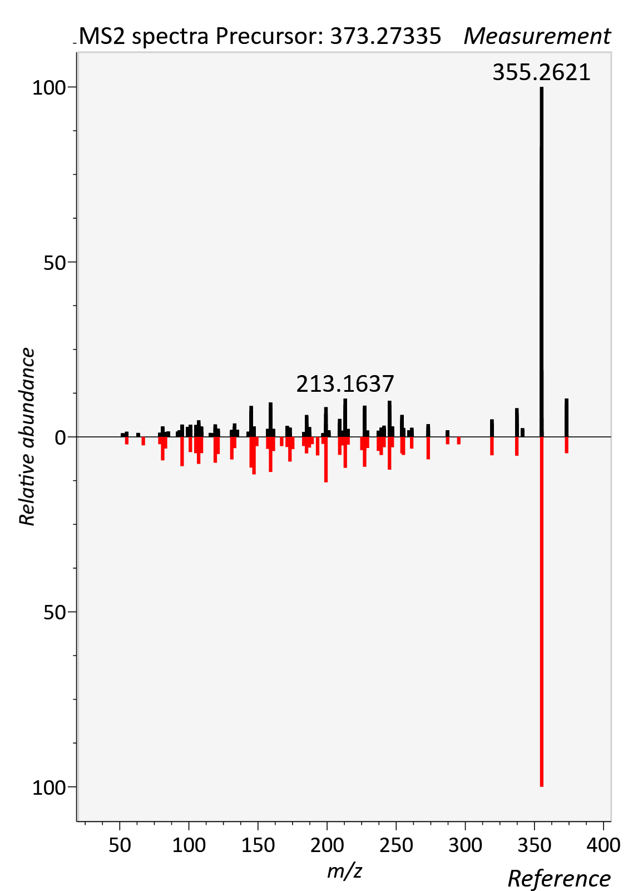

Cortisol
RT std: 6.79min, RT experimental: 6.99min, RT Δ 0.20min
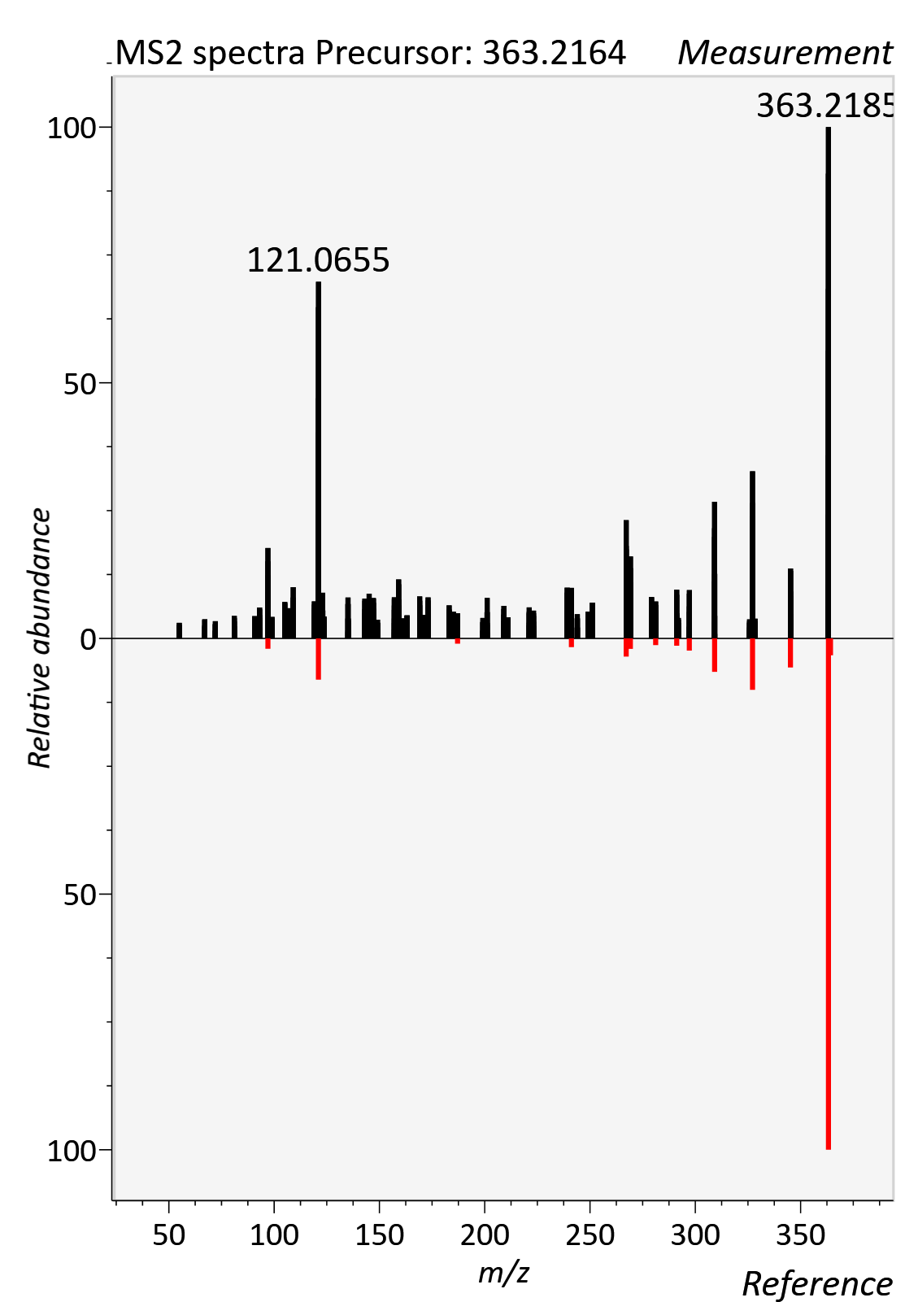

Cortisone, [M+FA-H]-
RT std: 6.55min, RT experimental: 6.73min, RT Δ 0.22min
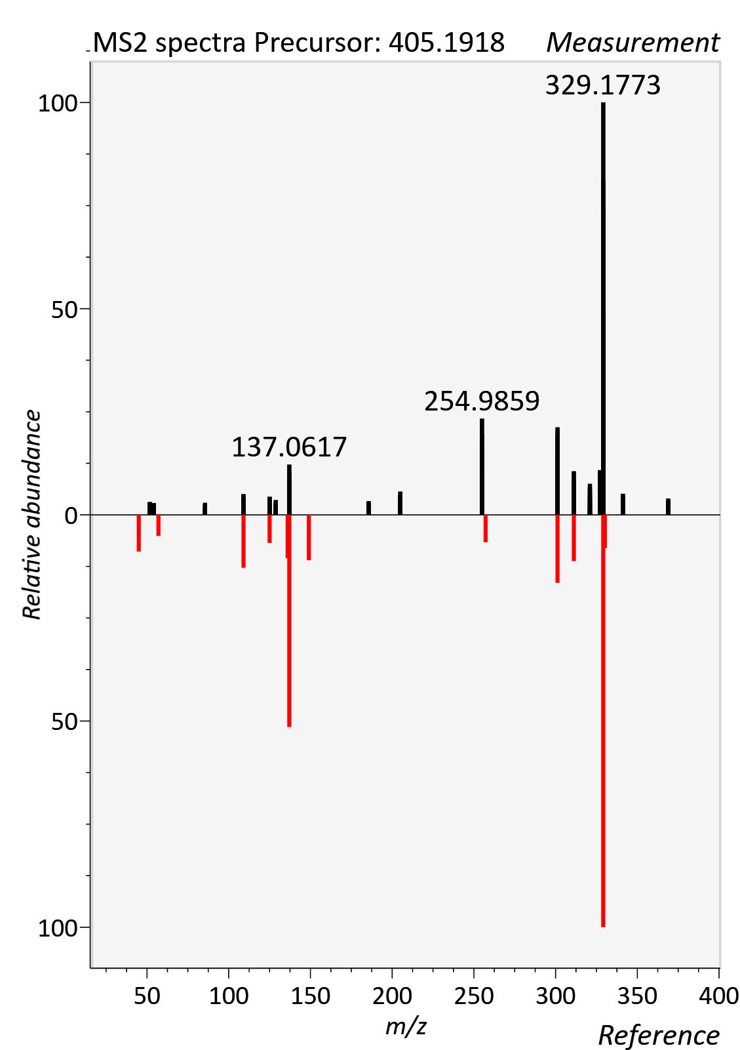

Creatinine
RT std: 1.22min, RT experimental: 1.35min, RT Δ 0.13min
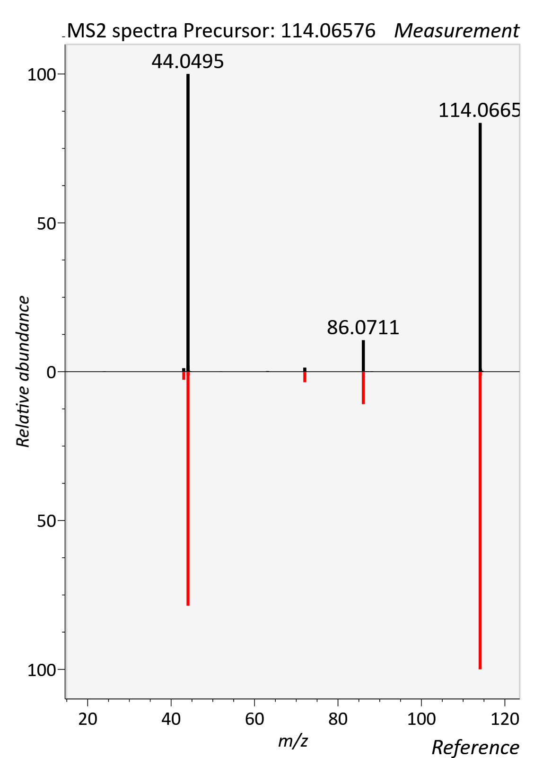

Deoxycholic acid
RT std: 9.71min, RT experimental: 9.90min, RT Δ 0.19min
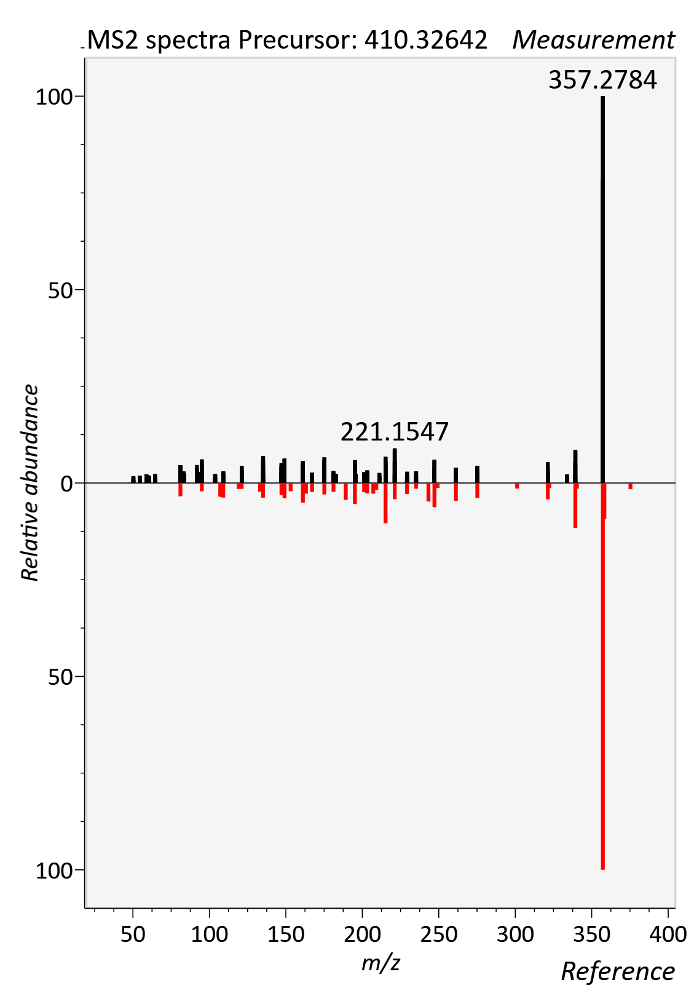
FA 18:1 (Octadecenoic acid)
RT std: 11.23min, RT experimental: 10.92min, RT Δ 0.31min
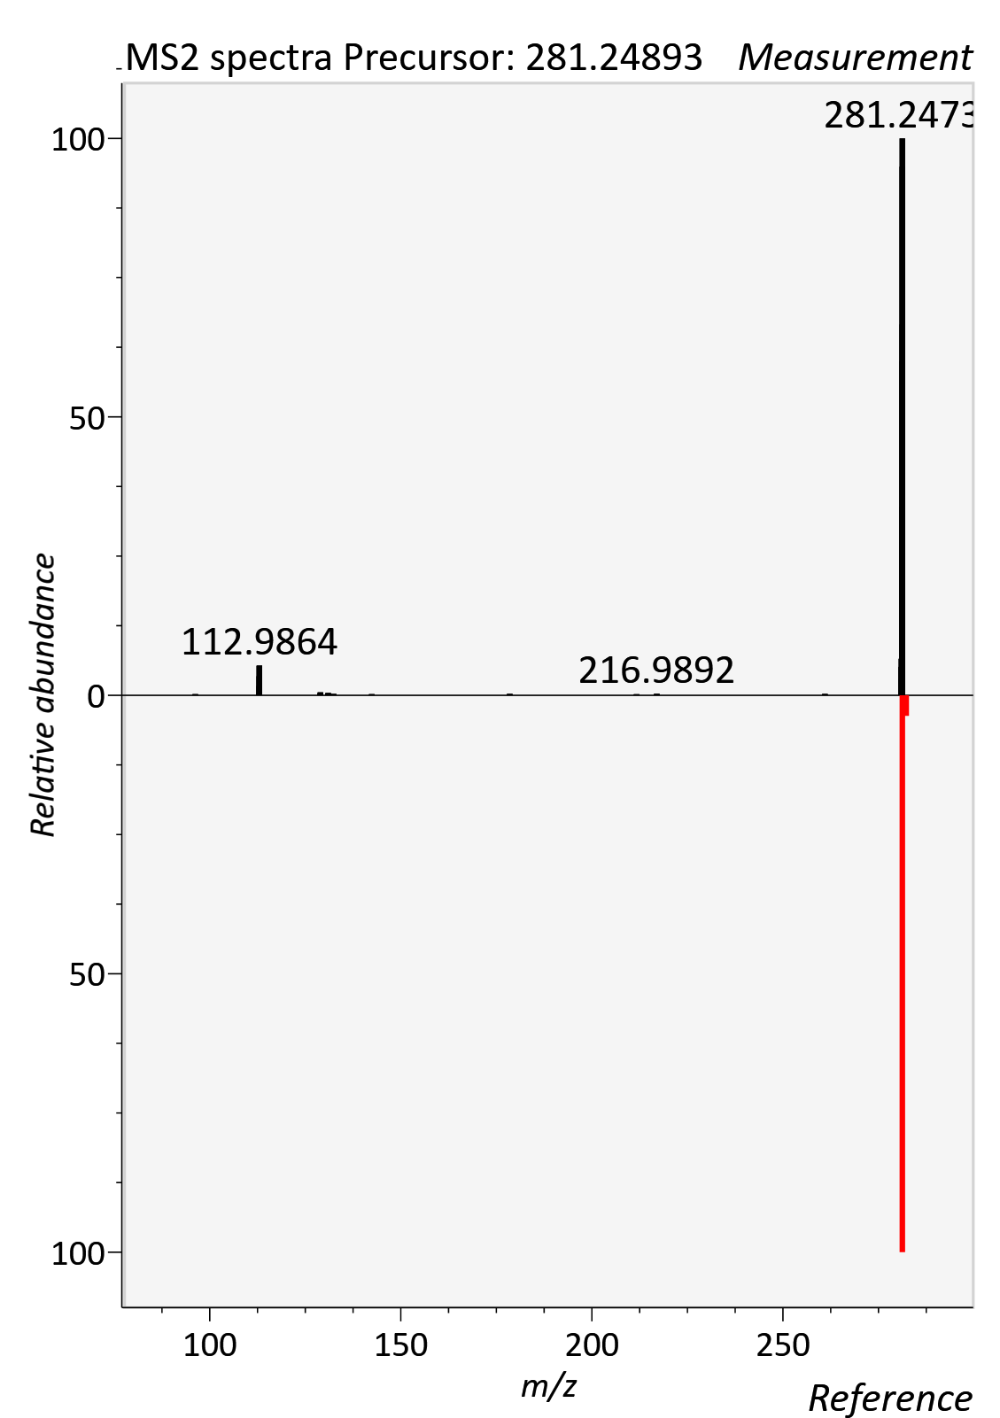

FA 22:6 (DHA)
RT std: 10.66min, RT experimental: 10.89min, RT Δ 0.23min
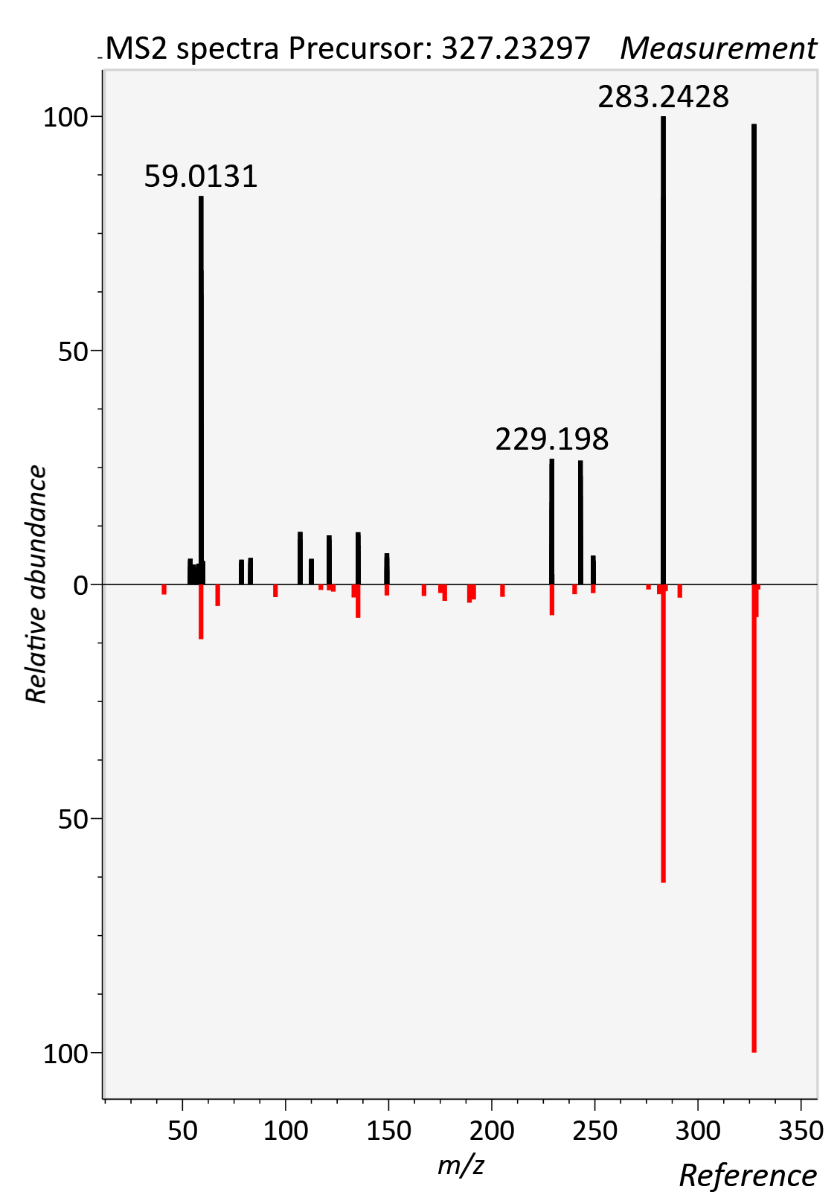

Glutamine
RT std: 6.13min, RT experimental: 6.27min, RT Δ 0.14min
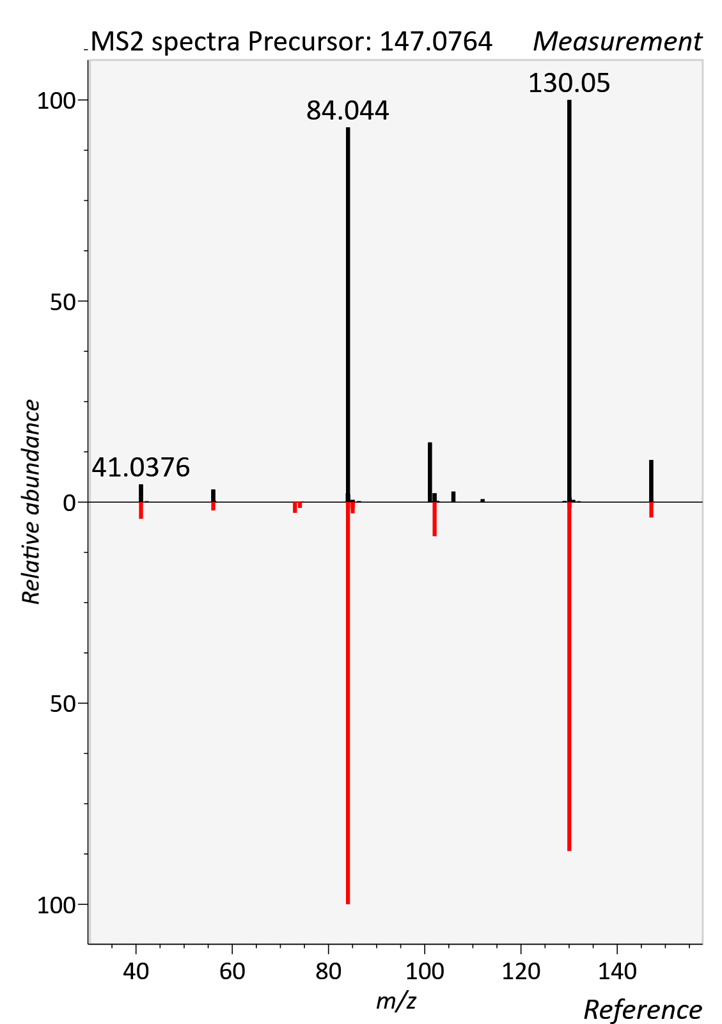

Glycine Betaine
RT std: 3.53min, RT experimental: 4.04min, RT Δ 0.49min
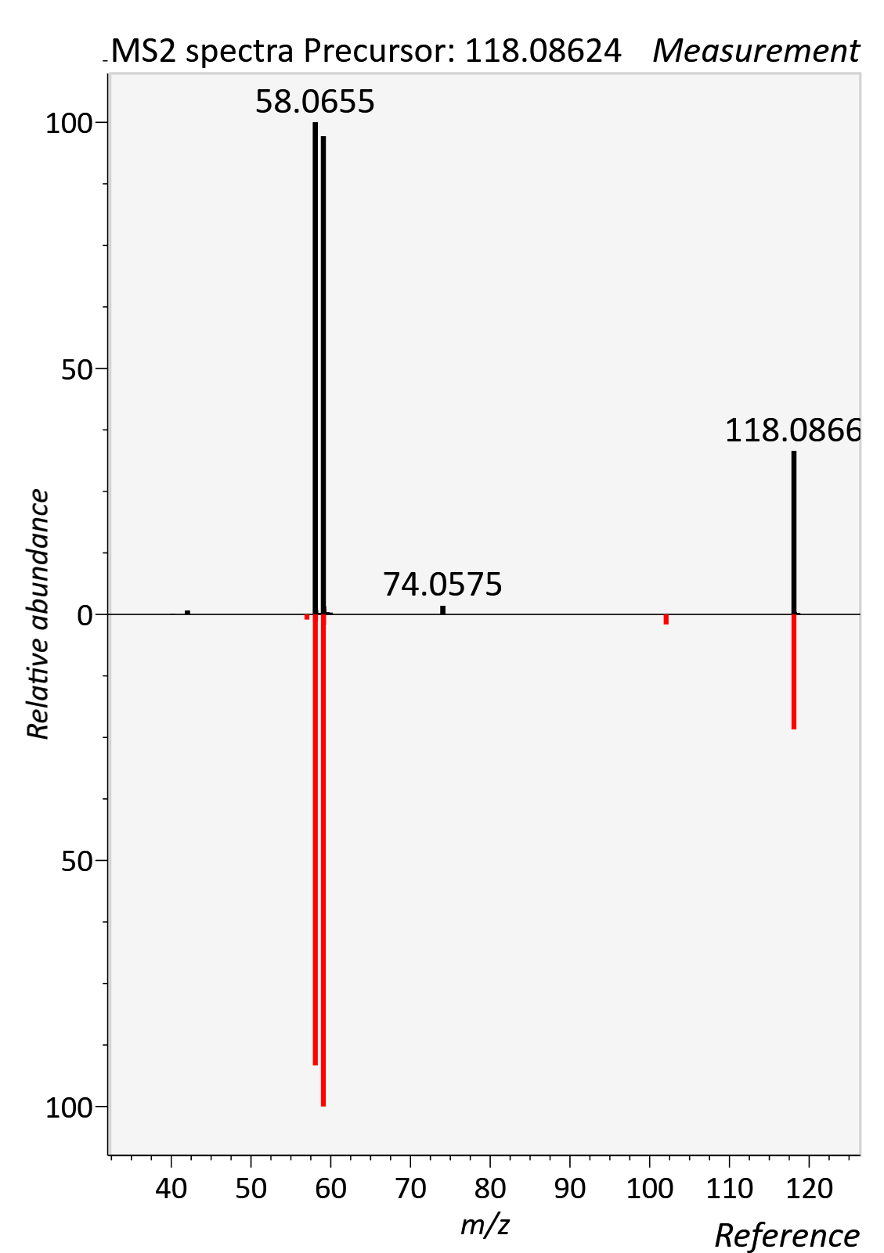
Glycochenodeoxycholic acid
RT std: 9.03min, RT experimental: 9.23min, RT Δ 0.20min
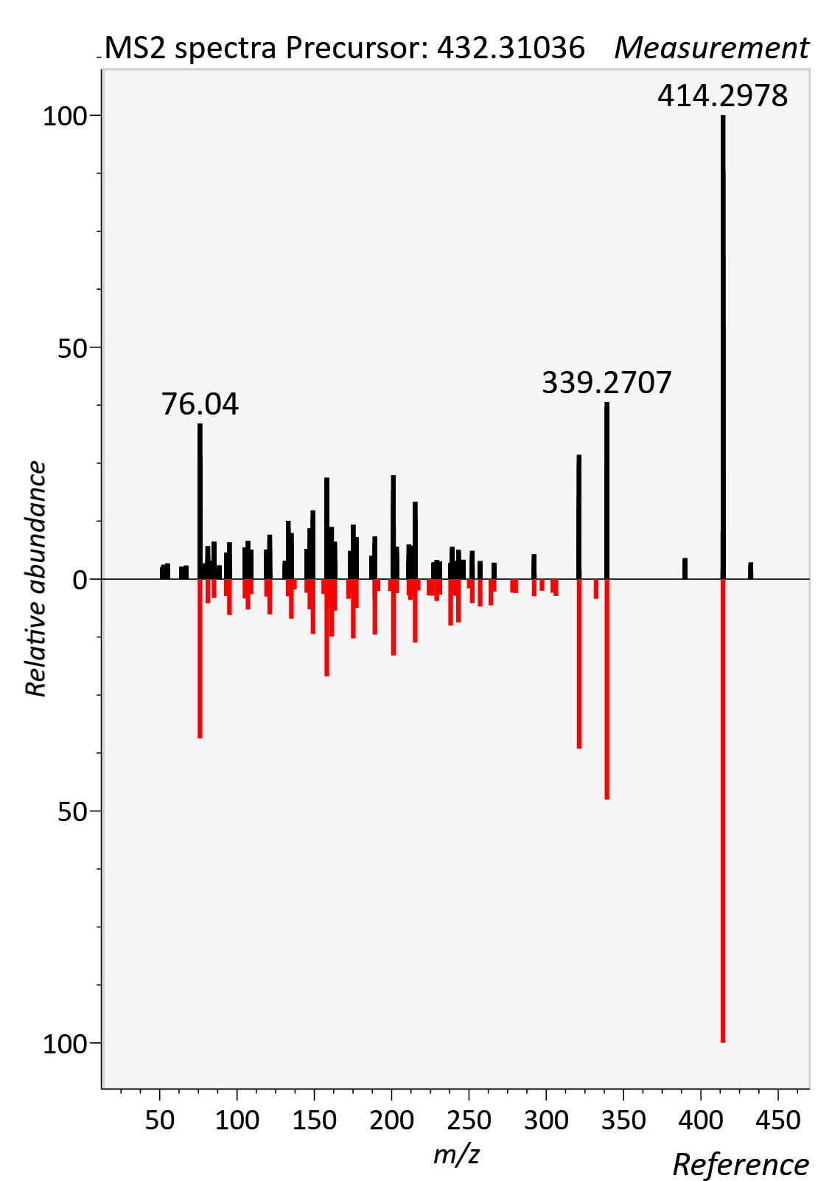

Glycocholic acid
RT std: 8.74min, RT experimental: 8.59min, RT Δ 0.15 min
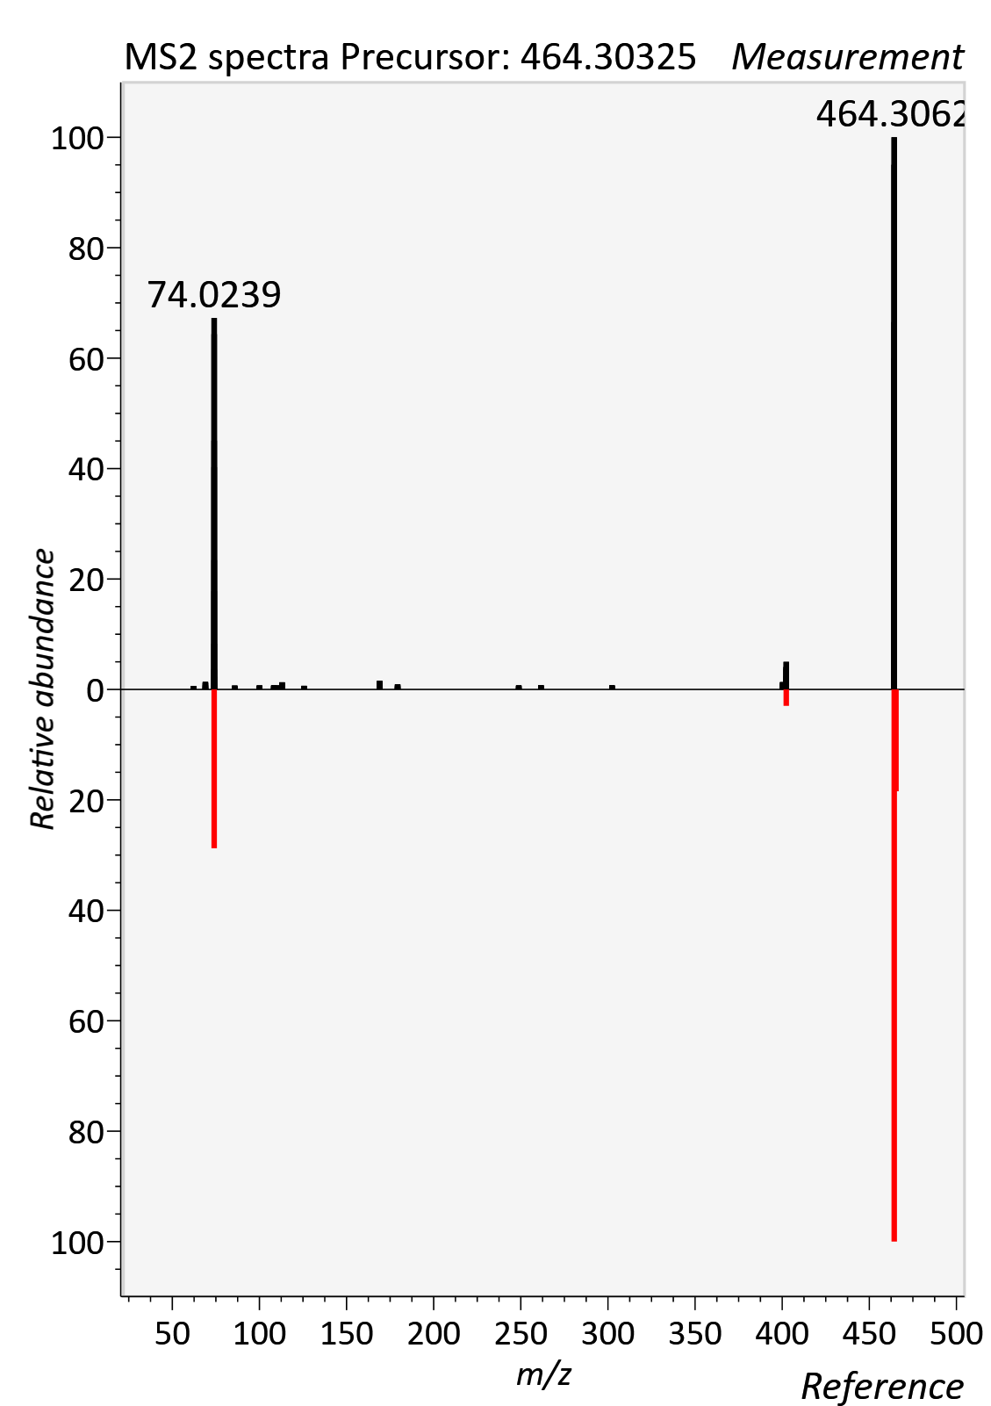

Glycohyodeoxycholic acid
RT std: 8.24min, RT experimental: 8.25min, RT Δ 0.01min
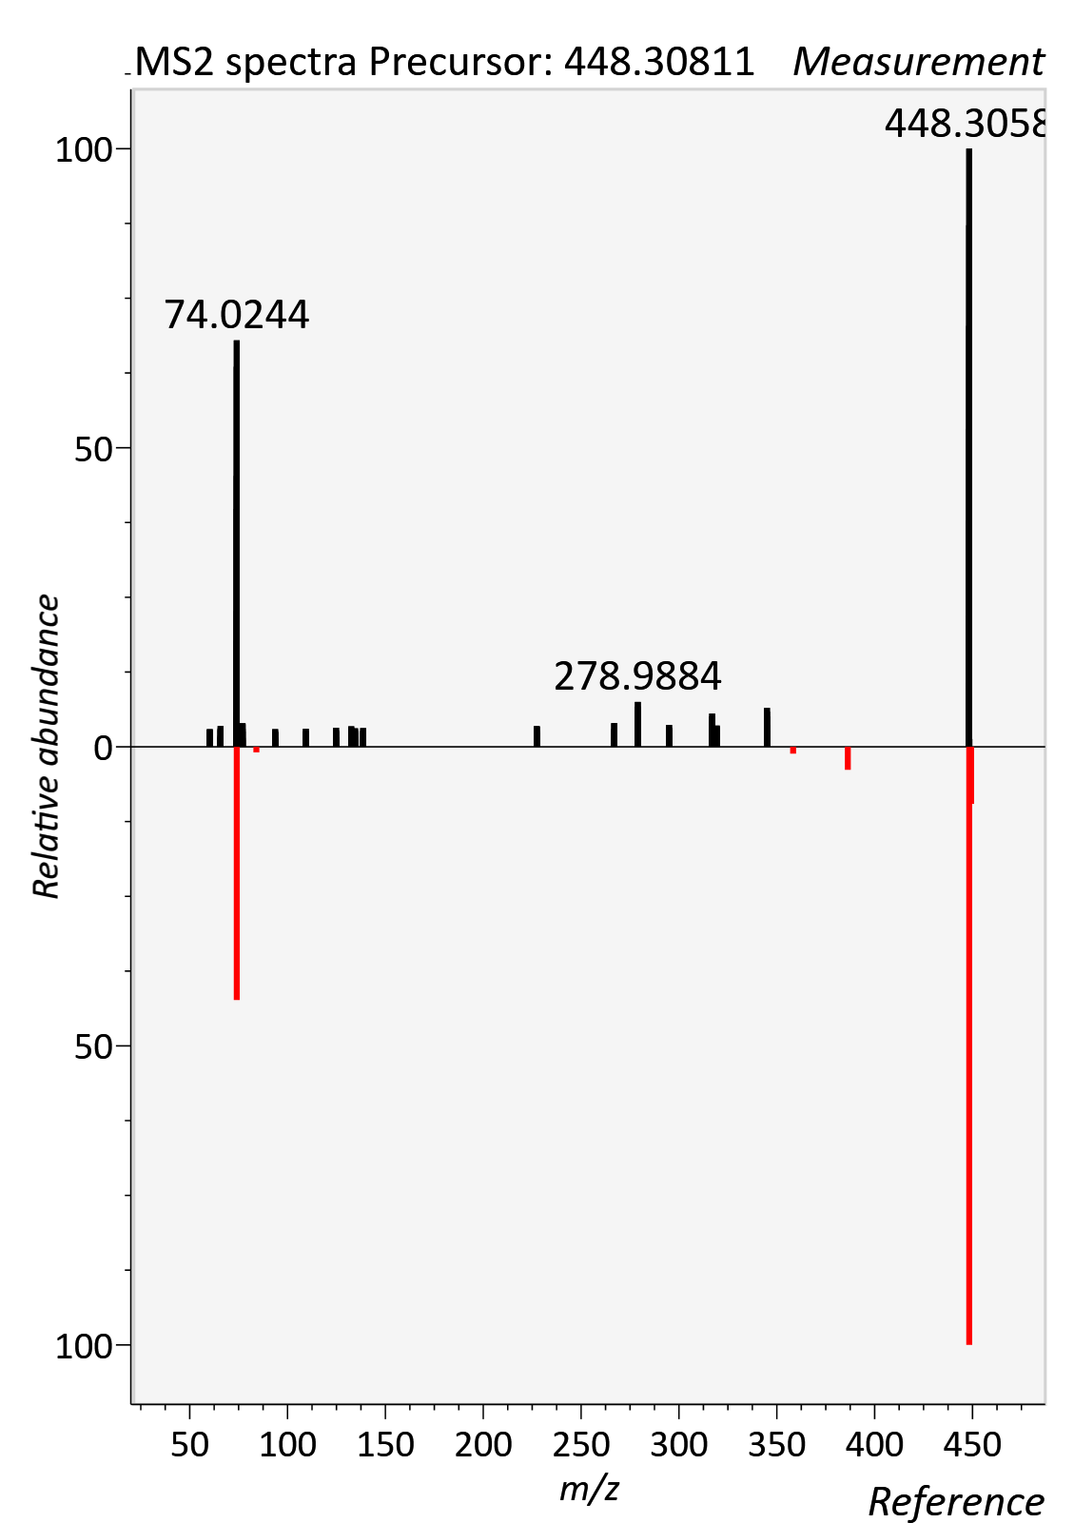

Glycolithocholic aicd
RT std: 9.33min, RT experimental: 9.58min, RT Δ 0.25min
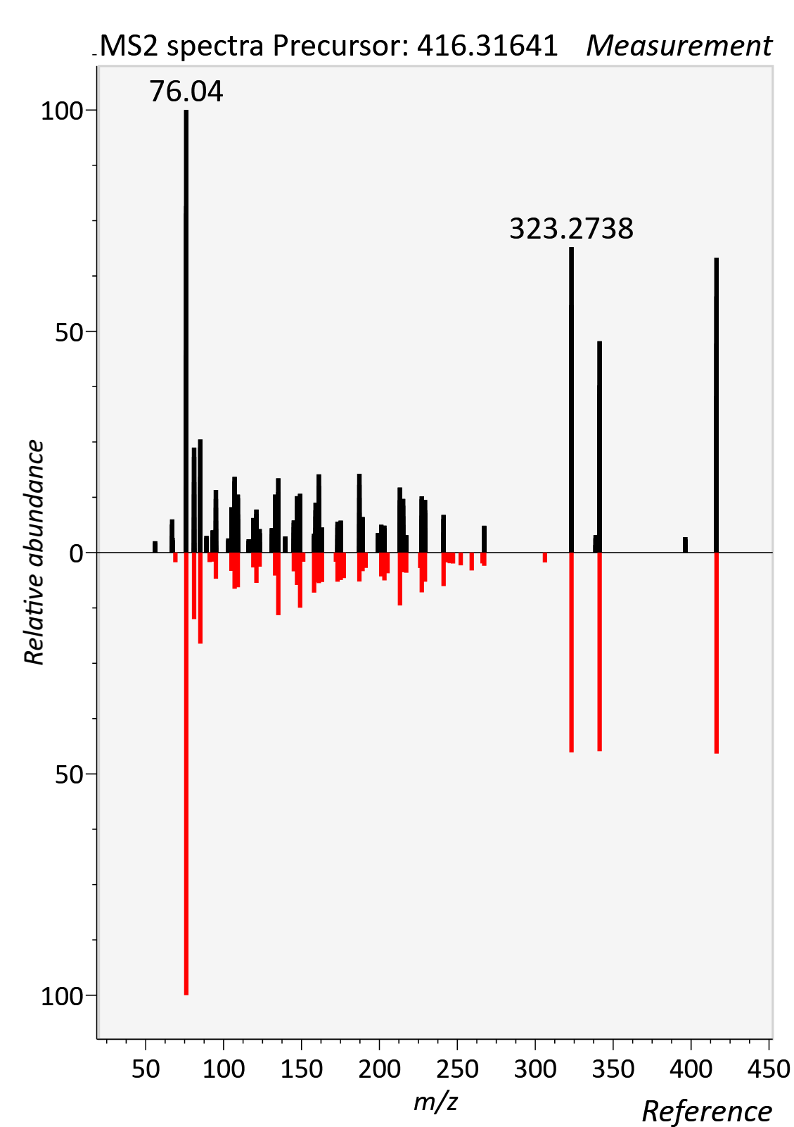

Hippuric acid
RT std: 3.30min, RT experimental: 3.54min, RT Δ 0.24min
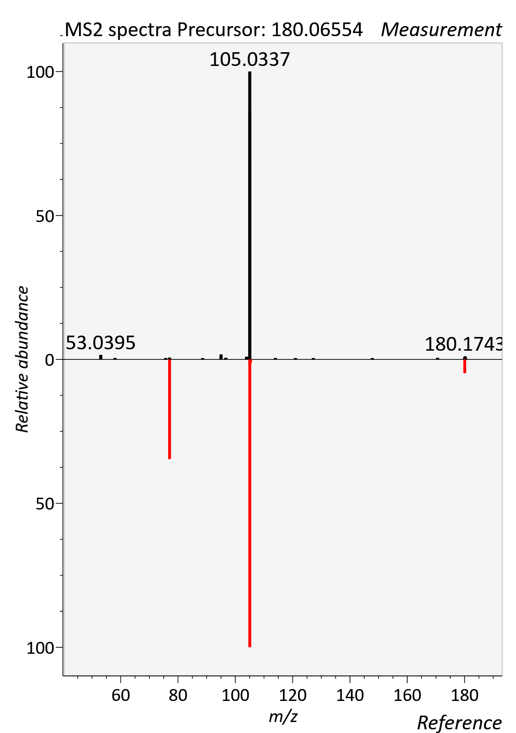
Hydroxyphenyllactic acid
RT std: 2.73min, RT experimental: 3.03min, RT Δ 0.30min
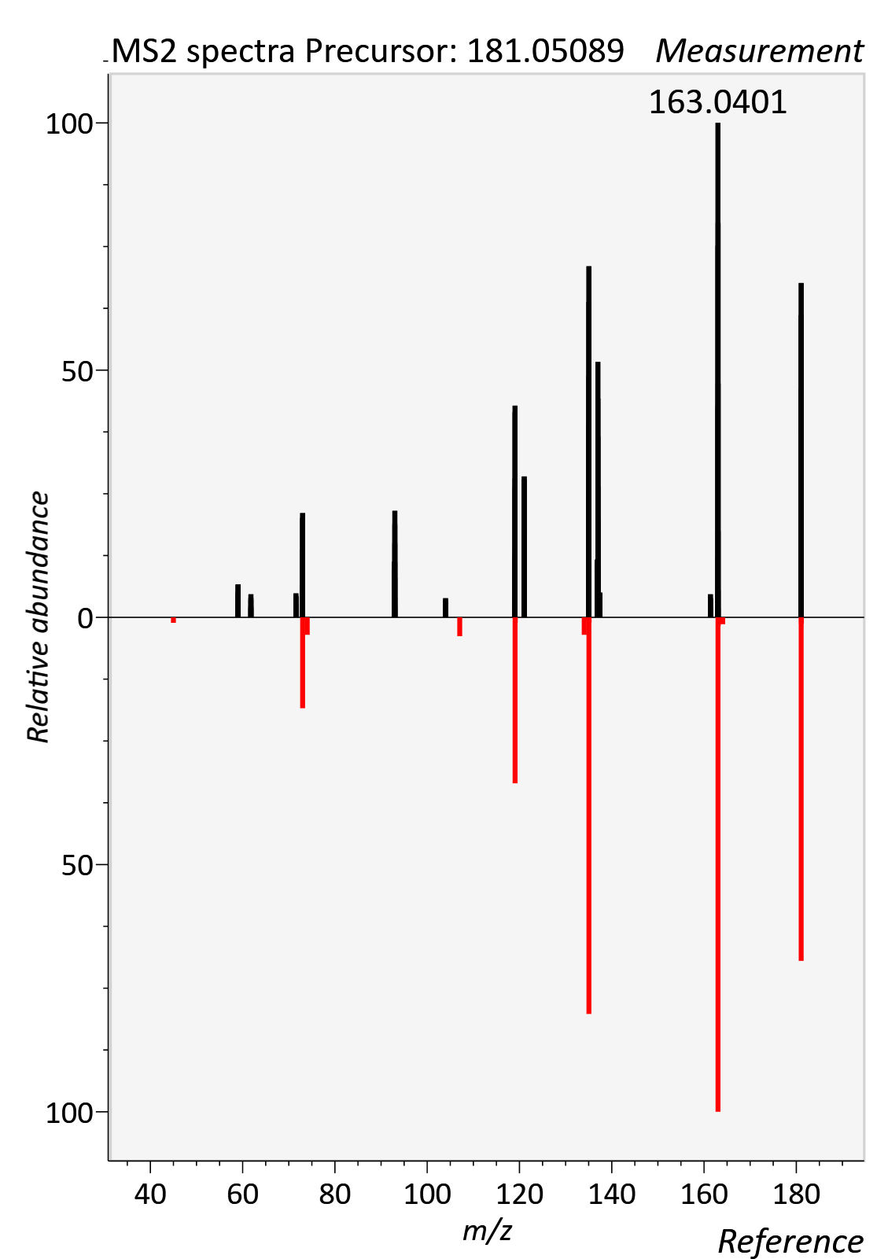

Hypoxanthine
RT std: 1.63min, RT experimental: 1.55min, RT Δ 0.08min
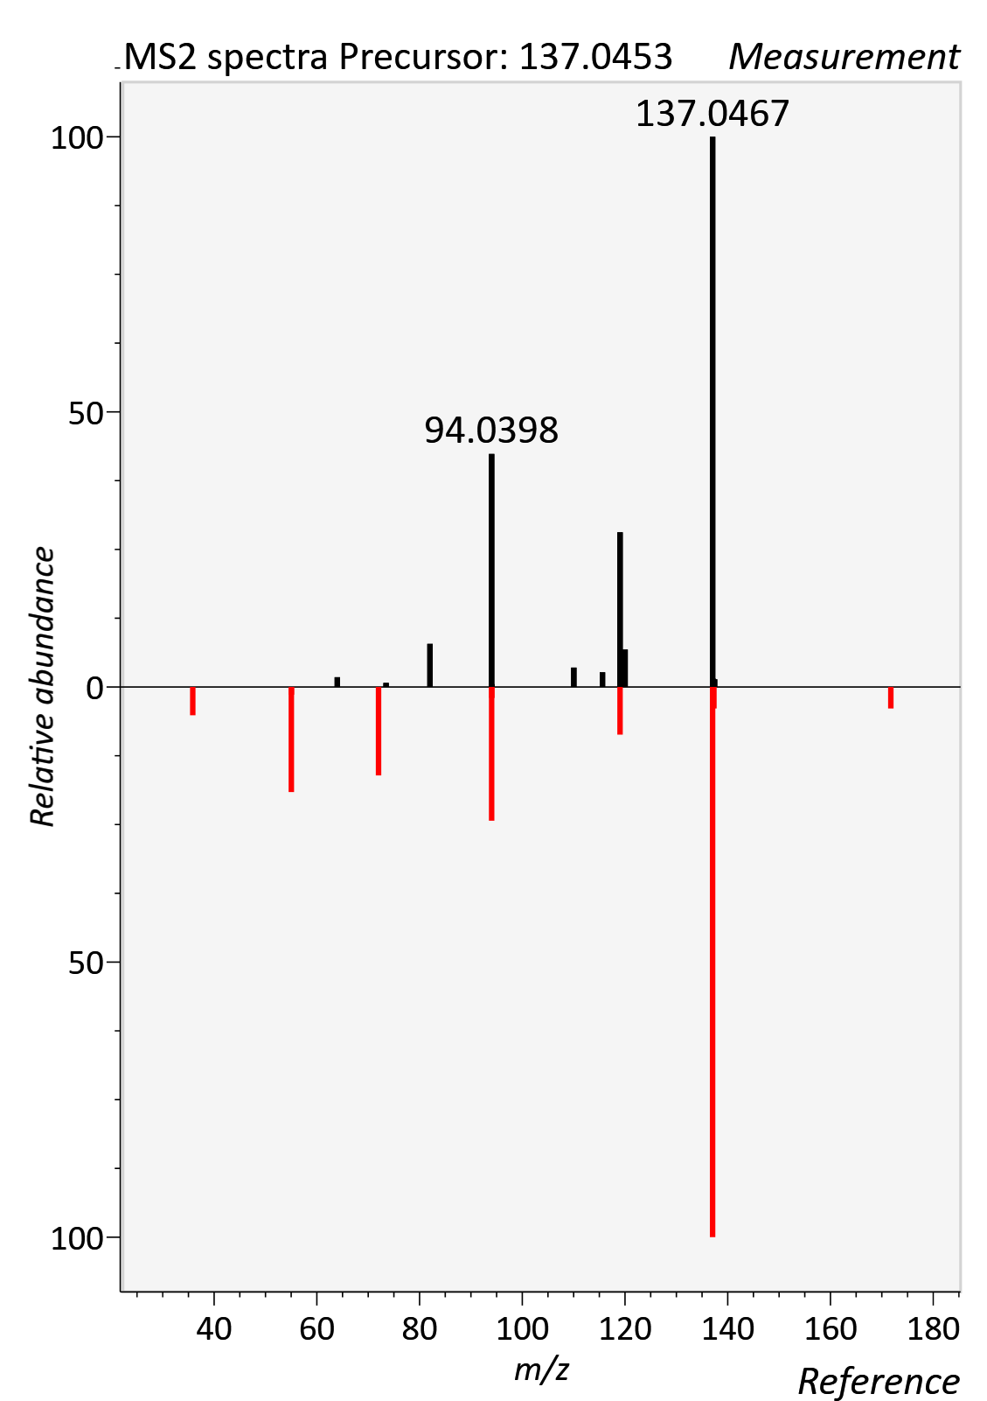

Indolelactic acid
RT std: 4.29min, RT experimental: 4.82min, RT Δ 0.53min
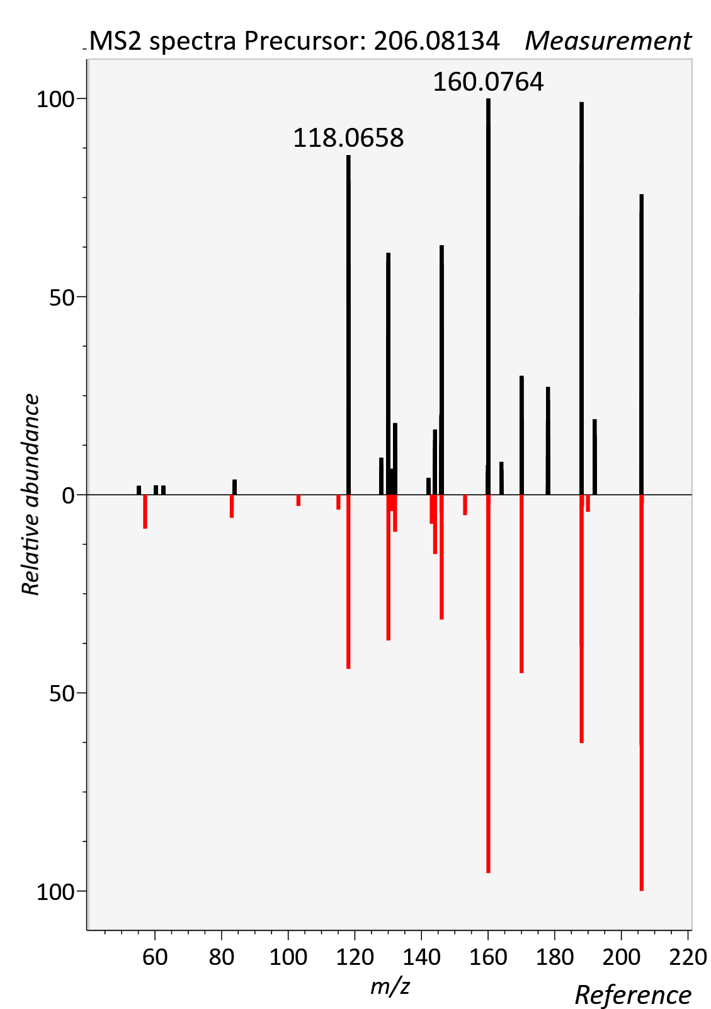

Indoxyl sulfate
RT std: 2.64min, RT experimental: 2.73min, RT Δ 0.09min
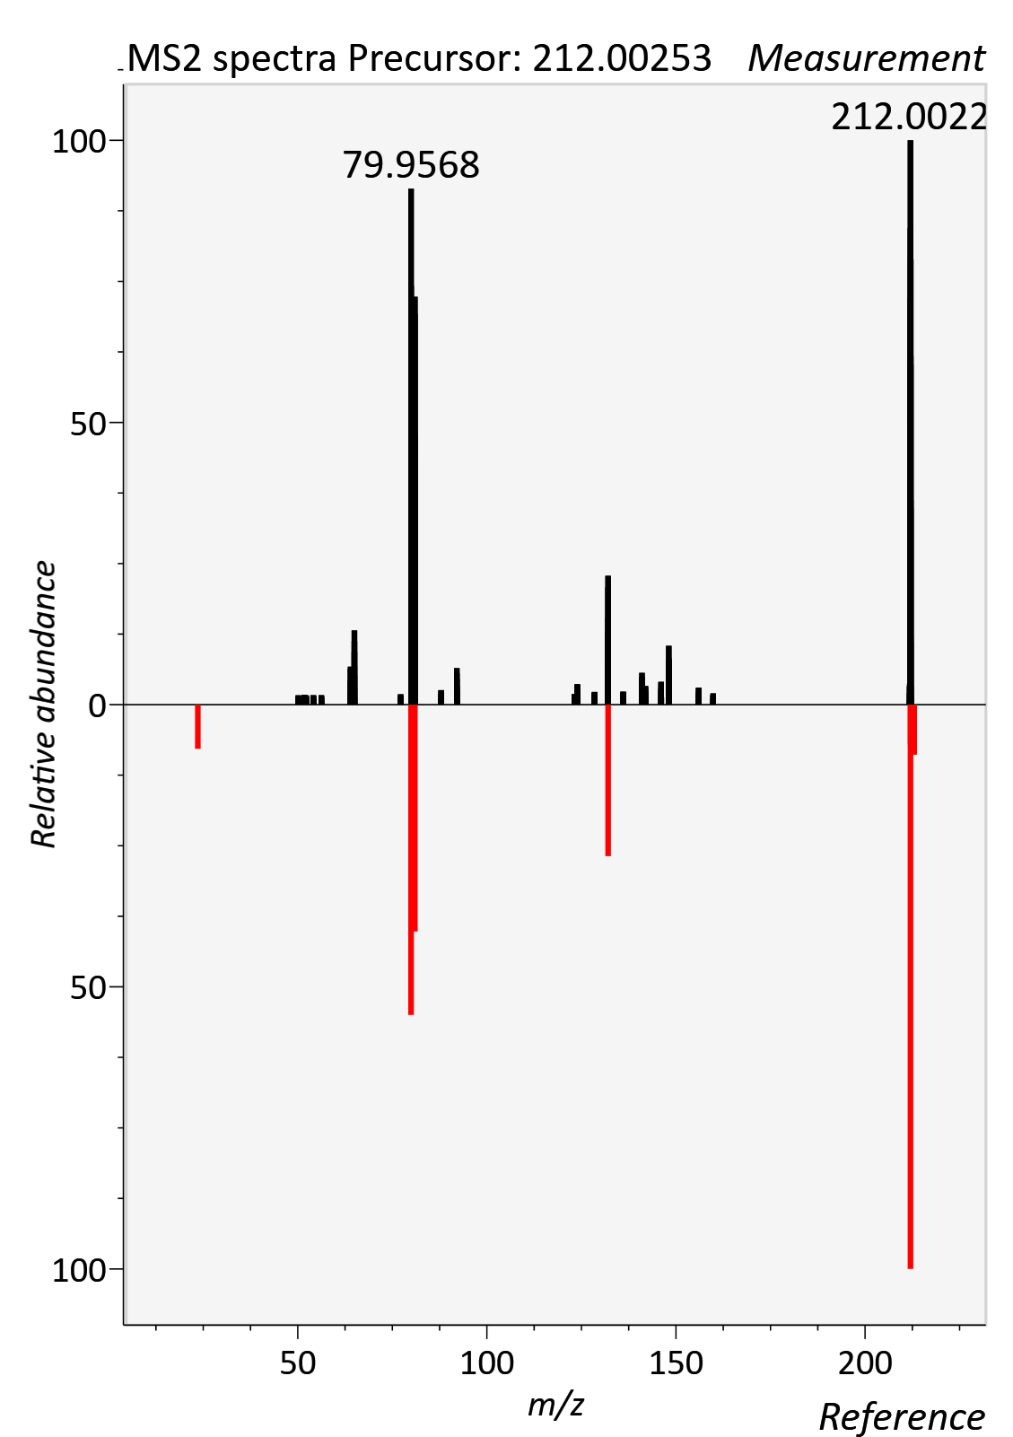

Isoleucine
RT std: 4.14min, RT experimental: 4.53min, RT Δ 0.39min
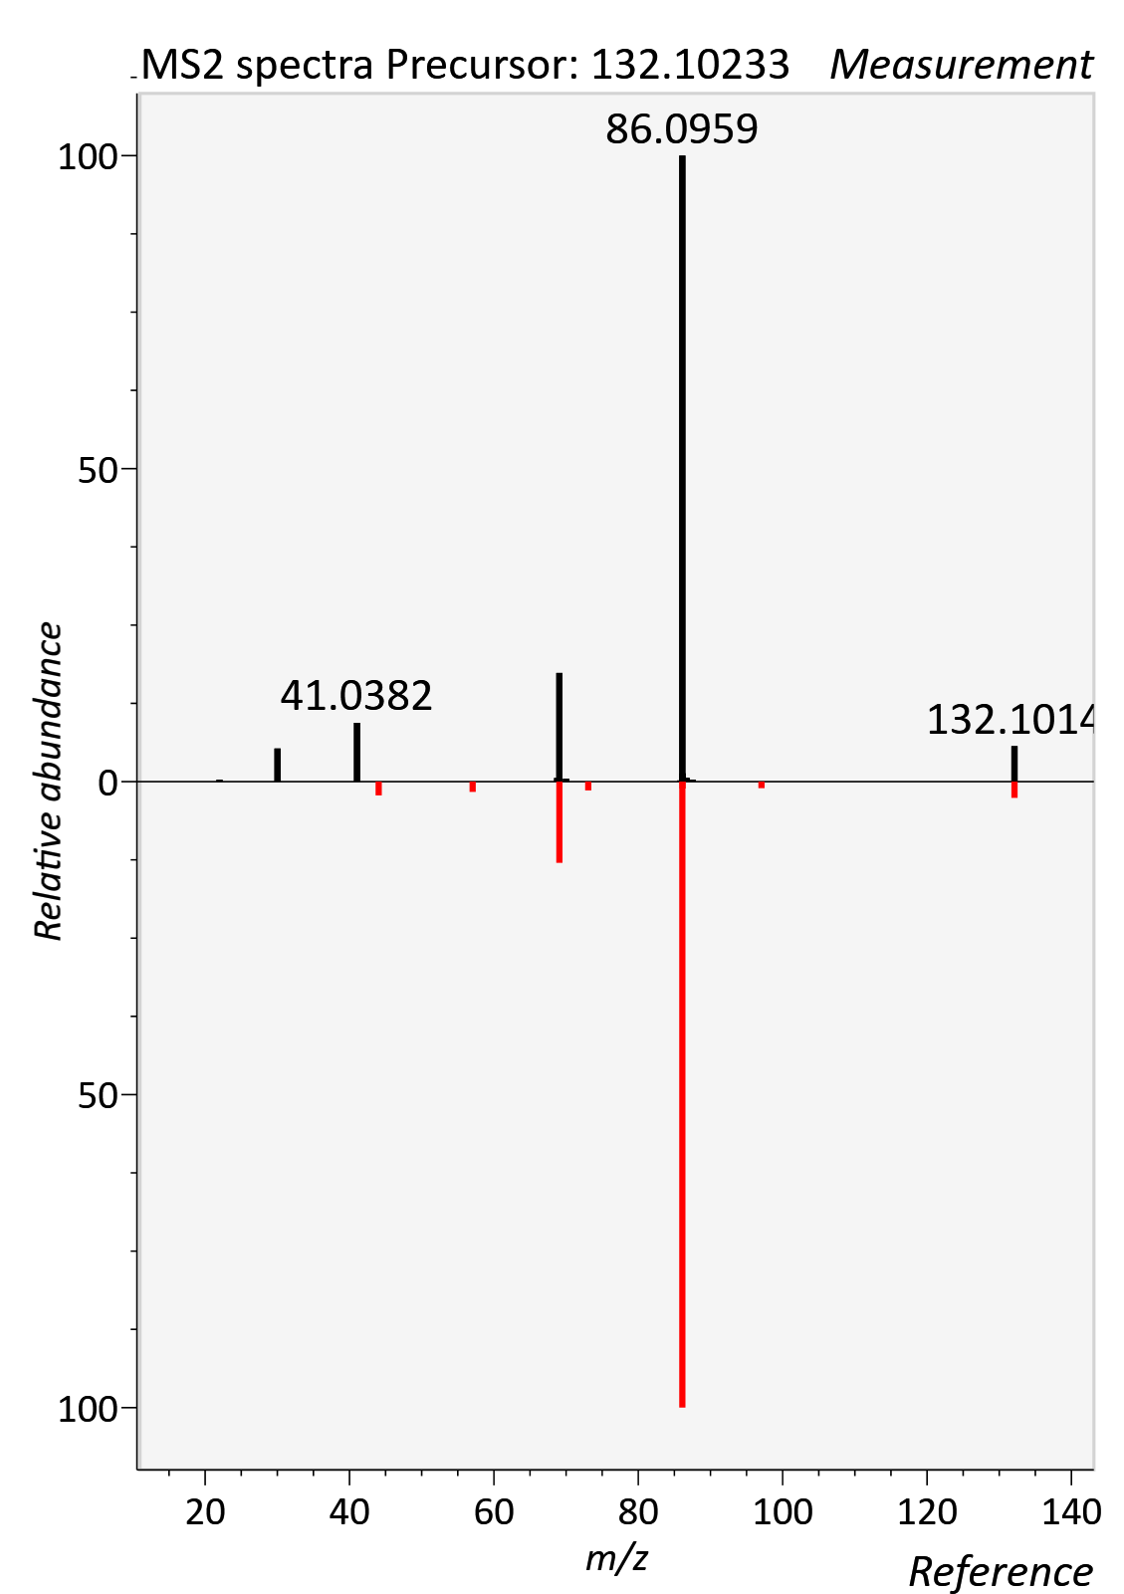

L-Arginine
RT std: 6.94min, RT experimental: 7.11min, RT Δ 0.17min
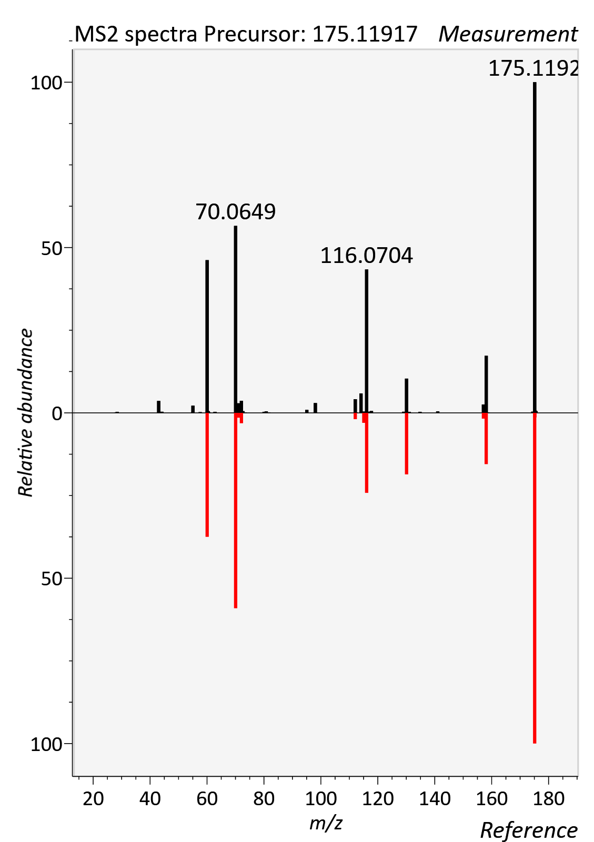

L-Carnitine
RT std: 4.77min, RT experimental: 5.10min, RT Δ 0.37min
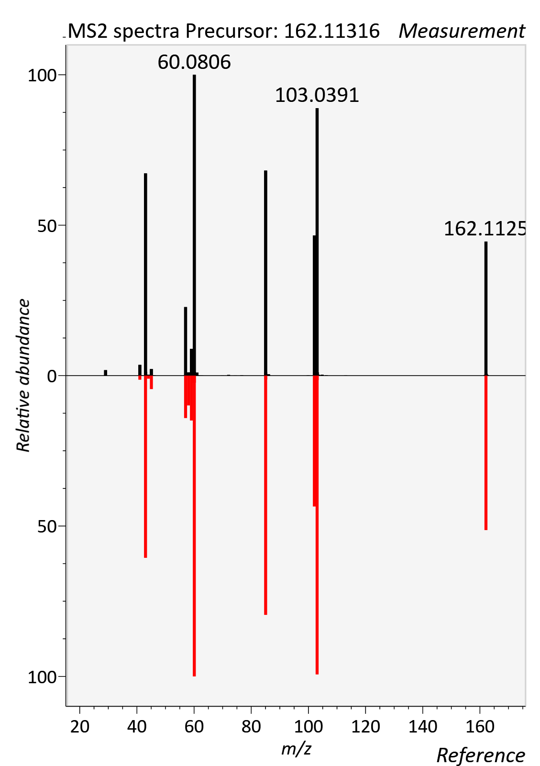

Leucine
RT std: 3.80, RT experimental: 4.28min, RT Δ 0.48min
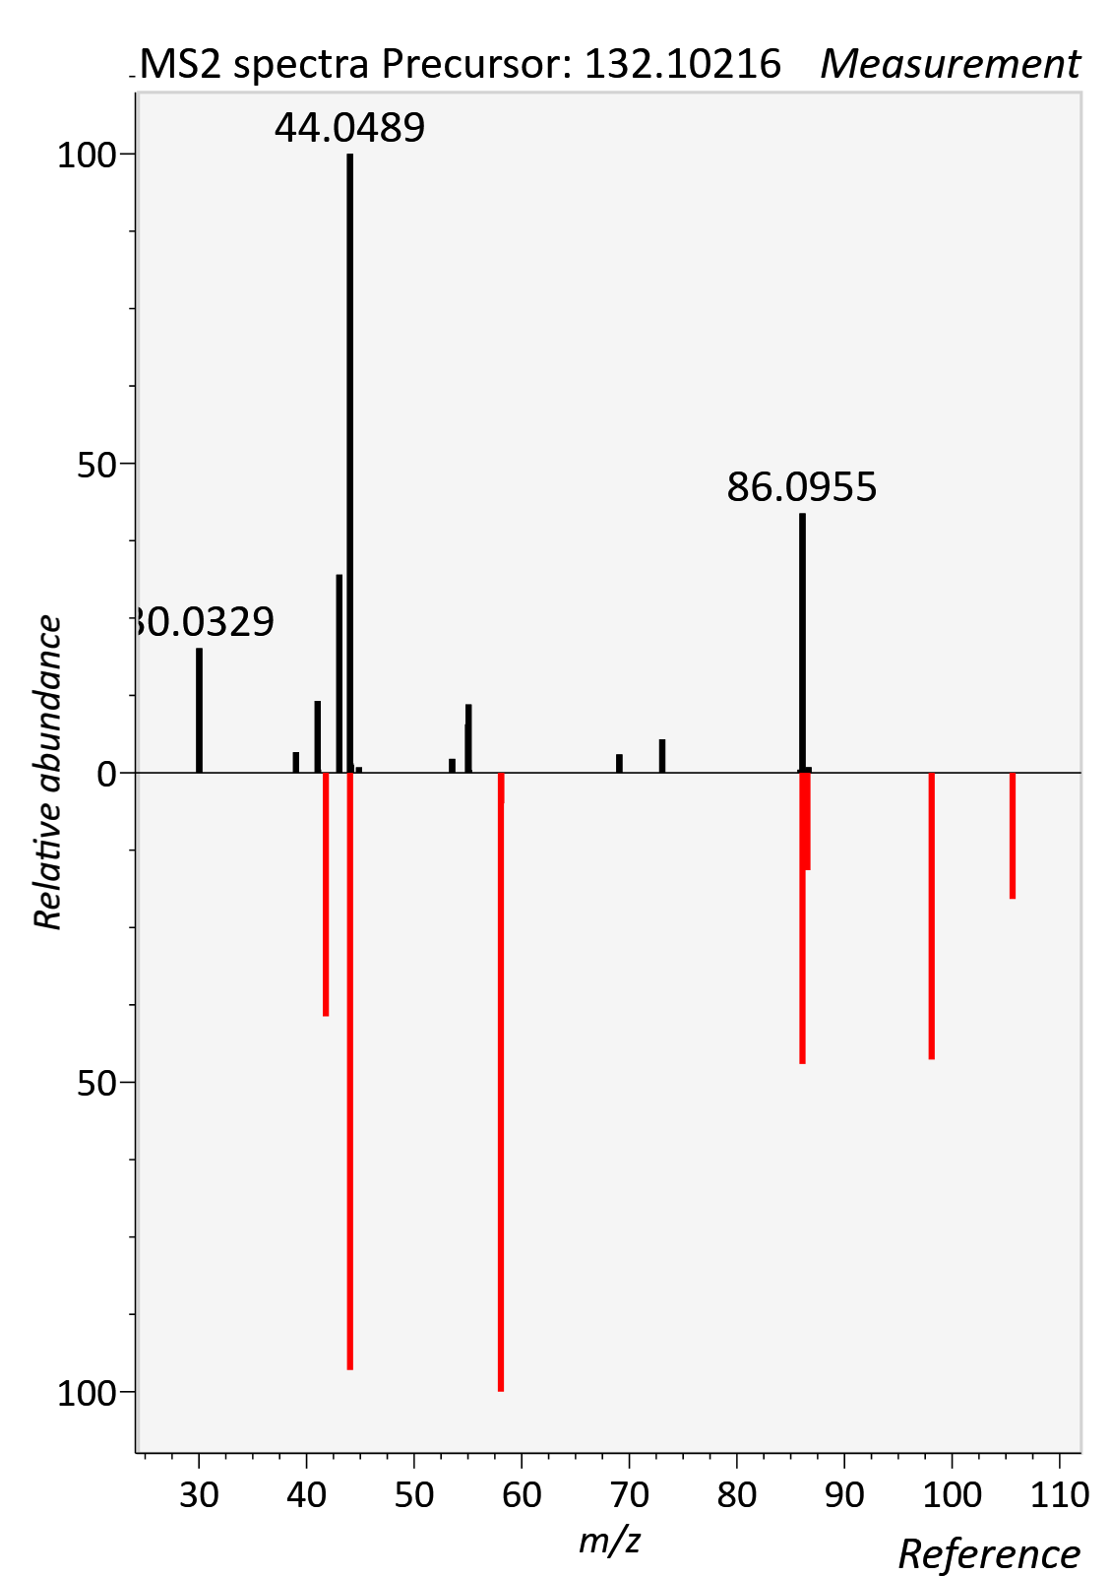

LysoPC 15:0_0:0
RT std: 10.04min, RT experimental: 10.21min, RT Δ 0.16min
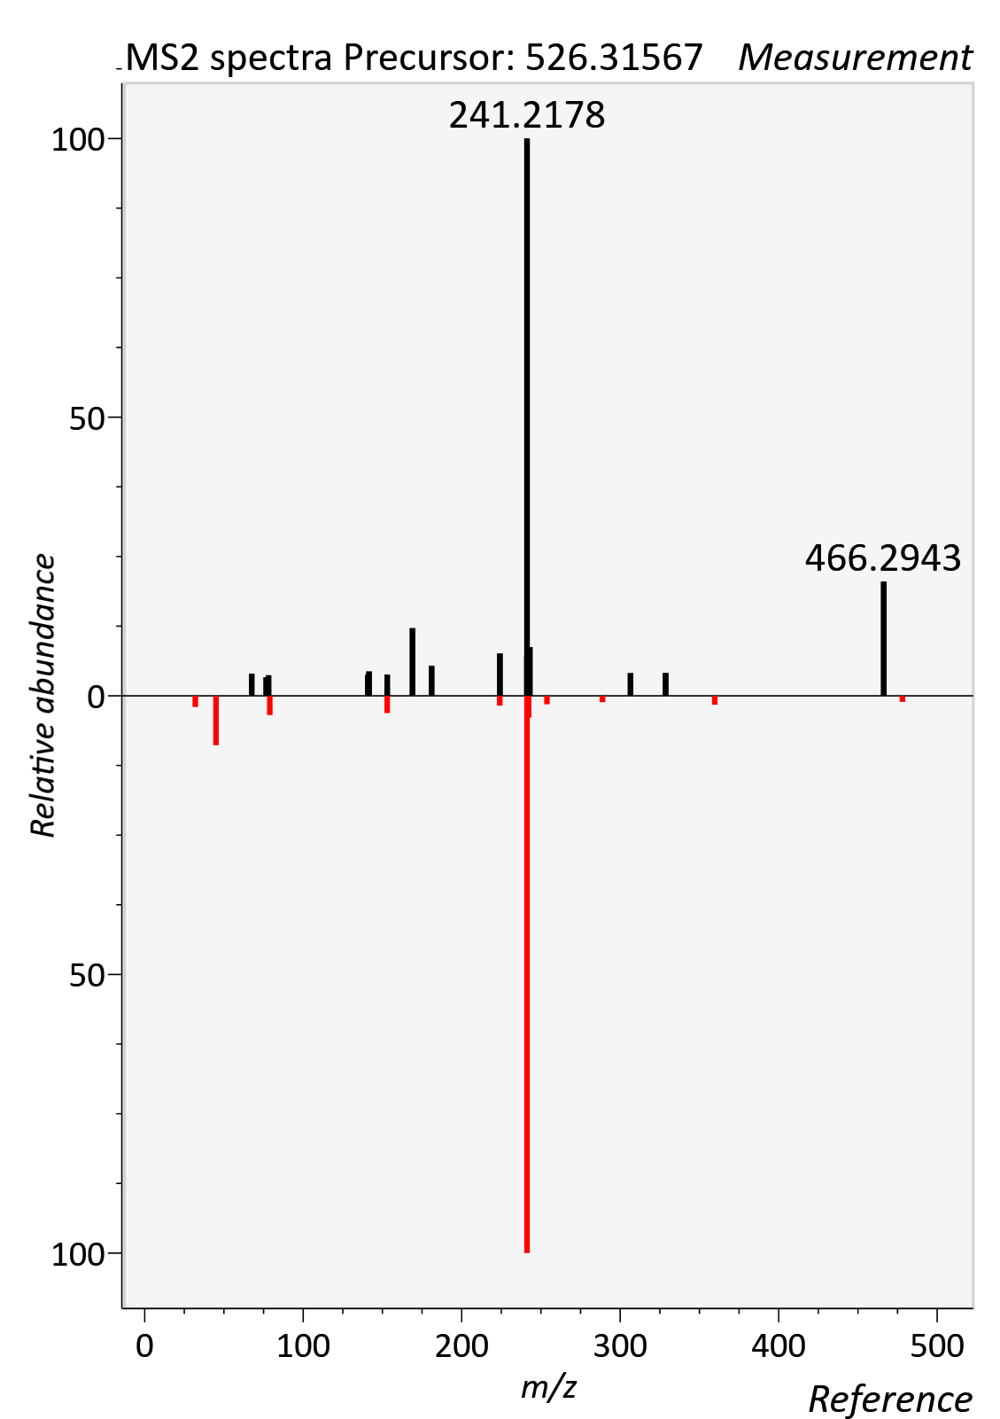

LysoPC 17:0_0:0
RT std: 10.42min, RT experimental: 10.70min, RT Δ 0.28min
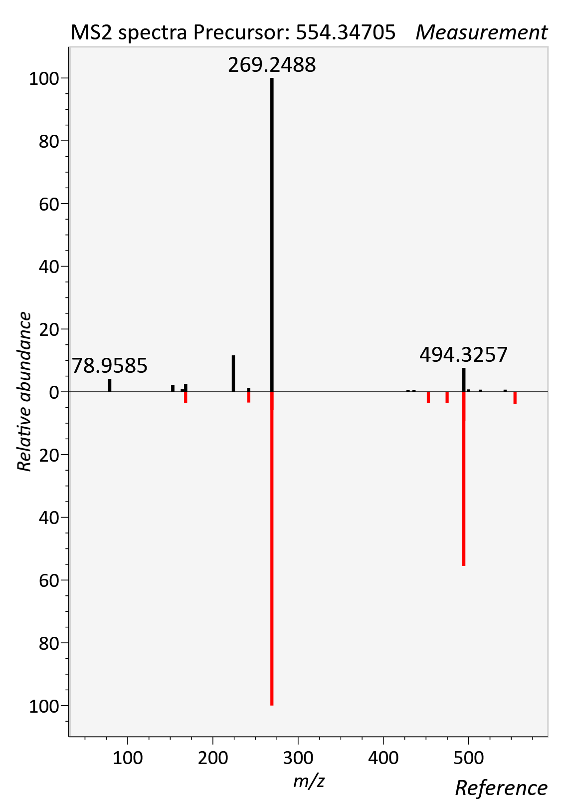
Kynurenine
RT std: 1.73min, RT experimental: 1.90min, RT Δ 0.17min
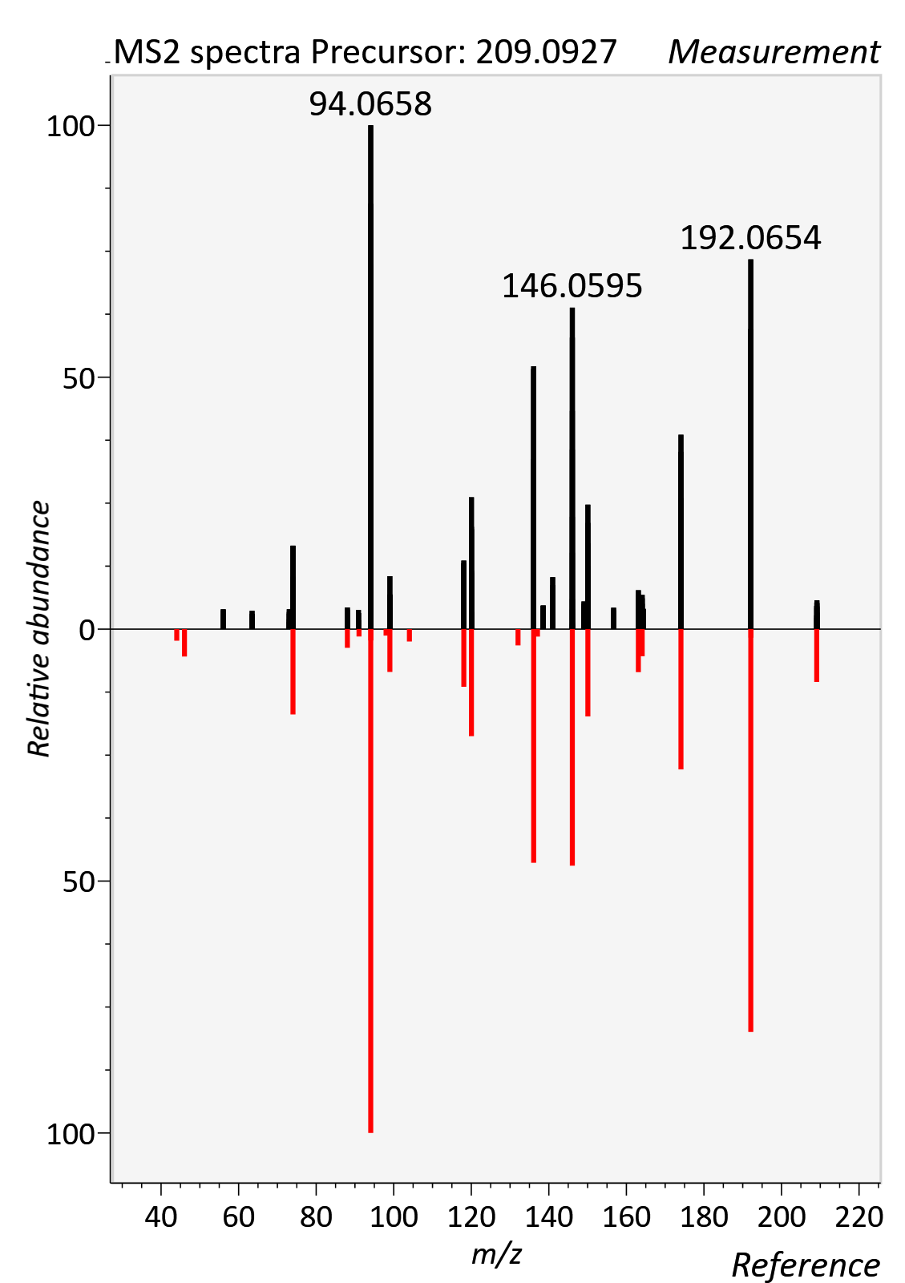

Ornithine
RT std: 7.17min, RT experimental: 7.30min, RT Δ 0.13min
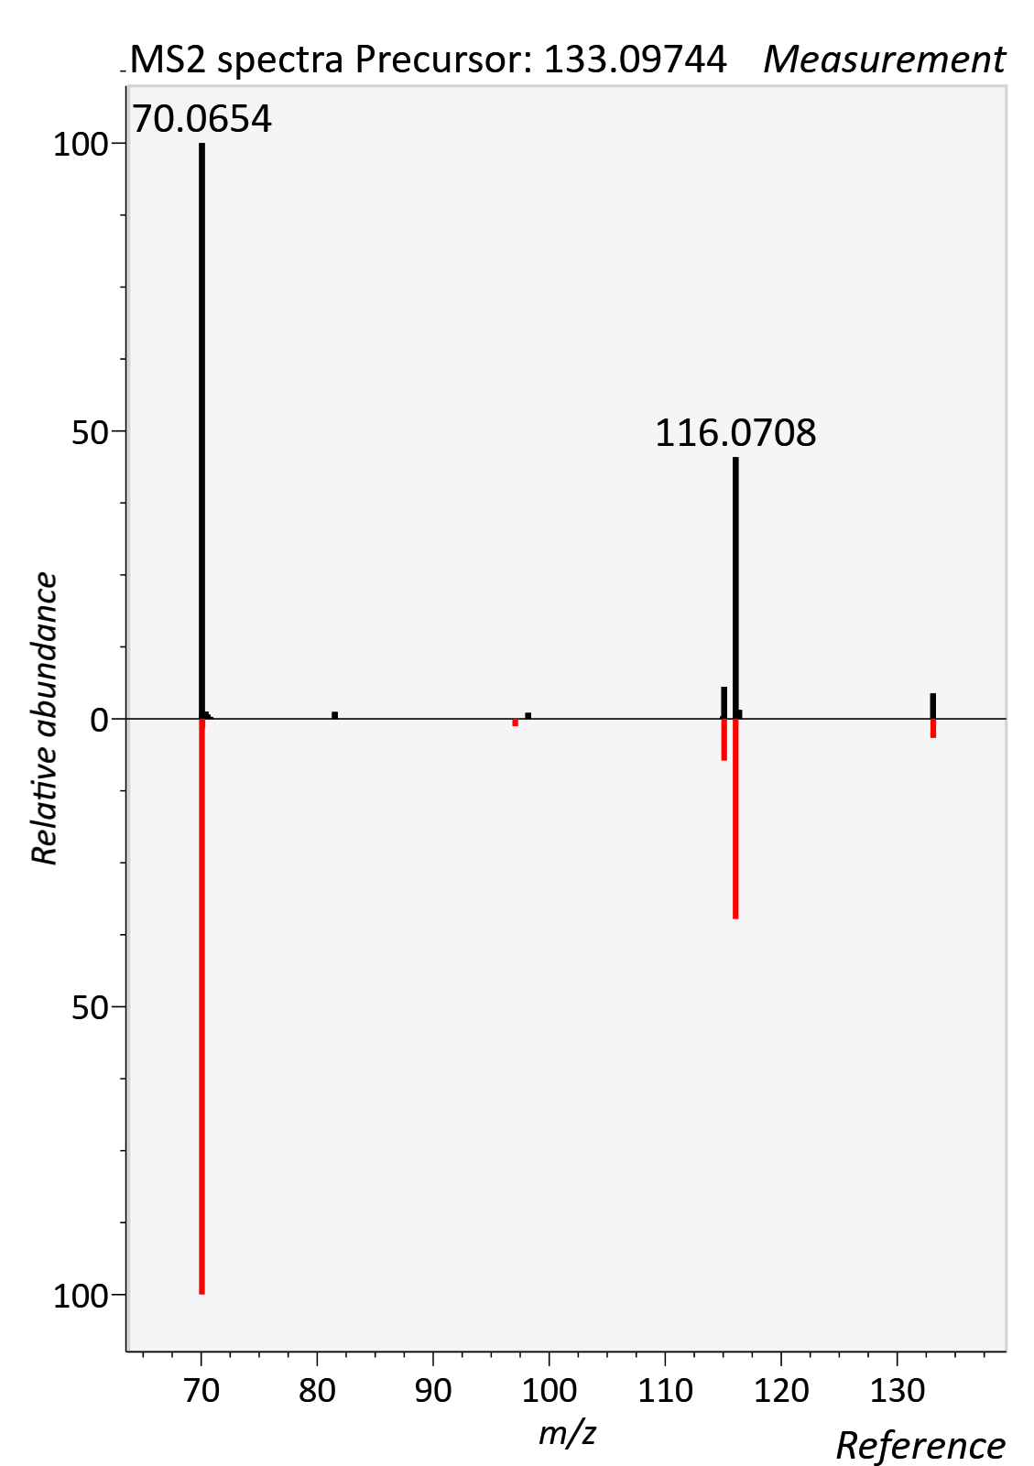

Paraxanthine
RT std: 2.93min, RT experimental: 2.61min, RT Δ 0.32min
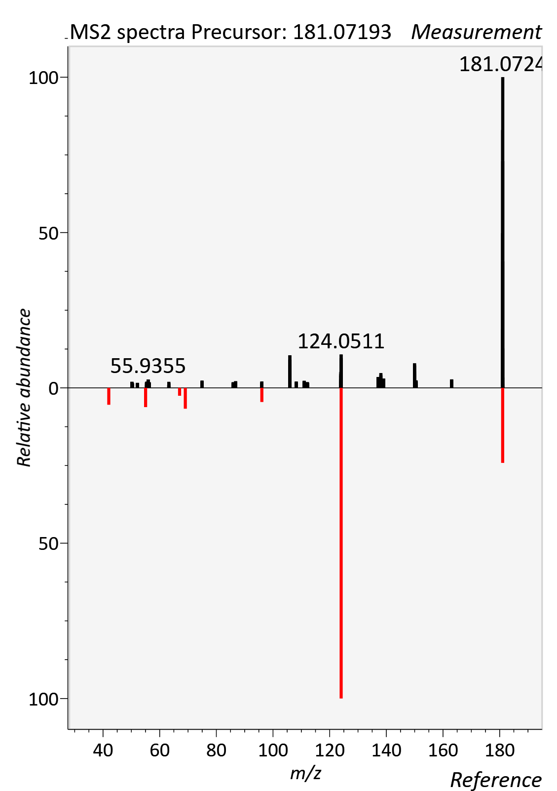

Phenylalanine
RT std: 3.71min, RT experimental: 4.22min, RT Δ 0.51min
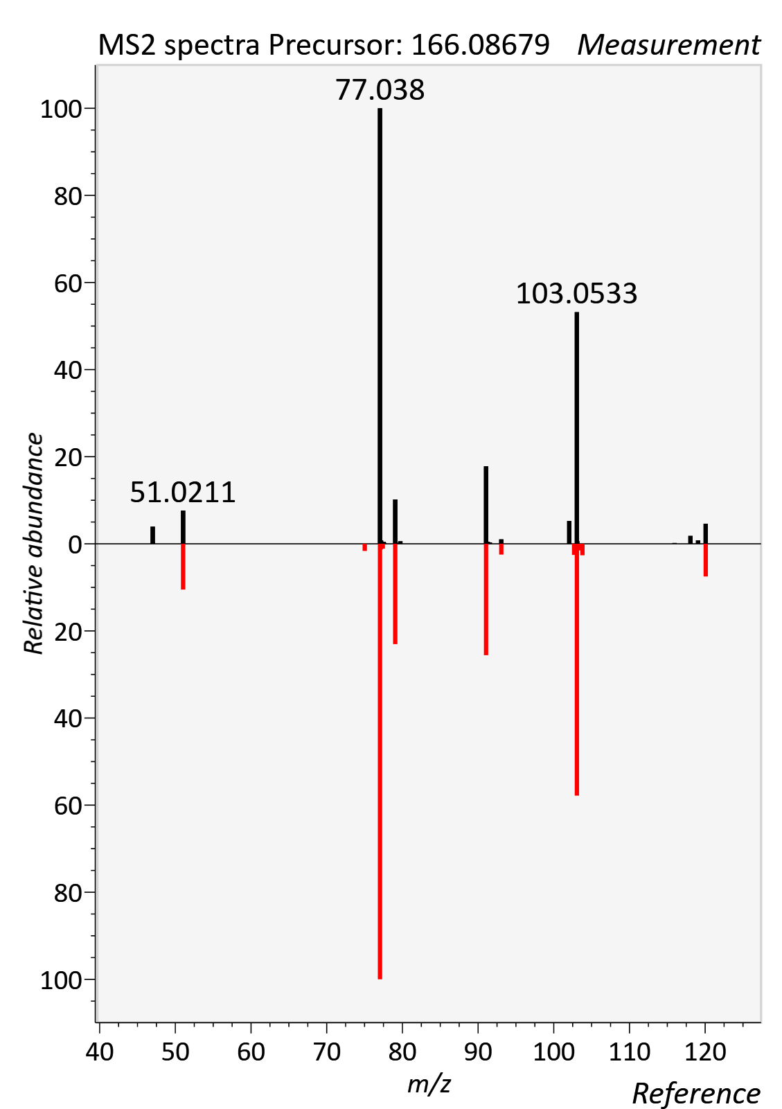

Pipecolic acid
RT std: 4.96min, RT experimental: 4.19min, RT Δ 0.75min
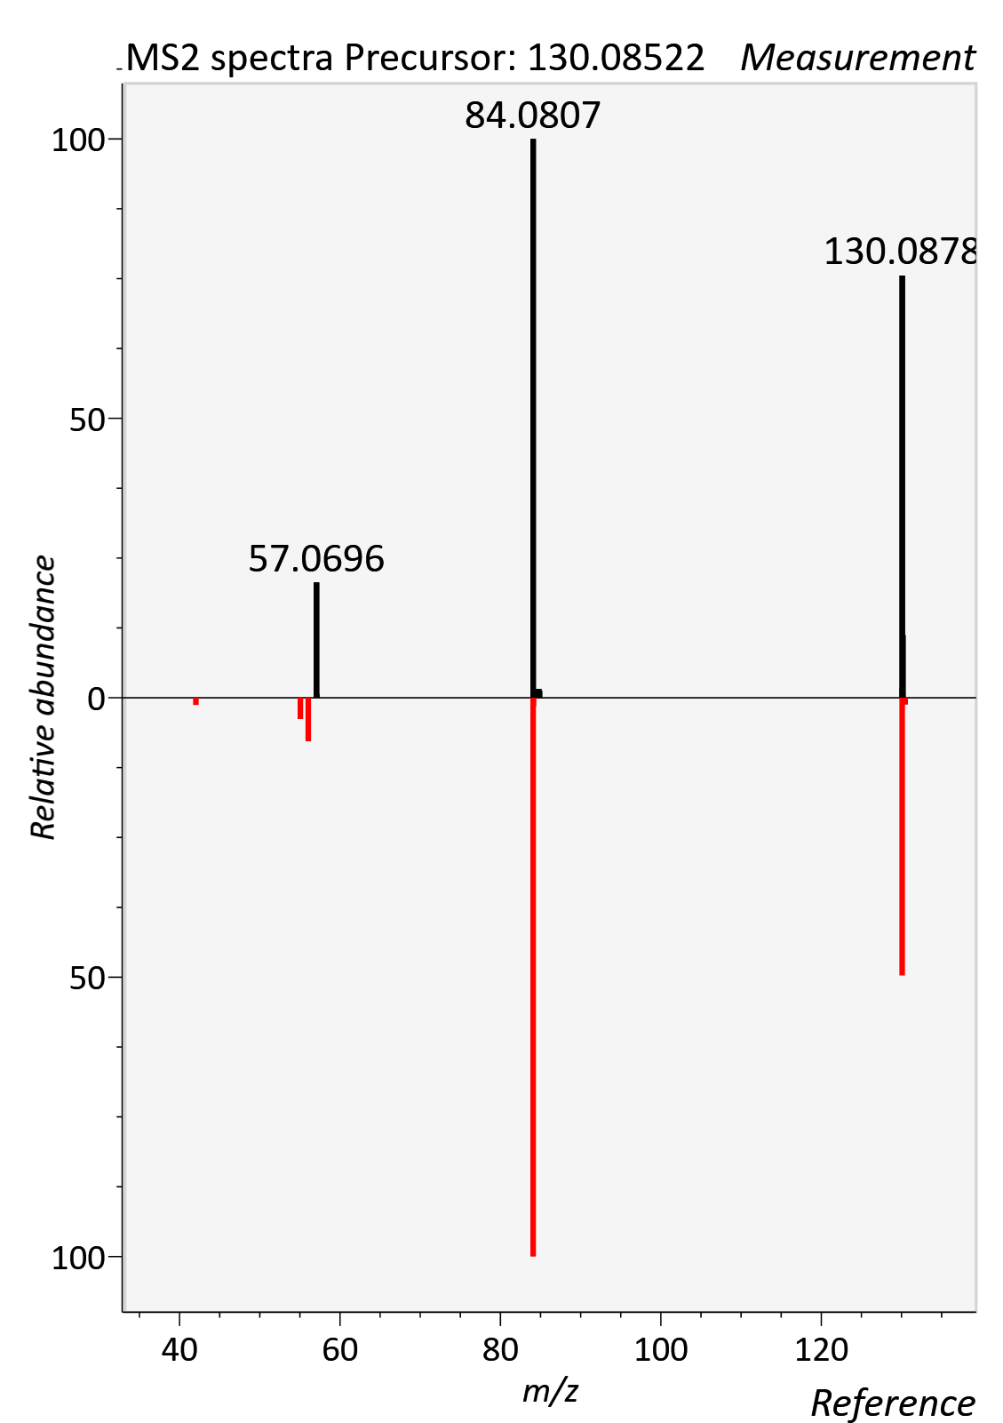

Proline Betaine
RT std: 3.46min, RT experimental: 3.85min, RT Δ 0.39min
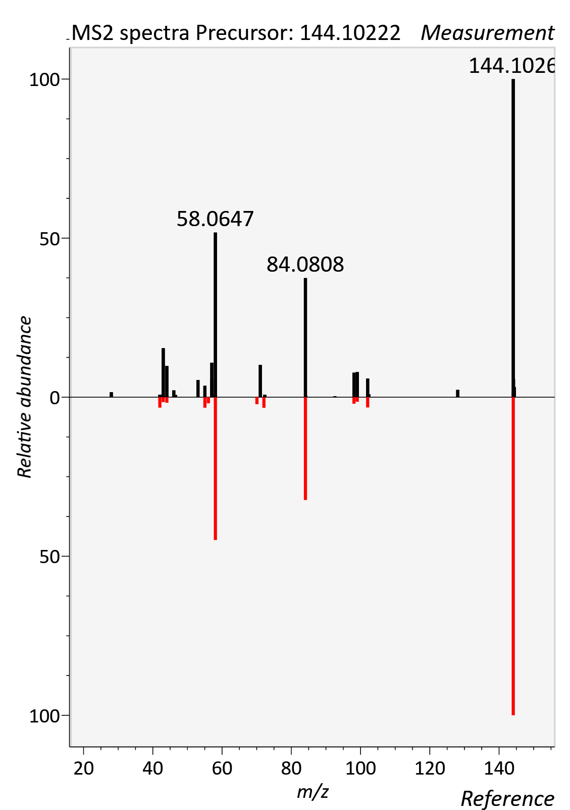

Theobromine
RT std: 2.40min, RT experimental: 2.07min, RT Δ 0.33min
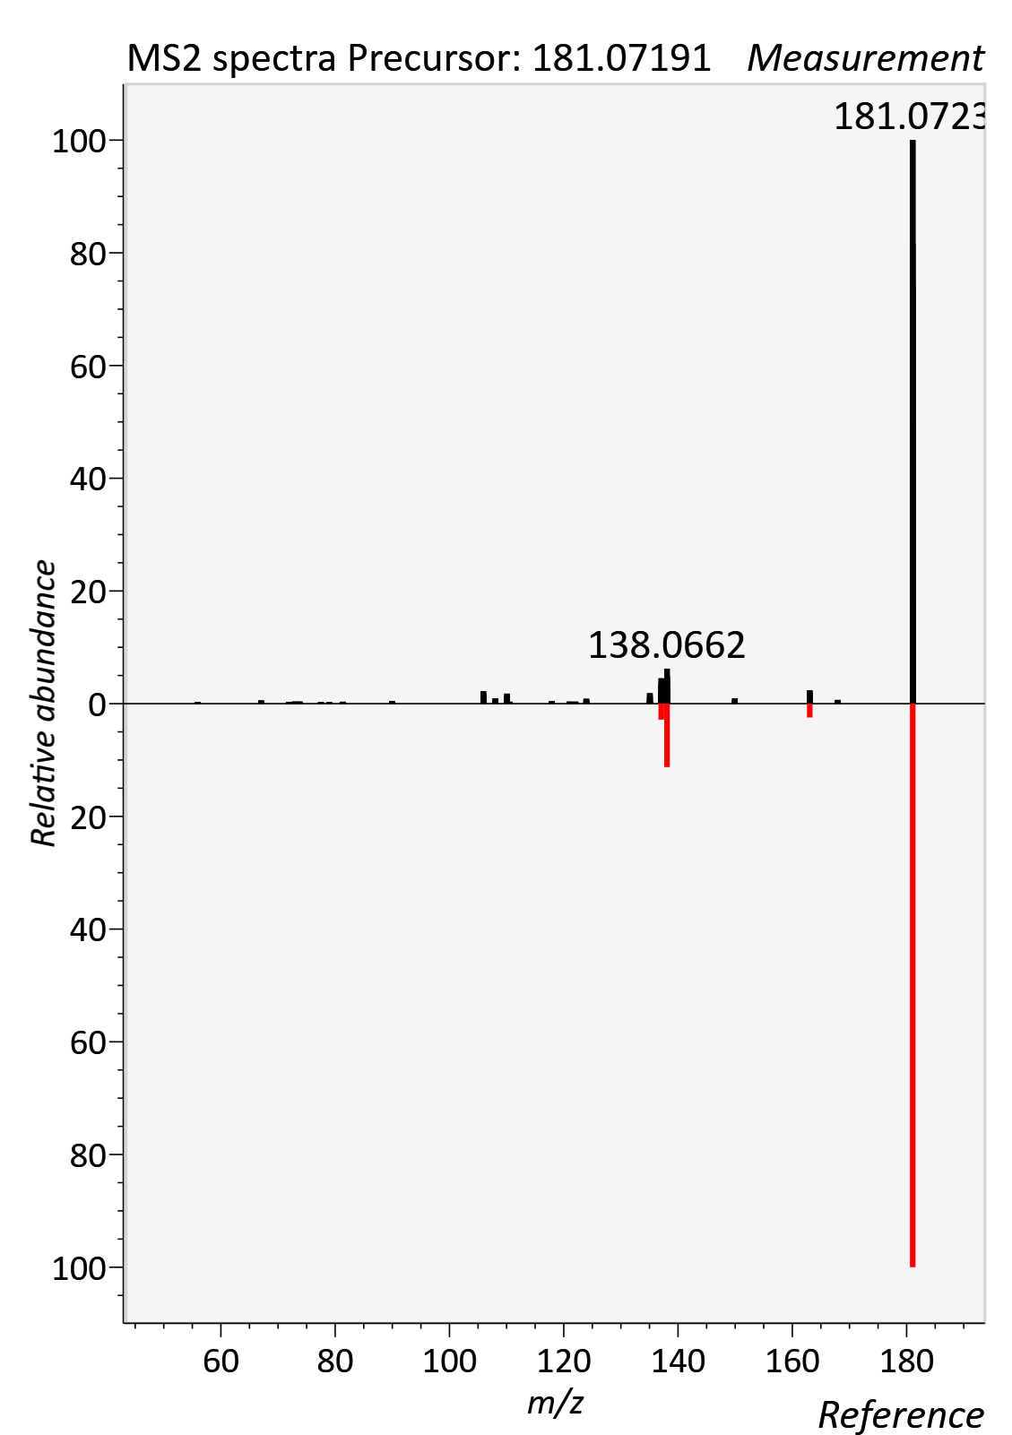

Theophylline
RT std: 2.93min, RT experimental: 3.06min, RT Δ 0.13min
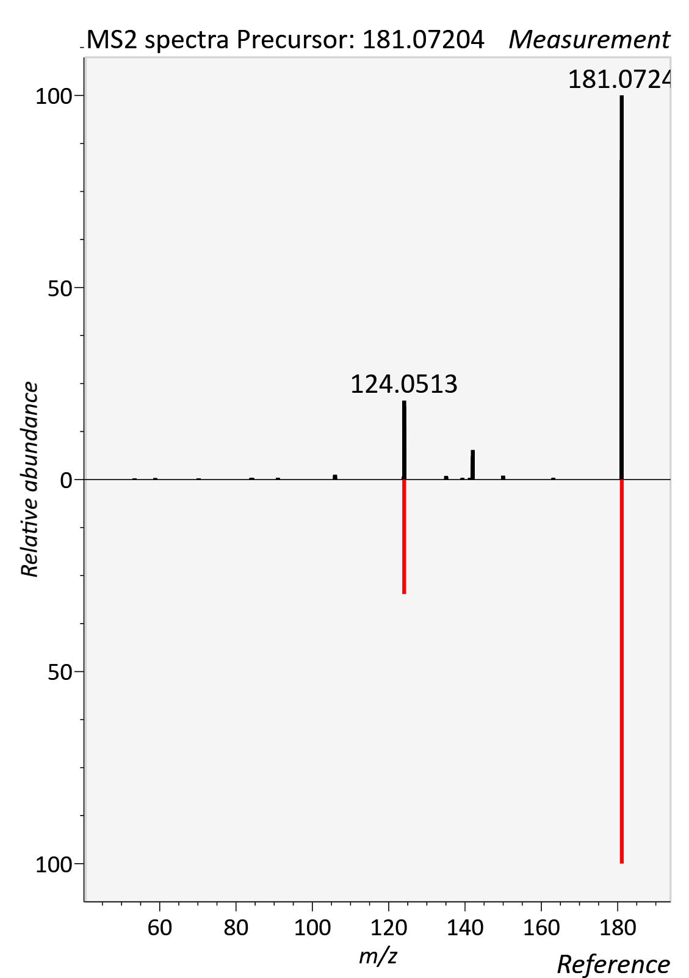

Threonine
RT std: 5.78min, RT experimental: 5.95min, RT Δ 0.17min
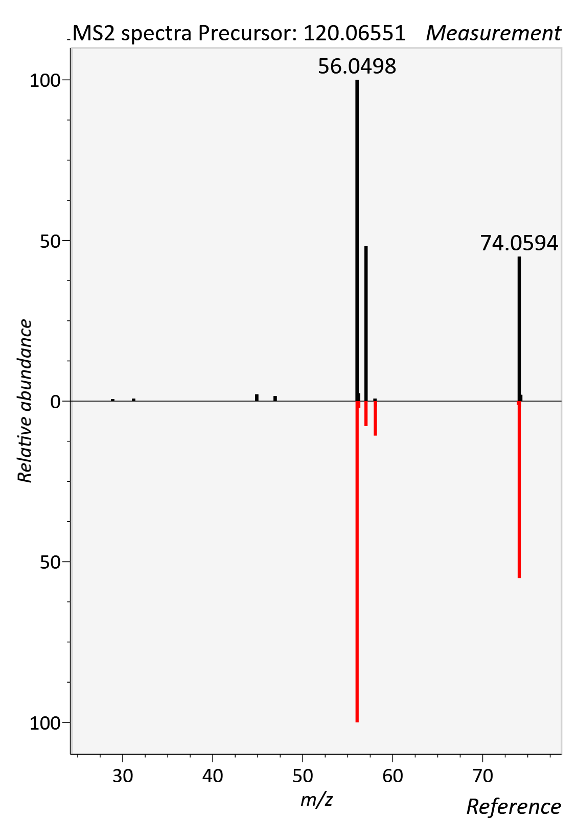

Trigonelline
RT std: 4.03min, RT experimental: 4.52min, RT Δ 0.49min
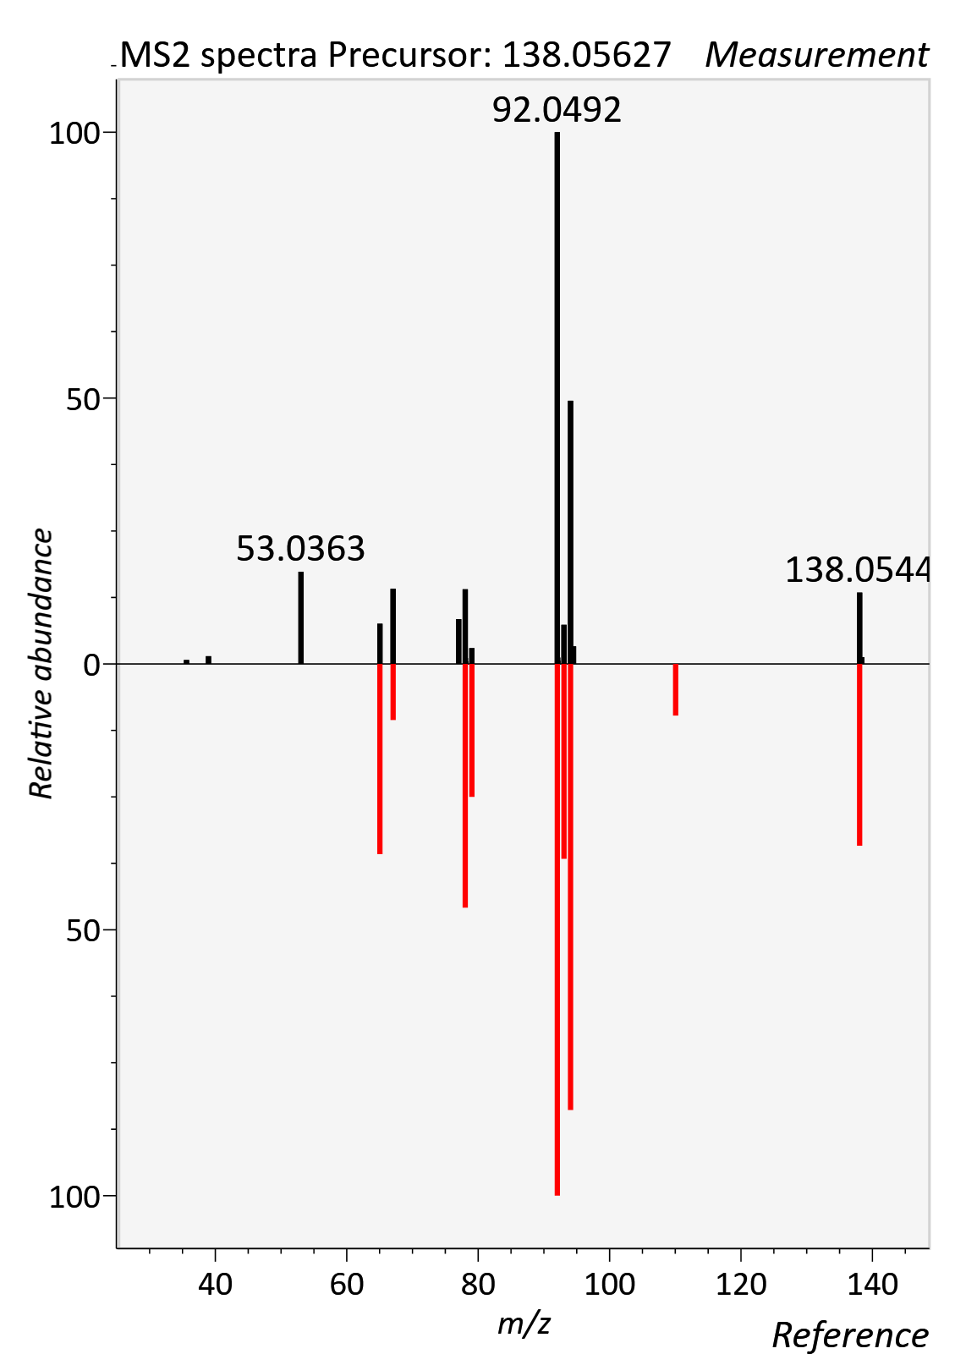

Tryptophan
RT std: 2.76min, RT experimental: 2.43min, RT Δ 0.33min
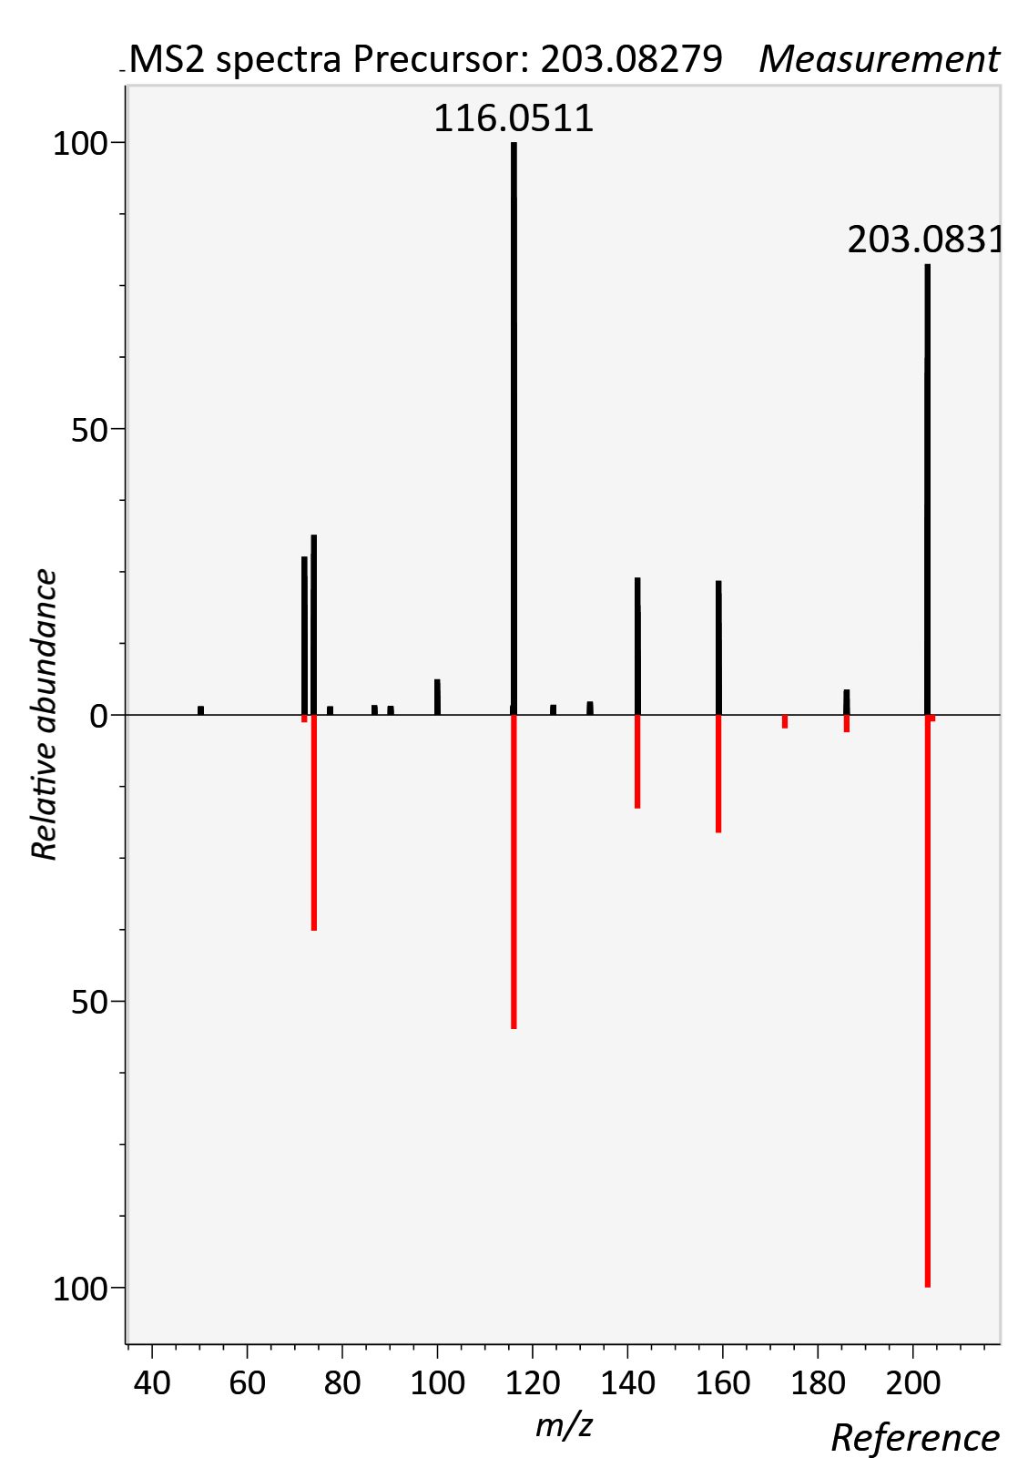

Tyrosine
RT std: 5.01min, RT experimental: 5.30min, RT Δ 0.29min
