 | Name | Matrix ID | Sequence logo | Score | Relative score | Predicted sequence
ieCtnnb1  (Mus musculus) | CREB1 | MA0018.2 | 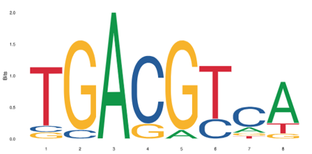 | 9.92 | 0.93 | TGACGTCT
 | HNF4𝛼 | MA0114.3 | 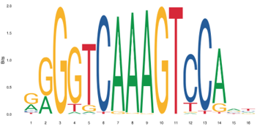 | 16.39 | 0.90 | GGGGGCAAAGTCTATC
Ctnnb1 Promoter  (Mus musculus) | CREB1 | MA0018.2 |  | 8.00 | 0.86 | TGAAGTCA
 | HNF4𝛼 | MA0114.3 |  | 5.18 | 0.79 | CGGTTCCAAGTCTGGT
ieCTNNB1  (Homo sapiens) | CREB1 | MA0018.5 | 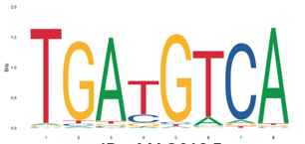 | 14.63 | 0.99 | TGATGTCA
 |  | MA0018.4 | 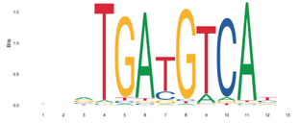 | 14.29 | 0.95 | CTCTGATGTCACC
 | HNF4𝛼 | MA0114.2 | 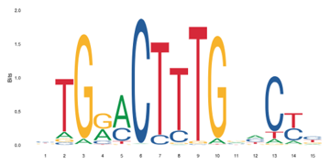 | 10.15 | 0.87 | CTAAACTGTGAACTC
 |  | MA0114.5 | 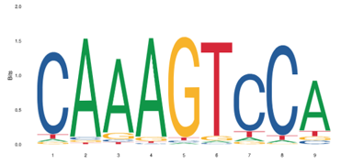 | 9.78 | 0.86 | CAGAGTCCT
ieCTNNB1 Promoter  (Homo sapiens) | CREB1 | MA0018.1 | 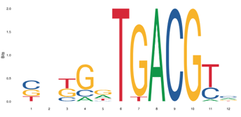 | 10.00 | 0.89 | CGGGGTGACGGC
 | HNF4𝛼 | MA0114.2 | 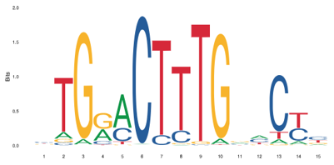 | 14.99 | 0.93 | GAGGACTTTGAACCG

