Kunming Cell Bank, Chinese Academy of Sciences
Mycoplasma Test Report
Cell Line Name: 293T
Accession Number: KCB 200744YJ
Sample Type: Cells
Result: Fluorescent staining, mycoplasma negative
Image Results
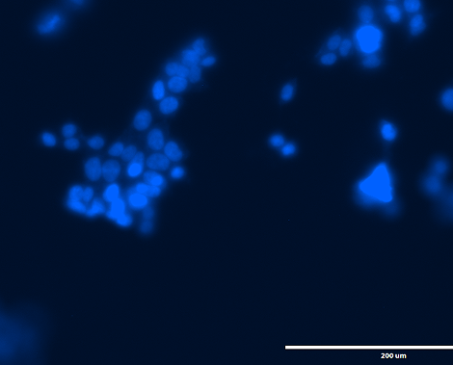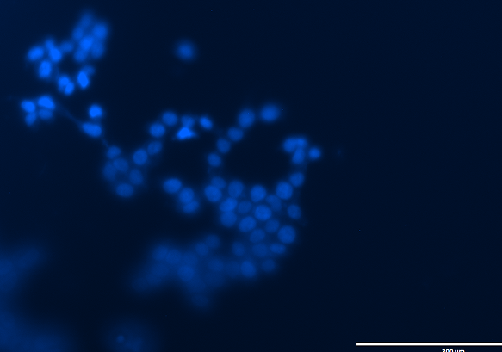
20X 20X
Bright Field Image Results
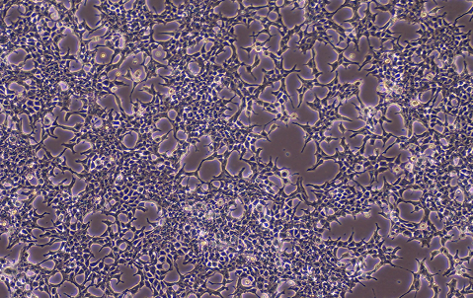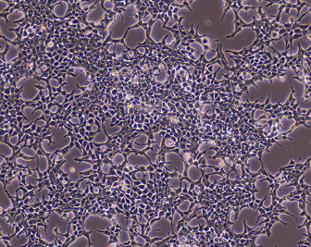
10X 10X

