Supplementary File 3. Analyzed proteomics data.
Supplementary File 3A. The pathway analysis for the upregulated proteins in the Δcrp strain compared to WT. This analysis integrates statistical analysis across the entire genome and includes various functional pathway classification frameworks such as Gene Ontology annotations, KEGG pathways, and Uniprot keywords. Count in Network: The first number indicates how many proteins in our network are annotated with a particular term. The second number indicates how many proteins in total (in our network and in the background) have this term assigned. Strength: Log₁₀(observed/expected). This measure describes how large the enrichment effect is. It’s the ratio between i) the number of proteins in our network that are annotated with a term and ii) the number of proteins that we expect to be annotated with this term in a random network of the same size. False Discovery Rate: This measure describes how significant the enrichment is. Shown are p-values corrected for multiple testing within each category using the Benjamini–Hochberg procedure.
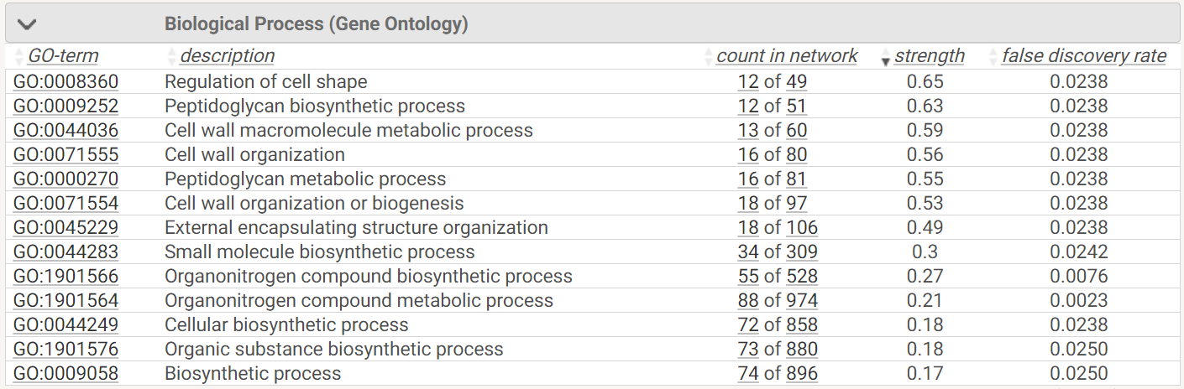
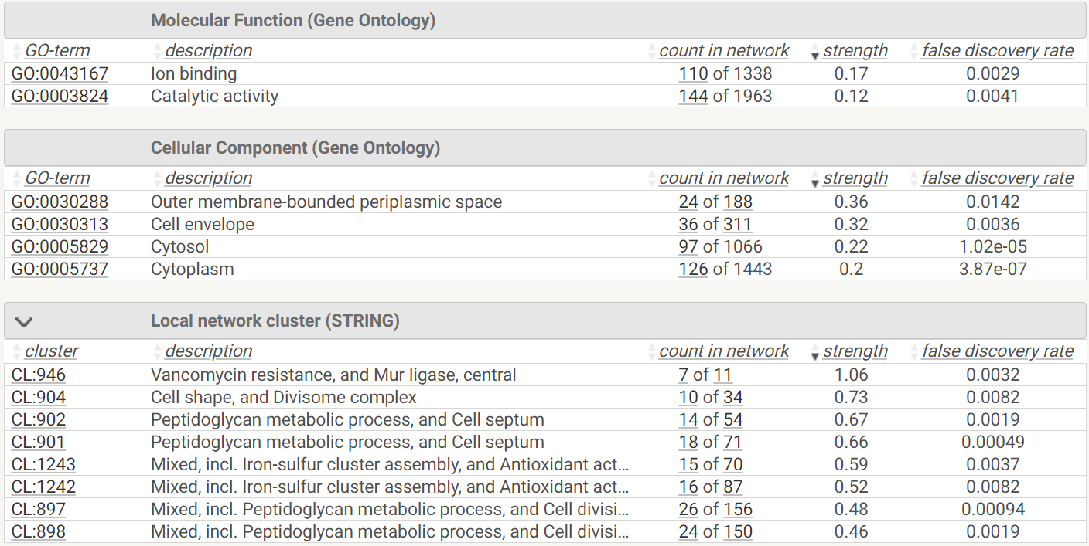
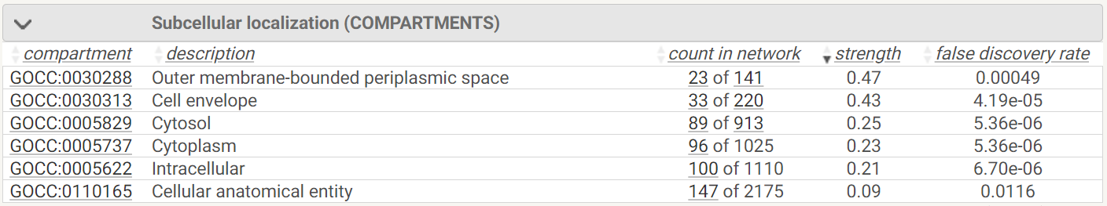
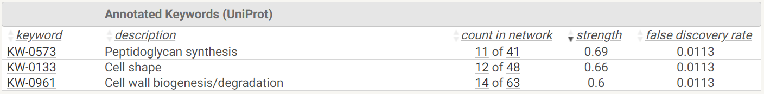

Supplementary File 3B. The pathway analysis for the downregulated proteins in the Δcrp strain compared to WT. See Supplementary File 3A for details.
